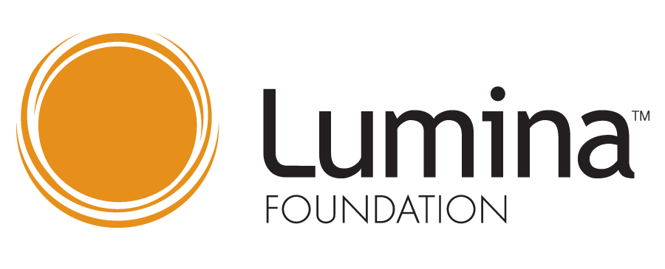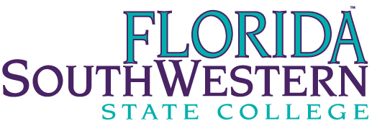

SWFL Talent Hub – FSW Action Team
  - Wednesday, November 4, 2020 at 1:00 p.m.
Dr. Christy Gilfert | Present | Dr. Debbie Psihountas | Present
Brenda Knight | Present | Dr. Tom Rath | Present
Andrae Jones | Present | Whitney Rhyne | Present
Amanda Lehrian | Present | Dr. Matthew Sanchez | Present
Keith Martin | Present | Dr. Norman Thomas | Present
Dr. Martin McClinton | Present | Dr. Michele Yovanovich | Present
Amber McCown | Present

Second Look Student Stop-Out Campaign
The committee discussed the ongoing work of the Second Look Student Stop-Out Campaign. With over 200 formerly stopped out students returning to FSW this fall, Whitney Rhyne asked the Office of Academic Advising to connect with this population. Keith Martin noted the advisors were having positive interactions and that the outreach was going well.
October & November Outreach
FSW is engaging in a call campaign geared towards stop out students that are seemingly within 15 credit hours away from graduation. Admissions processer, recruiters, and student assistants from both the Office of Admission and Office of Strategic Initiatives are working to call 2,115 students. Amber noted the call campaign is asking processing staff to grow and have conversations they would not usually have with students. Several students that were contacted via the call campaign were interested in changing program and had to be referred to an academic advisor for follow up.
This call campaign exposed a challenge of the CAPP audit process and report comparing students' coursework to the current catalog year. The credits applied to specific areas of the AA within the CAPP process exceed what is needed to graduate. 30 credits can be applied to the general elective area, and excess credits can be applied in others areas as well (Math, Social Science, etc.) For the purpose of this campaign, it is challenging to know how close a student may be to graduation. Brenda Knight noted they could explore the process. Dr. Christy Gilfert said reducing the CAPP limits could do more harm than good in awarding financial aid. An idea to cross-reference the report with a student's degree audit was suggested. However, that is an individual process.
40% of the 2,115 have been called. Of the students, a staff member talks to 50% state they plan to return. Unfortunately, the call team only gets to speak to 13% of students called. The majority of calls (57%) go to voicemail. And 13% of the students are unable to receive voicemails. 31% of the phone numbers are bad numbers. From the work so far, 39 students have completed an application for the spring term.
Dr. Psihountas shared that SoBT staff worked the list of students who had stopped out and, through other funding, was able to offer to fund the student needed coursework to completion. Dr. Psihountas noted she was surprised that more students do not respond to that offer. She noted faculty and staff are often not aware that students are not completing their degree programs and shared about a paralegal student who was featured in the SoBT newsletter that only through conversation for the newsletter, the students were identified as only needing one class to graduate. The professor who recommended the student was surprised, and Dr. Psihountas was able to fund the student's last class need to complete their degree.
Through this work, FSW identified 16 students who met all requirements to graduate under the current catalog and just needed to reapply to update their entry term. Whitney emailed and called all 16 students, and only six completed the re-admit application to graduate. FSW also sent a physical letter to the students hoping that it will serve as a catalyst to get the student to complete the re-admit application to graduate. Amanda Lehrian offered to help reach out to any H/G students on the list.
Departing FSW Survey
This fall, FSW launched a new survey focused on gaining insights from departing students. Students who took classes at FSW in the spring or summer but did not return to FSW this fall received the survey. Upwards of 600 students completed the survey. 71% noted they had degree aspiration when started at FSW, while 29% attended for another reason (personal fulfillment, job-related training, etc.). When students were asked why they choose to leave FSW, completed or changed, my goal was the top answer, followed by decided to attend a different college/university, and decided to take a semester off. 36% of students stated they planned to re-enroll in the future, 26% were unsure, and 38% said they did not intend to re-enroll.
The survey contained two open-ended questions. First, how can FSW best support you in achieving your goals? The top three themes that emerged were happy statements, noting FSW has already supported them in achieving their goals, comments focused on academics – the desire for attached space in existing limited access programs, more certificate, bachelor, and even the desire for master-level programs at FSW. The third theme was support; students noted a desire to be checked in on, to have academic coaching, and noted the need for additional mental health services.
When asked to provide additional comments on their exit from FSW, the majority of students noted they had a good experience, a high number of students noted they planned to return. A smaller number of students reported negative experiences, trouble navigating processes, not seeing their career pathway, not satisfied with the atmosphere at the school, and a poor website. The majority of comments were positive, but we often learn the most from our critics. Whitney asked if Admission or Advising could send a communication encouraging the 381 students who were considering re-enrollment at FSW a reminder/invitation to register for spring classes. The group decided the communication would be best to come out of the Office of Academic Advising through the Advise system.
Scholarship Dollars
Tessa LeSage, Director of the SWFL Community Foundation and Kitty Green, Foundation at FGCU, got the SWFL Talent Hub on the agenda on the next Industrial Development Authority (IDA) meeting to see if the IDA would provide a match to unlock the Soderburg family Foundation funds. Dr. McClinton is available to represent FSW at the meeting. Whitney will provide relevant data in advance of the meeting to Tessa and Dr. McClinton. The funds would be exclusively for students who are from Lee County.
Marketing Ideas
Whitney shared that the Lumina Grant funding managed by FGCU needs to be utilized by December 21, and FSW will receive $5,000 to be used on marketing efforts to support our work with stop out students. Whitney asked the committee for any ideas on ways to best use the funds. Postcard mailers, magnets, and keychains that are small and easy to mail were suggested.
FSW Student Voice Summit
In partnership with FutureMakers Coalition, FSW will host a Student Voice Summit. The summit allows leaders and administrations to hear directly from students. During the summit, we will provide specific data and ask students to tell us why they think a trend, etc. is occurring. We will pose questions about their challenges and solutions to hear our student's thoughts and ideas. Whitney asked the group if they thought Tues., Feb. 23, 2021 from 3-5p.m. would work well, and there were no objections.
Topics for Student Voice Summit breakout rooms could include: 55% - regional data, general enrollment data, retention and persistence data, ASC & other data, financial aid data, what can we do better at FSW, in the state of Florida, in the nation.
Destination FGCU
Whitney shared information about the upcoming Destination FGCU advising access Fridays and shared the newly developed Destination FGCU webpage. The Destination FGCU webpage can be found from the 2+2 webpage. In the development of the Destination FGCU, FSW redesigned the 2+2 webpage adding links to the Florida University system, developing a page promoting FSW's bachelor programs, and then linking to the Destination FGCU webpage. Dr. Gilfert provided an update that identified students by FGCU have received a communication and link to apply to the reverse transfer program. Keith asked about our student transfer rates to FGCU. Whitney noted of FSW's 2019-2020 graduates, FSW students transferred to 109 different institutions. Of our students that transfer, 48.5% transfer to FGCU. Mr. McClinton shared a report from the state noting FSW students' top majors at FGCU and their success as compared to students who stated at FGCU.
Minutes respectfully submitted by Whitney Rhyne.

