English Department Meeting Notes

01/08/2020

1:00 pm – 2:30 pm

https://fsw.zoom.us/j/92360133678

Meeting ID: 923 6013 3678
Meeting called by Department Chair, Amy Lynn Trogan
In attendance: Rebecca Harris, Shawn Moore, Ihasha Horn, Michael Barach, Tom Mohundro, Brandi George, Jeremy Pilarski, Suzanne Biedenbach, Cara Minardi Power, Amy Trogan, Jill Hummel, Leonard Owens, Cate Gooch, Katie Waddell, Jason Calabrese, Sara Dustin, Ellie Bunting, Mark Massaro, Eric Ivy, Laura Tichy-Smith, Michael Schrier, Arenthia Herren, Patrice Finn, Michelle Schrier
Missing: Jennifer Grove, Thomas Wayne, David Luther

Meeting begins
Approval of November Meeting Minutes
- Meeting minutes are unanimously approved.

Spring 2021 Objectives

Microsoft Teams for English Mentors

A Microsoft Teams account has been created for mentors

Syllapooloza

This will be addressed in the assessment section.

QEP

We spent a good bit of time discussing this during our last meeting, with an emphasis on how we might foster more collaboration and innovation.

Rebecca Harris

The QEP committee is in the process of building a three-credit hour interdisciplinary course that will be a capstone for all graduating students.

People agree that this sounds exciting!

Guided Pathways

This is something new coming from the state.

The objective is to retain students and close equity gaps.

More information will be forthcoming as the program continues to develop.

Community of Practice in English

Notes that the Community of Practice in English is a great new training opportunity that folks can attend.

ENC 1130/1101 Pathway

These are going well thus far and are continuing to be evaluated to ensure that students’ needs are being met.

2021-2022 AY Assessment Plan

Assessments will be conducted for ENC1101, ENC1102, and LIT2000. More on this in the assessment section
Library Embedded Courses—Prof. Arenthia Herren
- New pilot program will begin that will embed librarians into classes to help with information literacy. The program will begin this summer.
  - Everyone expresses their excitement about this new opportunity.

Textbook Discussion.

They Say, I Say--vote to adopt new edition of the book as a default for all iterations of ENC 1101 courses

New edition is adopted

Little Seagull Handbook--vote to adopt new edition of the book as a default handbook in all versions of ENC 1101

New edition is adopted

Little Seagull Handbook--vote to adopt new edition of the book as a default handbook in ground versions of ENC 1102 courses

New edition is adopted

LIT 2000

It is confirmed that Reading and Writing About Literature is the default textbook for LIT 2000.

People note the great quality of the OER resource that Dr. Harris created for this class.

Quick reminder that a new set of books just entered the public domain, including Mrs. Dalloway, In Our Time, and The Great Gatsby.

Assessment Update—Dr. Minardi-Power

Remind your department about Syllapalooza: the PD sessions for deans and chairs to review syllabi are scheduled for the months of January, February, and March. Now is the time for faculty to review their syllabi and discuss any possible changes with fellow faculty, chairs, and deans. Remind faculty to review their course learning outcomes as well as the CREATIVE acronym and consider any changes or refinements they’d like to see.

LAC is currently doing Gen Ed Assessment of “Communicate” and “Evaluate”: let faculty know that we are currently in the process of using their artifacts (the submitted assignments) for our gen ed assessment process. Answer any questions faculty might have about how their artifacts are being used and/or about the general process of gen ed assessment; if you need to, feel free to direct faculty to reach out to Elijah Pritchett or Joe van Gaalen for additional information about the process and what it entails.

Course level assessments are currently being analyzed/Act now to schedule a departmental review with Team AASPIRE: If your department wants a meeting-visit from a Team AASPIRE member to go over your department’s course level assessment reports, let AASPIRE know now so that they can prepare your reports in time. Be respectful of dates: if you want it for a departmental meeting, give them several weeks; Team AASPIRE will have to move your work to the front of the line to get it done by the time of that meeting.

English department assessment of Enc 1130 (November and December meetings

English faculty who taught English 1130 met twice last semester. Once to identify some research questions to consider and we choose assessment criteria and once to norm and discuss holistic scoring. Discussion about different methods of assessing final exam—holistic grading, pass/fail

How do students who take 1130 perform in 1101 compared to their peers?

How do they perform in 1102 compared to their peers?

What does a timed writing exam tell us about student writing abilities?

What can a timed writing exam tell us about student needs?

Are there needs that can tie into the QEP “Creative Connections: Breaking Barriers across Boundaries?”

How can it help us develop better English programs and pedagogical approaches? (exemplars?)

How can holistic grading improve faculty knowledge and response?

Who is willing to help with the assessment criteria in the spring?

Dual Enrollment Update—Prof. Pilarski

Survey was distributed on GoReact

Is reaching out to people now about portfolio deadlines.

Working on helping concurrent faculty members who need help with Blooming with Zoom training.

Things are going well and just making sure everything is going as it should.

Writing Center Update—Dr. Waddell

Everyone should have received an update from Writing Center about how things work this semester.

Everything this semester is following a similar path to the previous one.

Curriculum Updates

New Writing Intensive language

This writing-intensive course requires a minimum of 4,000 words across multiple college-level, faculty-evaluated written assignments. If completed with a “C” or better, this course will be counted toward partial fulfillment of the Writing Intensive course requirements.

Everyone likes this new language

If people want to propose a new course for the fall, they need to get going on the process now.

Administrative Updates

8.1.5 Scheduling C:

Assignment of early morning, evening, and/or weekend classes will be made from among those faculty who request such classes as part of their course load. If these classes cannot be assigned to a full-time faculty or an adjunct, the administration reserves the right to assign evening, early morning, and/or weekend course offerings to full-time faculty. The Academic Dean/Supervising Administrator will make reasonable attempts to honor each faculty member’s preference with regard to his or her assignments for the semester. Full-time faculty will have priority in class section assignments for base load and overloads before courses are offered to adjuncts. Summer course schedules vary and are not available on a regular basis. When summer courses are available in a given discipline, full-time faculty in that discipline will have priority in class section assignments.

Office Hours

1. To maintain safety standards during the COVID-19 pandemic, faculty falling into high risk categories as defined by the CDC have the option to complete office hours online during AY 2020-2021.

2. In order to support remote and online instruction in the AY 2020-2021, those faculty teaching 15 online hours as base load may hold their total 10 hours of office hours online. 3. In order to ensure availability of faculty choosing the temporary alternative office hours option, during online office hours, faculty will be available synchronously and virtually via Zoom or Canvas Conference. Faculty will provide their students and academic supervisors with a direct link to their virtual meeting room.

Dr. Teed and Dr. Page

Forms 1, 2, and 3 are coming due this semester

Form #1 is what you did during the last 12 months

Form #2, is the supervisor evaluation

Form #3 will be your plans for the following year.

Please send the forms to Dr. Teed even if you are using Portfolium so everything will be in one place.

Thank you for all the professional development work that folks have been doing

Summer/Fall scheduling will begin soon.

Questions are asked about faculty experiences with the new teaching modalities

Responses about Live Online courses are mixed.

People do enjoy being able to see and interact with students in real time.

Responses about Hybrid courses are not as positive, with people having concerns about the amount of work it involves for faculty and students to be successful.

Thank you so much for all of the work that everyone is doing!

Submit spring syllabi

Please submit your syllabi if you haven’t already done so.

Late Withdrawal vs. Late Drop

Late Drop – Students get money back and the course is off transcript.

Late Withdrawal – Student receives no money and a W.

Incompletes

You should still be in contact with student if you plan to grant an incomplete.

Please complete the new compliance training if you have not already done so.

Modalities Handout

Make sure that you are clear with your students about the modality that you are operating under and what will be expected of them.

SACS-COC Report – 2/15/2020

Faculty Updates and New Business
- Mental Health Matters training is recommended by a number of faculty members.
- Prof. Horn—Keep in mind that the Canopy database no longer works if you are teaching the online LIT 2000 master course.
- Dr. George The CRW Club this semester will be on Fridays from 10:30-noon. Please share the flyer with your students! We welcome all writers at all skill levels.
- Dr. Ortolano—Reminds everyone about upcoming January PD events (please refer to flyer in English PD Canvas group)
  - In particular, the Community of Practice in English’s first meeting of the semester is next Friday at 9:30.
- Dr. Ortolano—Invites people to become facilitators in April’s asynchronous Digital Pedagogy Open House (see flyer below)

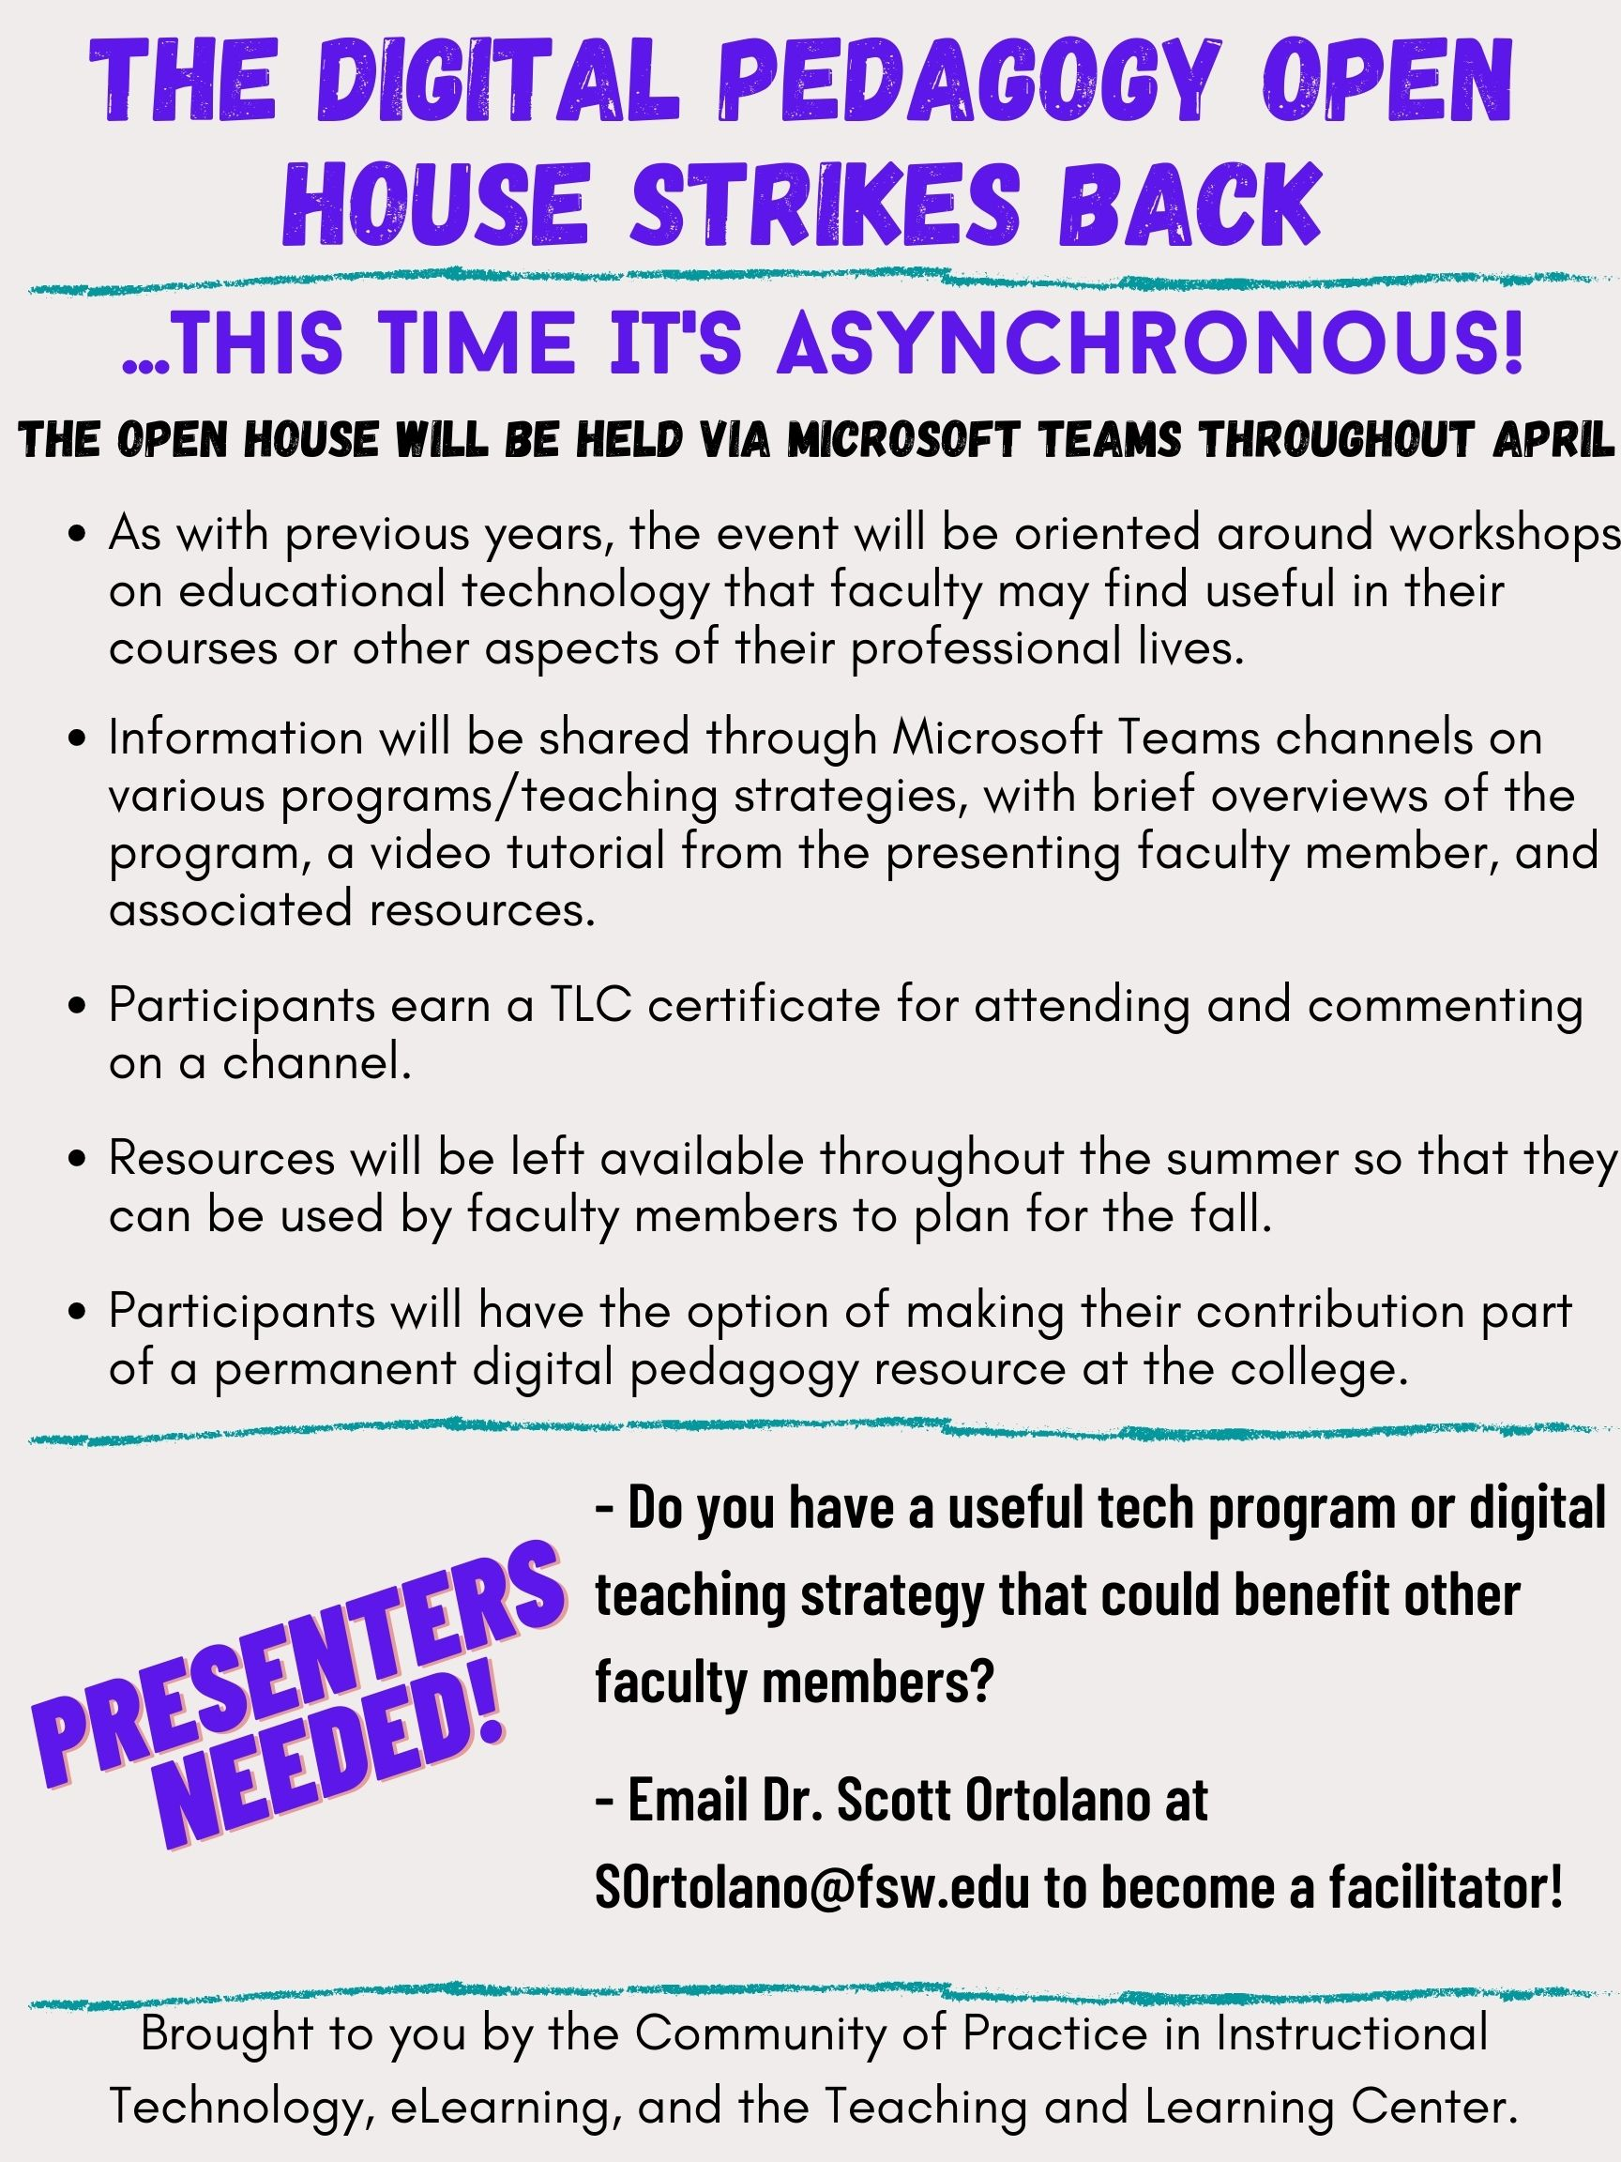

Notes prepared by Scott Ortolano

