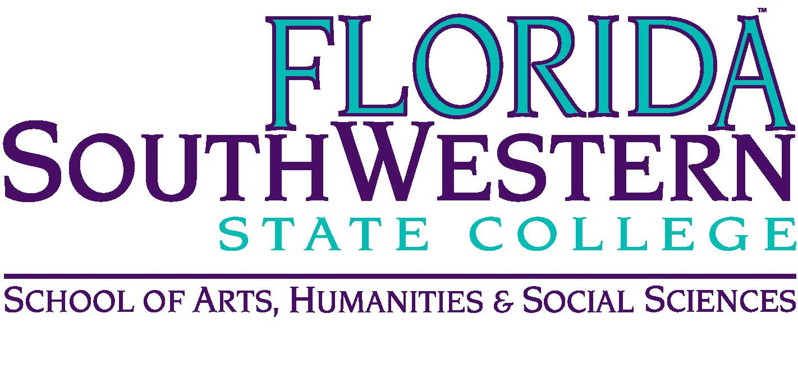
Department of Humanities and Fine Arts
Meeting Minutes
Date: November 13, 2020 - 10:00 a.m.
Location: Virtual/Online (Zoom)
Chair: Dana Roes
Minutes: Michael McGowan

 | Present | Absent | Excused
Brown | X
Chase, S | X
Chase, W | X
Doiron | X
Hoover |  | X (medical?)
Lublink | X
McGowan | X
Mompoint | X
Pritchett | X
Roes | X
Sutter |  | X
Smith | X
Swanson | X
Molloy | X
Krupinski | X
Wurst | X
Harrington | X
Chowdhury | X
Gresens | X
Guests | Also absent: David Luther

- Opening
  - Call to Order: 10:00 a.m.
  - Attendance taken
  - Minutes from Oct. 2020 approved
- Announcements:
  - Upcoming events were discussed (music, theater).
  - Call for proposals for 3rd annual Symposium on Teaching and Learning (deadline Nov. 20)
  - NISOD: nominations: today is final day to nominate someone
  - Music Production and Technology AS degree is on way to curriculum committee
  - Spring enrollment is open: remind students to register (we’re low on numbers)

- Information Items:
  - Assessment update (Elijah): syllapalooza is in motion. Reach out to Elijah if you have questions or comments. Chairs and Deans review the syllabi, but we should think about whether the competencies and learning outcomes match what we do in the classroom. Start with what we do in the classroom and then go to the outcomes (not the other way around). Also, they’re doing a Gen Ed assessment through blind reading using volunteers (get paid $250 stipend if interested).
  - Professional Development Update (Sarah Lublink): New director of the TLC; get to know her. There’s still money for virtual conferences (no one is traveling). This year they’re doing rolling applications, and most proposals will likely get approved. Talk to Sarah for more info.

- Discussion: what kind of country do we want? (led by Elijah Pritchett)

- Next Meeting: 1/8/21

