 | Present | Excused | Absent
Anne Angstrom | X
Karen Buonocore |  |  | X
Michael Chiacchiero |  |  | X
Marius Coman | X
Camille Drake-Brassfield |  |  | X
Ann Eastman | X
Susan Holland | X
William Kelvin | X
Brenda Knight |  |  | X
Jay Koepke |  |  | X
Qin Liu | X
David Logan | X
Karen Maguire | X
Martin McClinton |  | x
Thomas Mohundro | X
Kristi Moran | X
Mary Myers | X
Yadab Paudel | X
Jessica Slisher |  |  | X
Les Sutter | X
Melanie Ulrich | X
Tejendrasinh Vala | X
William Van Glabek | X
Vera Verga | X
Valentin Zalessov | X

Academic Standards Committee Meeting
All Campuses via Zoom
September 1, 2023
2:00 – 3:30 pm
Meeting called to order at 2:02 pm by Bill Van Glabek.
Approve meeting minutes from April 21, 2023. Motion to accept presented by Marius Coman, seconded by Bill Kelvin. Minutes approved.

Discussion Items
New Business
- Academic Standards Committee members
  - Discussion regarding committee membership, school representation, and size (a., b., and c. from the agenda)
    - Bill Van Glabek – Do we have valid school representation?
    - Vera Verga – Can we see if all schools are represented?
    - Bill Van Glabek – The School of Pure and Applied Sciences has a lot of members. He is the only one from The School of Business and Technology other than Dr. Myers.
    - Melanie Ulrich – I prefer at least one member from each college, but more would be great. How do we recruit more from some of the other colleges?
    - Bill Van Glabek – The School of Education and The School of Business and Technology are the lowest represented.
      - Anne Angstrom – The faculty from the School of Education are already all on committees.
      - Bill Van Glabek said he can try to recruit another member, but it will be tough for smaller schools because of the new schedule with all committees meeting at the same time.
    - Bill Kelvin
      - https://www.fsw.edu/viewdocs/doc/365729 (link to membership)
      - Three-year term – Does that mean we are supposed to leave the committee after three years served?
    - Tom Mohundro – feels committee representation is fine and with smaller schools it would be hard to find someone else.
    - Vera Verga – Maybe it’s heavy on the sciences as we have had the biggest number of academic issues. Mary Myers said this is true with the biggest number of issues.
    - Vera Verga – Dr. Yovanovich is no longer Vice President, Student Affairs
      - Anne Angstrom – According to the directory she holds the title: Vice President, Student Life/Director, Collier Campus.
      - Vera Verga said we need to get representation from that office again.
      - Karen Maguire asked if the Vice President of Student Affairs has changed.
      - Vera Verga – Jacob McAbee also left, and he was our go to person.
      - Mary Myers – Student Affairs reports to Dr. Bilsky now and has moved to Vice President of Academic Affairs. Dr. Gilfert reports to her.
      - Vera Verga – April Palmer used to be under Dr. Yovanovich, so is she still in that role?
    - Susan Holland – School of Health Professions is well represented.
    - Teju Vala – Do we have the registrar’s office on the committee? Susan Holland answered that Dr. Knight is on the list.
    - Karen Maguire – There are a number of people from the School of Humanities and Social Sciences, but most are from different departments.
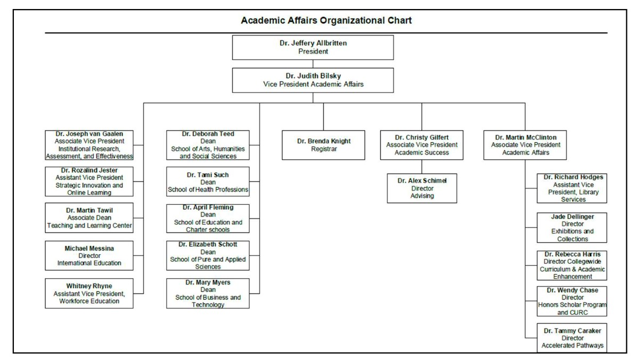
    - Anne Angstrom put the organizational chart in the chat for review:
    - There is a need to get the administration back involved – Student Affairs, Academic Affairs and Academic Success.
- Help, meeting minutes – Melanie Ulrich volunteered.
- Committee Charge (goals)
  - Academic year 2023-2024
    - Karen Maguire – We need to clarify:
      - Where form goes
      - Who does the student counseling since Jacob is gone.
        - Vera Verga said it went to April Palmer who took care of them over the summer.
        - Teju Vala and Bill Van Glabek both confirmed.
      - Everything the committee spent two years working on has now become very cloudy.
      - Anne Angstrom said Dr. Palmer is listed as Assistant Vice President, Student Life.
    - Anne Angstrom – It sounds like one of our first goals needs to be getting clarification on the process for academic misconduct.
    - Karen Maguire said they put out a new policy including Artificial Intelligence
      - Melanie Ulrich – Used a page from Heather Olson catered to her class, such as “I accept the use of Packback AI, but not ChatGPT.”
      - Karen Maguire – AI Toolkit in Canvas to use for student teaching.
      - Anne Angstrom – Was on the AI excellence committee during the summer so emailed Roz Jester to ask if there would be a college statement. The consensus was to post the statement again for this semester until the committee can get back together and revisit if there is a college-wide policy.
      - Bill Van Glabek – Is this college-wide or department specific? Anne Angstrom said they are meeting sometime in September (no date scheduled yet) to address this issue and she will let the committee know the results of their discussions.
  - Long-term
    - Vera Verga said maybe we can just keep pushing for that Academic Integrity flowchart to be put where it needs to be and kept there long-term.
      - Bill Van Glabek – Have any cases gone through this new system yet?
      - Vera Verga. – No, it is not in the catalog yet so the only person dealing with this once it goes through the appropriate Dean is Dr. Palmer.
    - Bill Kelvin – Maybe we could create a web-based best practices guide with videos to walk new professors through our academic misconduct flow process (once officially established)
      - Once we get the flowchart approved, we could make a multi-media site so everyone can get it faster.
      - Vera Verga – this would include adjuncts.
      - Anne Angstrom – That’s a great idea! I wonder if the New Faculty Seminar offers any support like that.
- Faculty Handbook
  - Volunteers to work on it before our next meeting.
    - Vera Verga said we went through it during the spring 2023 semester.
      - A subcommittee checked links and updated language.
      - The only missing part is student misconduct because it is new.
  - The current linked handbook on the website is from 2020-2021 – is that the most recent version? It has a 1/25/2021 revised date.
    - Vera Verga said there is a new version from Spring 2023, and she has the new file.
    - What is not updated is the academic misconduct part since it was changing, but not complete yet.
  - Current file in the Document Manager Academic Committees main folder is from 2019-2020
    - Vera Verga said the newest version is not on the Document Manager because Dr. McClinton said to wait since the Document Manager is going away.
    - Karen Maguire said the new Portal is out there, but we are operating both. If we update one, will it transfer to the new one?
      - Teju Vala said he understands it is just a new interface leading to the same locations.
      - Melanie Ulrich said the question about the links is a good IT question.
      - Karen Maguire and Bill Van Glabek said the new Portal goes into effect October 1, 2023.
  - Webpages – academic dishonesty, consistency (no specific discussion)
  - Timeline to check that the links work and update the cover – already updated.
- Program Handbooks – below are the ones Bill Van Glabek is aware of:
  - Nursing
    - Susan Holland said it was just updated and now the BSN and ASN are combined.
    - Bill Van Glabek asked it to be shared with him to provide to committee.
  - EMS – no update
  - Education
    - Anne Angstrom is working on updating theirs now.
    - It focuses primarily on the Bachelors of Elementary Education program.
  - Other? No one else knows of any others.

Old Business
- Academic Standards Committee web address: https://www.fsw.edu/vpaa/academicstandardscommittee
  - Member list is not current – Please check the current list attached to the meeting email to ensure your name and position are correct.
- Work on a statement on integrity for college wide use “ChatGPT concerns about how it impacts academic integrity”
- Statement about academic integrity for the syllabus.
- Infraction form
  - Bill Van Glabek asked how hard he should press about this?
  - Vera Verga said we need to know where it is and where it goes officially.
  - Dr. Bilsky is the one to ask since it was approved by Faculty Senate.
Other Comments/Discussion
AI Discussion:
- Karen Maguire asked about the Student AI information.
  - AI for Students: https://fsw.instructure.com/courses/1124461
  - Are we using that or is it just reference?
- From Simple Syllabus:
  - This means cheating on coursework is unacceptable, will receive a "0" grade, and may be subject to disciplinary action. FSW faculty may use Turnitin, Packback, CheckGPT, or similar tools to evaluate coursework for plagiarism and/or artificial intelligence (AI) generated content.
  - Cheating or other academic misconduct can include, but is not limited to:
    - Copying information from published or unpublished sources (online or in print) without citing those sources.
    - Copying someone else’s work or allowing someone else to copy yours.
    - Submitting written work generated by AI as your own without direct authorization from your professor.
    - Submitting work for credit that has already been submitted for credit in another class, even if you wrote it.
    - Unethical distribution or use of exam content.

- Mary Myers provided an updated for the School of Business and Technology
  - Shared at adjunct meeting and is also on resource page for all faculty. She doesn’t know what other schools may have done, but that was their way to make it available.
  - AI statement in Commons
    - Written by Rochelle Hopkins, Professor of Cybersecurity
    - IS about the ethics of using AI correctly.
    - Includes a getting started activity.
  - Suggested inviting Cybersecurity to a meeting to give insight or help craft statements – Professor Hopkins is the main Professor for that program.
- Karen Maguire – all our students need to have some AI literacy since it will be part of their work and life.
- Bill Van Glabek – it is important to teach students how to use it properly.

The next Academic Standards Committee meeting will be on October 6th, 2023at 2:00 pm.
Motion to adjourn proposed by Vera Verga, David Logan seconded. The meeting adjourned at 2:56pm.

