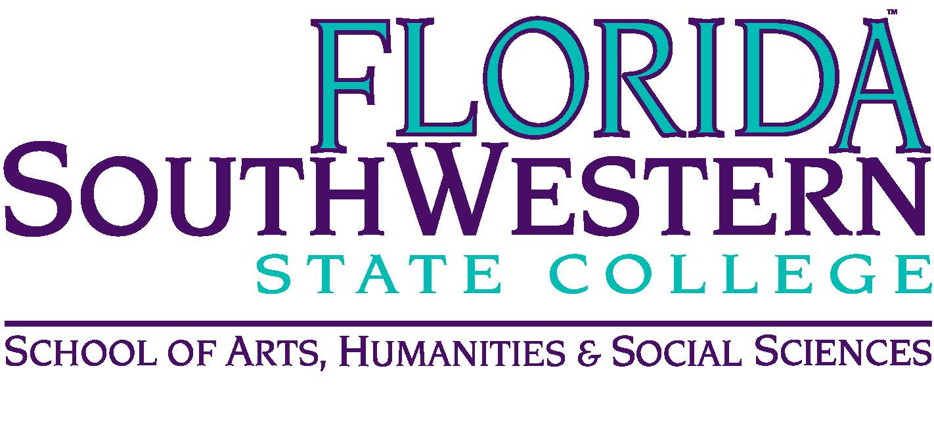
Department of Humanities and Fine Arts
Meeting Minutes
Date: April 10, 10:00 a.m.
Location: Virtual/Online (Zoom)
Chair: Dana Roes
Minutes: Michael McGowan

 | Present | Absent | Excused
Brown | X
Chase, S | X
Chase, W | X
Doiron | X
Hoover |  | X
Lublink | X
McGowan | X
Mompoint | X
Pritchett | X
Roes | X
Sutter | X
Smith | X
Swanson | X
Molloy | X
Krupinski | X
Wurst | X
Guests | J. Davis, L. Olson, M. Harrington, K. O’Neil

- Opening
  - Call to Order: 10:00 a.m.
  - Attendance taken
  - Minutes from February 2020 approved
- Announcements:
  - Zoom Successes/Fails
    - Free editing software: DaVinci Resolve
    - For Live: OBS (screen capture software)
  - Record of Artifacts and learning outcomes: make sure you’re leaving a paper trail
  - Legalities concerning recording of Zoom: make them aware that they’re being recorded, if you do that.
  - Incomplete Grades:
    - For some classes, we’ll consider the possibility of Pass/Fail
    - Students feel like the workload has increased while the individualized attention has decreased.
  - Graduation
    - It’s not clear what’s going to happen yet
    - Someone suggested a drive-by graduation
    - One suggestion: Individual emails to students
  - New Hiring Committees: Humanities and Emerging Tech
    - Creative Technology: interview 6 candidates via phone
  - Online Training cohorts

- Information Items
  - Honors: Wendy
    - Help them identify students (1/2 is graduating in Dec or April)
    - We’ll be down to 39 students
    - Forward the info to worthy students.
    - Dr. Deluca is supportive of specialized Honors classes (wants more of them)
  - Schedules: Summer and Fall 2020
    - Only classes this summer: online classes
    - Fall: typical schedule (but we need a plan if we’re still online only)
  - Professional Development Committee: Sarah
    - There’s no travel and no conferences
    - Sarah’s staying on the TLC until Dec.
  - Review competencies in each course
    - As far as we know, syllapalooza is still going on
    - Everyone’s happy with our competencies
- Discussion
  - Plan B
- Other
  - Les’s new trivia book is on Amazon
  - FEE Grants: delayed until fall
  - Big Purchase Items: delayed until fall
  - April 16, 2020 at 7 pm there’s play reading using Zoom
- Next Meeting: Fall!

