Note required information: Program or certificate changes require a change to the catalog page. All change of program or certificate proposals must include the new catalog page, with all proposed changes, at the end of this document. All changes that affect the courses, words, numbers, symbols, program description, admissions requirements, and graduation requirements must be documented. Note before completing this proposal that all new courses and current prerequisite, co-requisite, core, or elective courses changes must have already been reviewed (or submitted for the same meeting) by the Curriculum Committee and approved by the Provost. The Track Changes feature in Word must be used to illustrate all changes to the catalog page.

School or Division | School of Business and Technology
Program or Certificate | Network Systems Technology, AS
Proposed by (faculty only) | Mary Myers, Melinda Lyles
Presenter (faculty only) | Mary Myers
Note that the presenter (faculty) listed above must be present at the Curriculum Committee meeting or the proposal will be returned to the School or Division and be resubmitted for a later date.
Submission date | 1/6/2021

Section I, Important Dates and Endorsements Required
nOTE: Course and Program changes must be submitted by the dates listed on the published Curriculum Committee Calendar. Exceptions must receive approval from the Provost’ Office.
Term in which approved action will take place | Fall 2021
Provide an explanation below for the requested exception to the effective date.
Type in the explanation for exception.

List all faculty endorsements below. (Note that proposals will be returned to the School or Division if faculty endorsements are not provided).
Mary Myers, Melinda Lyles, Fred Bruno

Section II, Proposed Changes
Do any of the changes affect the AA focus? (If so, a Change of Program proposal is also needed.) | ☐ Yes  ☒ No
Have the deans of the General Studies been contacted/consulted? | ☐ Yes  ☒ No
Have you attached an updated catalog page? | ☒ Yes  ☐ No
Change of School, Division, or Department | N/A
Change to program or certificate name | N/A
List below, any changes to the program or certificate prerequisites. Include course titles and credits if applicable.
Removing SPC1017; Changing PHI2100 requirement to Any General Education Humanities; Adding CNT1512-Wireless Network Administration; Removing SLS requirement; Increasing elective credit to 6 credits.
List below, any changes to the General Education requirements. Include course titles and credits if applicable.
- Decreasing General Education Requirements to 15 by removing SPC 1017 Fundamentals of Speech Communication (3 credits).
- Changing the PHI 2100 requirement to: Any General Education Humanities (PHI 2100 Introduction to Logic recommended) - 3 credits
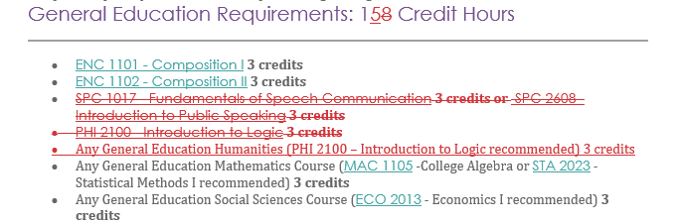
List below, any changes to the program or certificate Core requirements. Include course titles and credits if applicable.
- Adding CNT1512 Wireless Network Administration – 3 credits.
- Removing the SLS requirement: SLS 1331 Personal Business Skills (3 credits) or SLS 1515 Cornerstone Experience (3 credits).
- Cleaning up CGS2108 and CGS1100 language from last year’s curriculum action:
  - Removed CGS 2108 Computer Applications with Flowcharting (3 credits).
  - Added CGS 1100 Computer Applications for Business (3 credits).
- Added CEN as a prefix for specified electives under “Any 1000 or 2000 level computer course.”
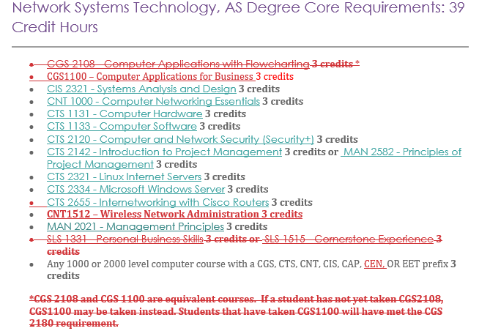

List below, any changes to the program or certificate Elective requirements. Include course titles and credits if applicable.
Adding 3 credits to the Approved Electives, for a total of 6.
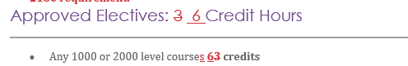
List below, any other changes to the program or certificate requirements.
none
Change to program length (credits or clock hours to complete) | N/A

Include complete new catalog page as an attachment. Proposals without the new catalog page will not be reviewed by the committee.

Section III, Justification for proposal
Include state frameworks, accrediting or professional organization recommendations or requirements, workforce data, and/or crosswalks.
Provide justification (below) for each change on this proposed curriculum action.
Core requirements changes:
In anticipation of the new BAS in IST, we need to add a class to the AS degree in Network Systems Technology. The class is CNT 1512 - Wireless Network Administration. There is an upper-level class (CNT 4514 - Wireless Networks and Portable Devices) that has CNT 1512 as the prerequisite. By adding this class to the AS degree, students will not have to take an extra class when they enroll in the BAS.
To make room for this class in the Core Requirements without adding credits to degree, the SLS 1331/SLS 1515 requirement is being deleted. This College requirement may be counted toward the approved electives, below.
CGS 2108 Computer Applications with Flowcharting has been replaced by CGS 1100 – Computer Applications for Business. CGS 2108 was discontinued last year via Curriculum Committee.

General Education changes:
We are decreasing the General Education requirements to 15 hours by removing SPC 1017. Students will satisfy communication outcomes through CIS 2321 (Systems Analysis and Design) and CTS 2142 (Intro to Project Management).
Also under General Education, the requirement of PHI 2100- Logic, will be changed to Any General Education Humanities (PHI 2100 recommended) – to add flexibility for students.

Approved Electives change:
Reducing the GenEd requirements by 3 credits allows those credits to be added in the Approved Electives section, resulting in 6 total hours. The elective option in this section has been revised to “Any 1000 or 2000-level courses – 6 credits.”
Students who need to take SLS 1515 will be able to count it as one of the electives in this section. Those who do not need it will be able to take a 3- credit elective of their choice.

