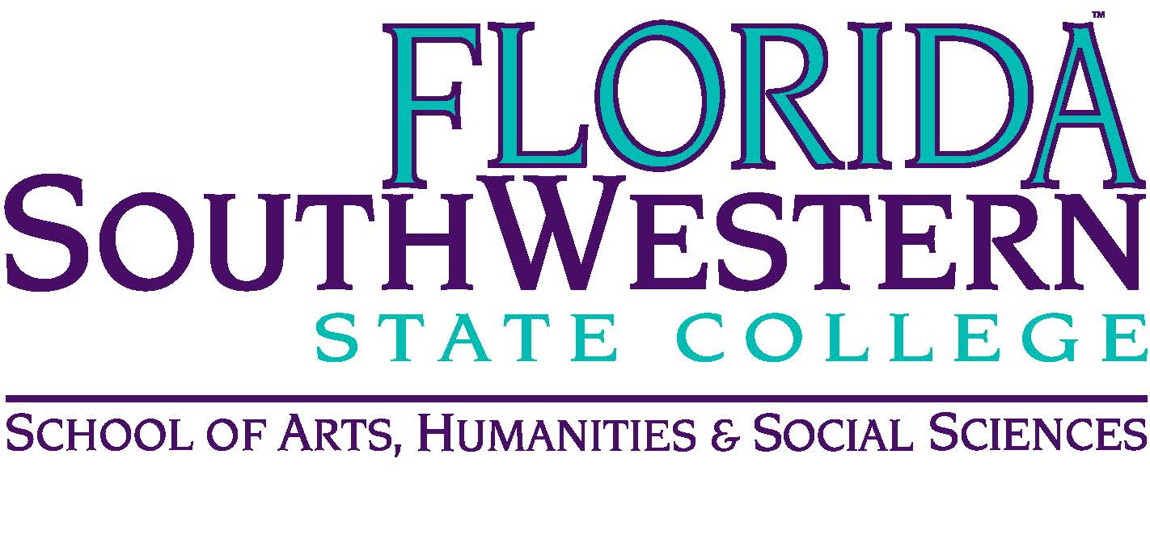
Department of Humanities and Fine Arts
Meeting Minutes
Date: August 17, 2022—2:30 p.m.
Location: Lee/Edison Campus, U-109
Chair: Elijah Pritchett
Minutes: Michael McGowan

 | Present | Absent | Excused
Brown | X
Chase, S | X
Chase, W | X
Chowdhury | X
Doiron | X
Harrington | X
Krupinski | X
Lublink |  |  | X
Luther | X
McGowan | X
Molloy | X
Mompoint | X
Moore | X
Olguin | X
Pribyl | X
Pritchett | X
Roes | X
Smith | X
Sutter |  | X
Others | Herren, O’Neill, Puls

- Opening
  - Call to Order: 2:50 p.m.
  - Attendance taken
  - Minutes from April 2022; McGowan uploaded revised minutes 8/17.
- Announcements:
  - Arenthia Herren: she’s the liaison w/ library. They can do “micro-workshops” and there is a “Genealogy and Ancestry” event coming up.
  - Deadlines for fall semester: see agenda
  - Syllabus Templates/Format: they’re screwed up, but do the best you can (use the simple format Elijah sent out)
  - Covid and Spring 2023: department meetings will be in person in spring but still on Zoom this fall
  - Textbook problems – reach out to Elijah or Dr. Page to resolve any outstanding Pearson issues

- Committee and Dept. News:
  - OER: Monica and Monique – trying to create a HUM 2235 publication (big task; good luck!)
  - CCIG committee: Mike Molloy: Tom Smith (Chair), Dana Roes, Mike McGowan
  - Music: See Kelly’s Concert Date handout
  - Theater: opening Nov. 3rd (not sure which show yet), no spring show (Stuart on sabbatical)
  - Fine Arts: Shimul has an upcoming exhibition (will let us know the dates and give us the links); Dana has an upcoming painting/drawing exhibition (will give us dates when they’re finalized).
  - Assessment:
    - Senate Bill 7 has some consequences for changing accrediting bodies (FL colleges potentially stuck between FL and USA). Questions/comments: see Joe (email first)
    - Pre/post-tests: Monique is sending out today (8/17) or tomorrow (8/18). Dates: pretests 8/29-9/4 and posttests 11/28-12/4. (see Monique’s forthcoming email)

- Discussions and New Business
  - Two internships at Gulf Coast Symphony and one at a recording studio. The program is now officially alive!
- Next Meeting: 9/9/22 from 10-11 a.m.
- Action Items:
  - Arts faculty meets Dana Roes following this meeting
  - Humanities and Philosophy faculty will meet after our 9/9 meeting to discuss assessment disposition questions

