Academic Success Department Meeting
November 13, 2020
12:00-1:30pm
On Zoom https://fsw.zoom.us/j/94718353424

Agenda

I. Good News!

II. Dean’s Reminder: We are not seeing the usual traffic in Advising for Spring Semester enrollment, and we are concerned students are not tracking dates as they normally would. Now that we are close to the end of Fall Semester 2020, please encourage students in your classes to register for Spring Semester 2021. We want them to get the courses they need to complete degrees, and with our room capacities set lower to compensate for Covid social distancing concerns, they might be disappointed if they delay. Also, if you have the opportunity, please remind students to pay attention to the differences between modalities. For example, we have heard complaints from students that they did not realize Live Online meant they were required to attend class at a set time and day for Zoom meetings. Our colleagues in Admissions, Marketing, and Registration also will be working to remind students of the differences between modalities.

Thank you for everything you do for your students and for your support of FSW in general. It’s been a unique year, but with your flexibility and resolve, we will close another fall semester successfully.

III. Spring Schedule: Dr. Page

- Remember the short lead time after Winter Break; Jan 1 is a Friday, back to work Mon, Jan 4 and classes start Wed, Jan 6.
- Syllabi due to Professor Maguire NLT Monday, Jan 4. Recommend they be done in December before you start your break.

IV. Library: Jane Charles

Wish List---Website---Canvas Commons---Collaboration

V. FSW/FGCU Symposium
The Third Annual Southwest Florida Symposium on Teaching and Learning
February 4 – 5, 2021 via Zoom
Call for Proposals extended to Fri, Nov 20 (Details last page)

VI. Student Opinion Survey (SOS)
open through Nov. 27; encourage students to complete it!

VI. Committee Updates

  - Curriculum Committee
  - Professional Development Committee
  - Academic Standards Committee
  - Academic Technology Committee
  - Calendar Committee (2021-2022 Calendars posted)
  - Learning Assessment Committee
  - OBOC
VII. PD
- Online Certifications
November 15, 2020 – Facilitation for Live Online/Blended (Blooming with Zoom) and Online Teaching Certifications are suspended until duty days Spring 2021.
- No PD Friday in November.
- PD Day January 5, 2021

VIII. Evaluations
- Portfolium Trainings/Q&A Drop-In Sessions for Full Time Faculty ongoing with the TLC
- Adjunct Faculty Mini-Portfolios Sessions Fri, Nov 13 (3-4pm) and Thurs, Nov 19 (3-4pm) on Zoom. Register with TLC.
IX. EAP Update
Curriculum/Course Change
X. REA Update
Syllabus Update Approved
XI. Advising Update—Silvia Guerrero-Smith
XII. Student Engagement Update—Catherine Gorman
XIII. SLS Update
- CCTDI-- Post Test completed between Mon, Nov 16 and Mon, Dec 7 (Hill, Keough
Lampos, DiPofi, Steves)
- Webpage updates needed:
Critical Thinking Lecture Series https://www.fsw.edu/ctls
Faculty https://www.fsw.edu/fye/faculty
Faculty Resources https://www.fsw.edu/fye/facultyresources
FAQ https://www.fsw.edu/fye/faq
Logo Meaning https://www.fsw.edu/fye/logomeaning

XIV. Additional Items?
NOTE: Future Meetings: November 13, December 11?, January 8, February 12,
March 12, April 9 On Zoom. https://fsw.zoom.us/j/94718353424
V. 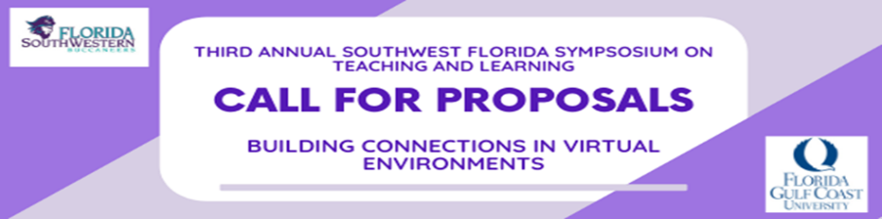
The Third Annual Southwest Florida Symposium on Teaching and Learning is a collaboration between FGCU’s Lucas Center and FSW’s Teaching and Learning Center. This year’s symposium will focus on the myriad ways in which faculty and staff can build connections in virtual environments. Whether connecting with students or colleagues in a synchronous or asynchronous remote setting, building good working relationships is integral to teaching, learning, and fostering motivation and morale. Connecting virtually isn’t a new concept, but has certainly made its way more profoundly into our daily lives. We welcome proposals from all faculty and staff who have successfully cultivated connections in a virtual environment and who are:

1) integrating and/or researching strategies that promote connection in virtual meetings, or
2) interested in leading a roundtable discussion on a topic about building connections in virtual
environments.
Symposium Dates:

- Thursday, February 4 (keynote speaker)
- Friday, February 5 (presentations, roundtables, webinars)

All sessions will be 50 minutes in length to allow adequate time for demonstrations and discussions.
If you have any questions please contact: FGCU Lucas Center at lucascenter@fgcu.edu or FSW TLC at tlc@fsw.edu.

