Encumbrance Query Procedures for Banner Self-Service

Log into the Edison College Portal at my.edison.edu.
Click on the District Resources tab.

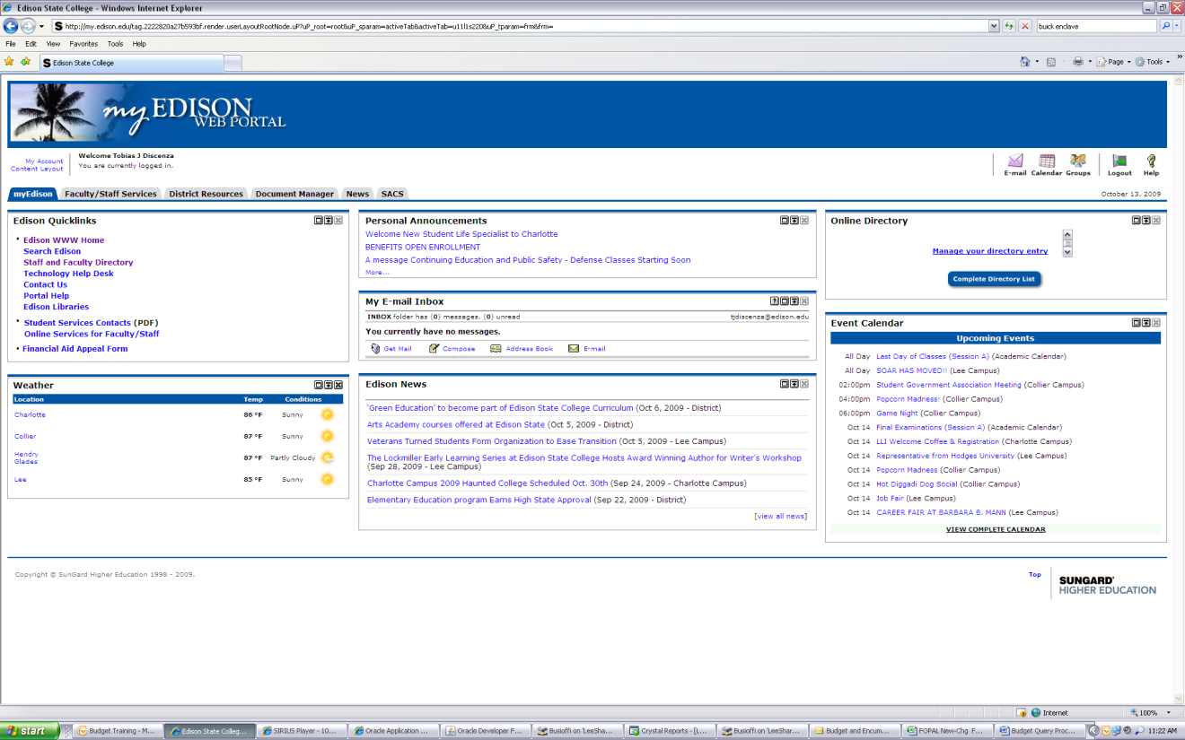

Scoll down to the bottom left to view the Finance and Accounting Channel and then click on Encumbrance Query.

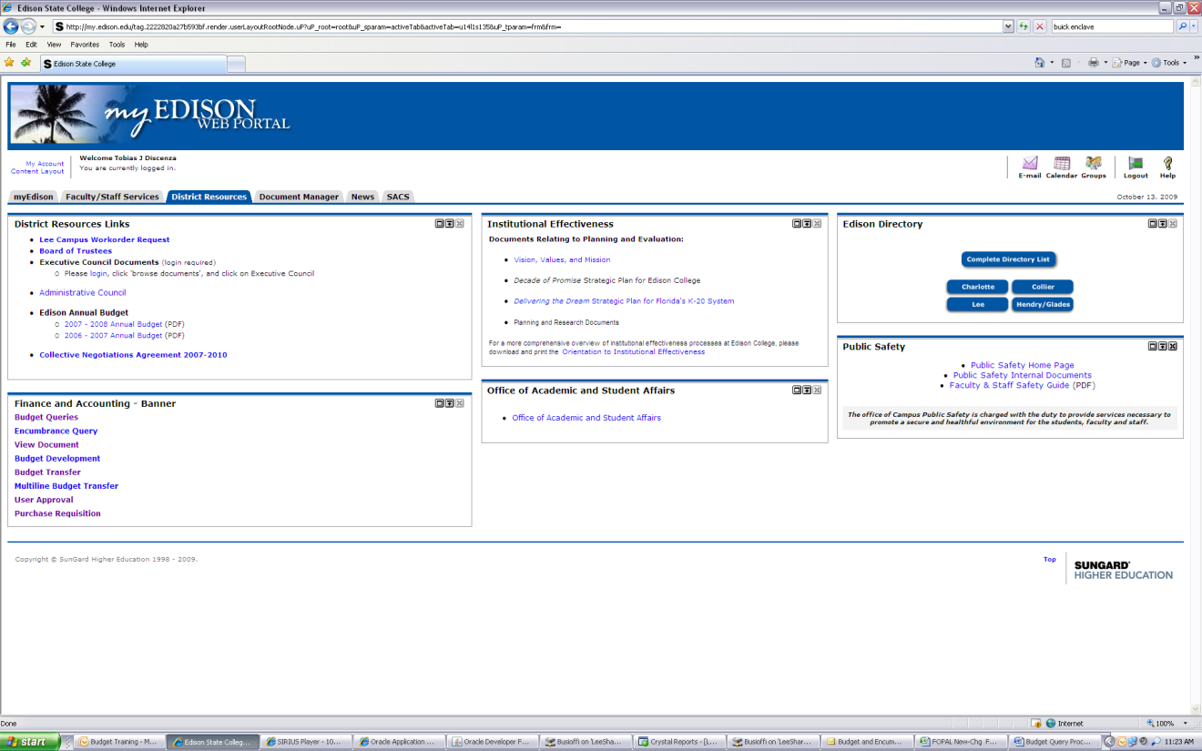

Ensure the correct Fiscal Year and Fiscal Period are populated.
**Note: Fiscal Period – July = 1; August = 2, etc.
Enter 1 for Chart of Accounts.
Enter YOUR Index Code.
Click Submit Query.

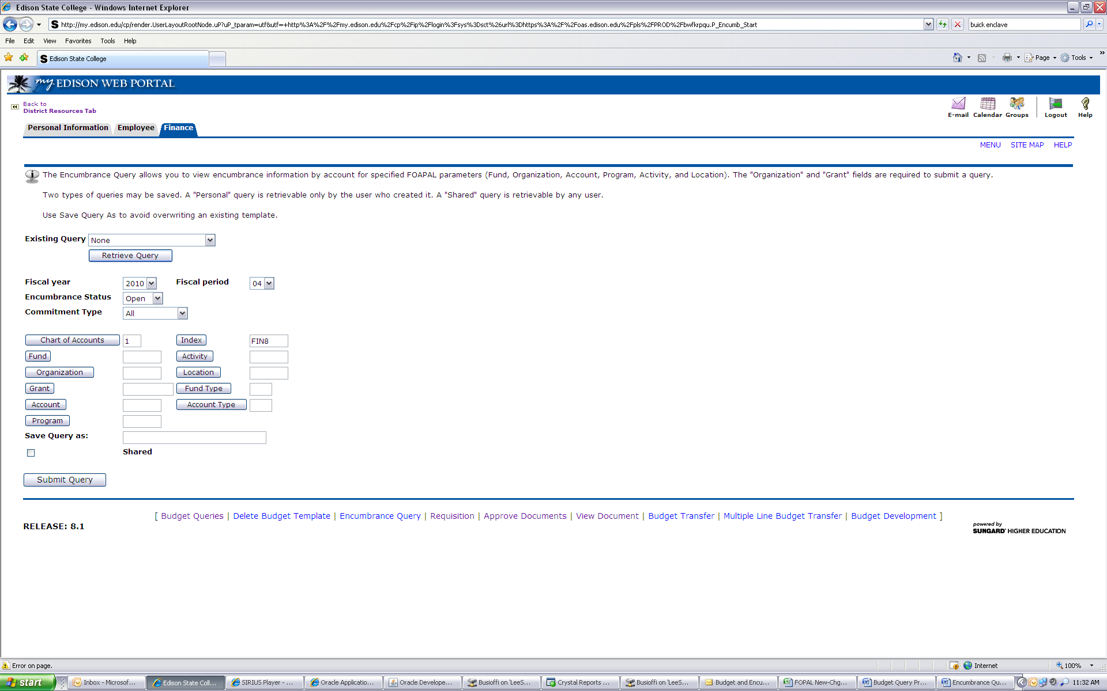

Clicking Submit Query will populate the Fund-Organization-Program.

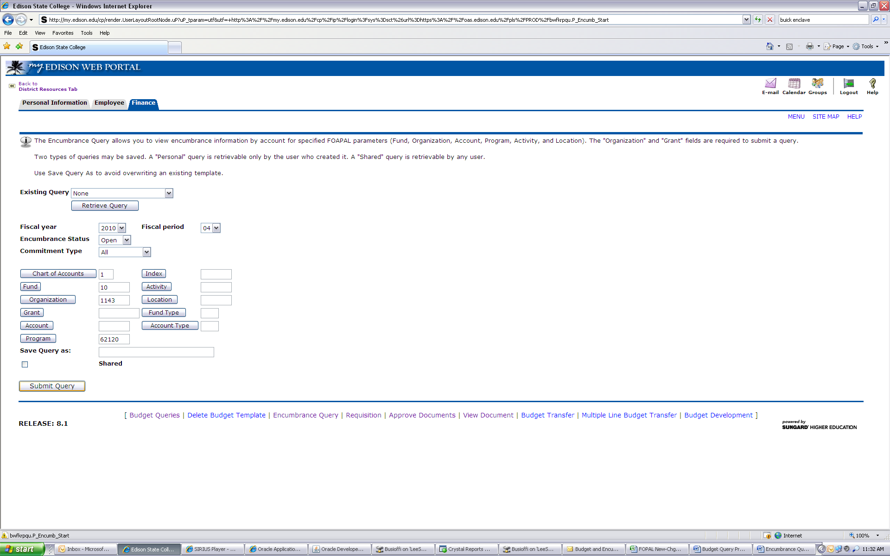

Click Submit Query a second time to view detail.
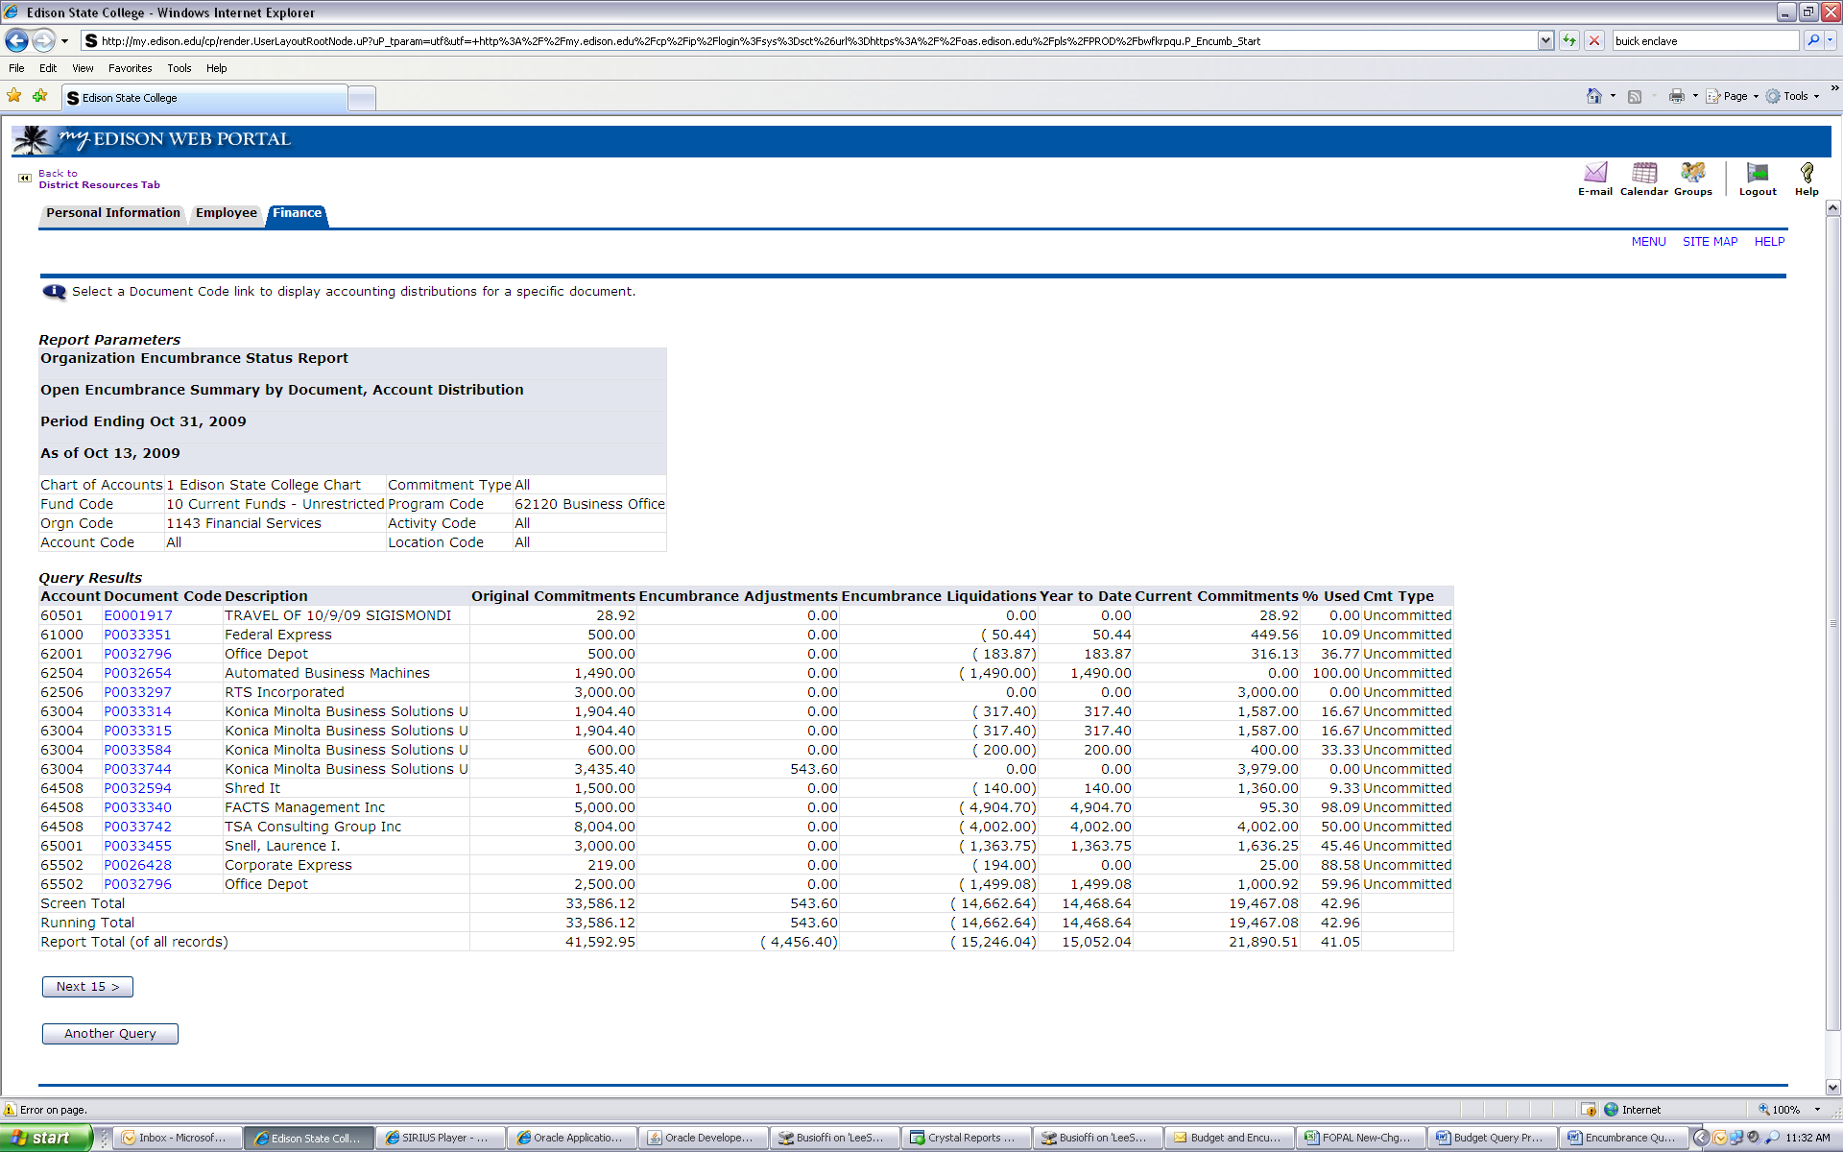

A listing of all current Purchase Orders will populate.
Click on a specific Document Code to view detail for that Purchase Order.

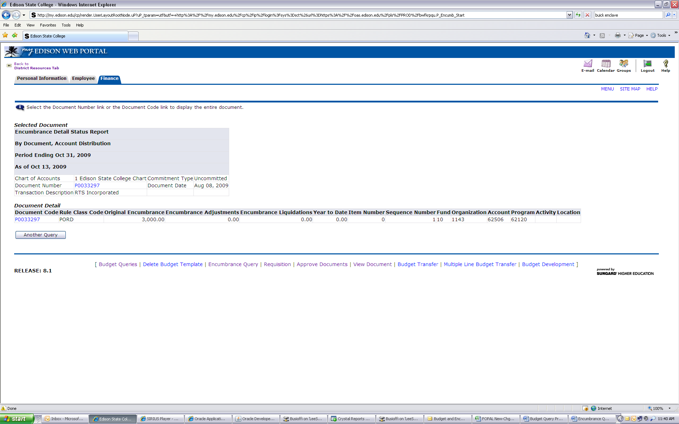

This will show the total encumbered for this Purchase Order.
You can continue to drill down to a specific invoice by clicking on an “I” Document Code.

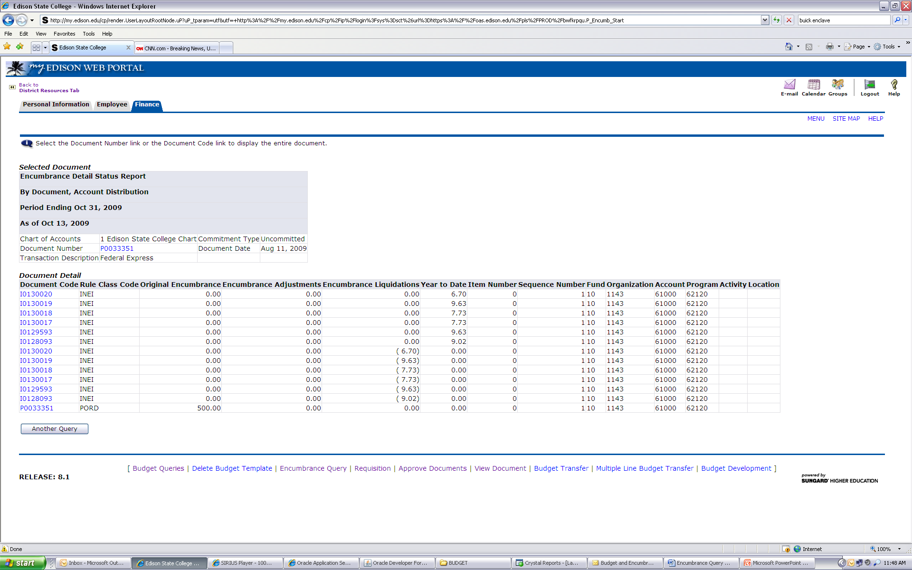

This will show dates and vendor information.

