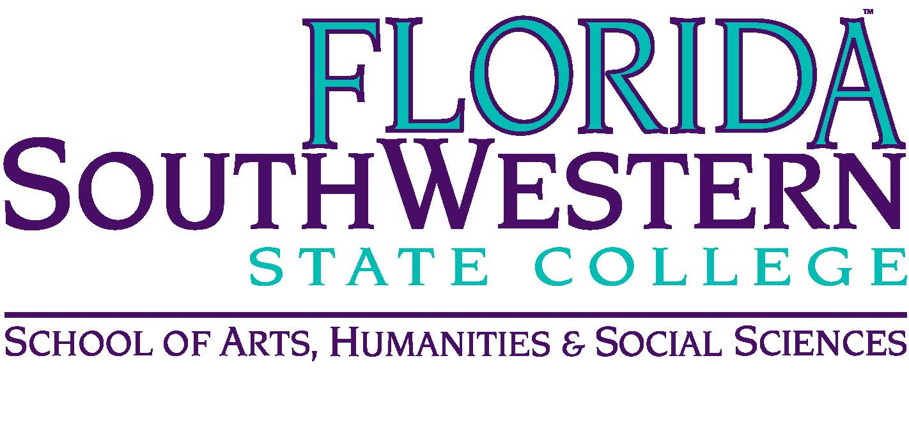
Department of Humanities and Fine Arts
Meeting Minutes
Date: January 9, 2020, 10:00 a.m.
Location: Edison/Lee campus (L-141)
Chair: Dana Roes
Minutes: Michael McGowan

 | Present | Absent | Excused
Brown | X
Chase, S | X
Chase, W | X
Doiron | X
Hoover |  | X
Lublink | X
McGowan | X
Mompoint | X
Pritchett | X
Roes | X
Sutter | X
Smith | X
Swanson | X
Molloy | X
Krupinski | X
Wurst | X
Guests | Becky Quimby

- Opening
  - Call to Order: 10:00 a.m.
  - Attendance taken
  - Minutes from November 2019 approved
- Announcements:
  - Send syllabi to Dana in this format: “HUM2235 Spring2020 Chase”
  - Check COP for office hours
  - New calendar for next year. Updates include:
    - Spring break next year is synchronized with the area schools
    - Two new “study days”
    - New class start times: 8:30, 10, 12 noon, 1:30
  - Upcoming Events
    - 1/16 Mark Schoening (painter) at 12 noon.
    - 1/16 Rauschenberg opening of Beatriz Monteavaro (6 pm)
    - 1/18 Ethics Bowl – all day
    - 1/21-22 Craig Coleman – Chair of art at Mercer University (workshop on activism in art). Ryan’s, Wendy’s and Dana’s classes. TBD.
    - 1/24 State of the College (maybe)
    - 2/5 Nick Calabrese (10:30 a.m. to Wendy’s and Dana’s classes) about something awesome
    - 2/5 master class on opera
    - 2/5 at 5:30 and/or 7:30 p.m. Department Get Together in President’s Box for Basketball game
    - 2/6 Liat Yossifore speaking at Rauschenberg (12 noon) about activism and painting (L-109)
    - 2/19 trumpet
    - 2/22 3 pm in J-103 Colloquium on Immigration issues (major speakers: UC Davis girl, Elizabeth, and FSU Prof on human rights)
    - 3/13 orchestra
    - 3/16 12:30 in J-103 Julie Wade (queer poetics, lyrical essays, memoir, etc.). Potentially doing a master class on poetry. Bring your class!
    - 4/16 rock concert in BB Mann
    - Dates not certain:
      - James Hoff is interested in speaking about art book publishing.
      - Jarrod Ragland (sp?), archivist for Obama’s photographer
      - Symposium, some Friday afternoon. Possible topic: Language (but send Russell theme suggestions). Possible dates: 3/20 or 4/3
  - Academic Calendar dates to remember:
    - 1/13 add/drop
    - 1/14 attendance verification
    - 1/24 Mentoring PD workshop from 8:45-10:45 (room TBD, zoom link available)
    - 2/28 Mentoring PD workshop 1-3 pm
    - 3/18 last day to withdraw
    - 4/21 first day of final exams
    - 4/29 final grades due at 4:30
    - 5/1 graduation ceremony
- Information items
  - PD Committee (Sarah):
    - Thursday (at FGCU) and Friday (here at FSW) at end of month is the SWFL Symposium on Teaching and Learning. Theme: Active Learning
    - Faculty Learning Community: Cornell’s 5-week course on teaching/learning in a diverse community (facilitated by Sarah and Monica). See email for the dates.
    - Travel date: end of February for April, May, and June travel.
  - Assessment Update (Mike Molloy): no updates now.

- Discussion Items
  - None.
- Next Meeting: February 14, 2020 at 10:00 a.m. in L-141.
ACTION ITEMS:
- Check committee meeting dates/times if interested (see link in agenda).

