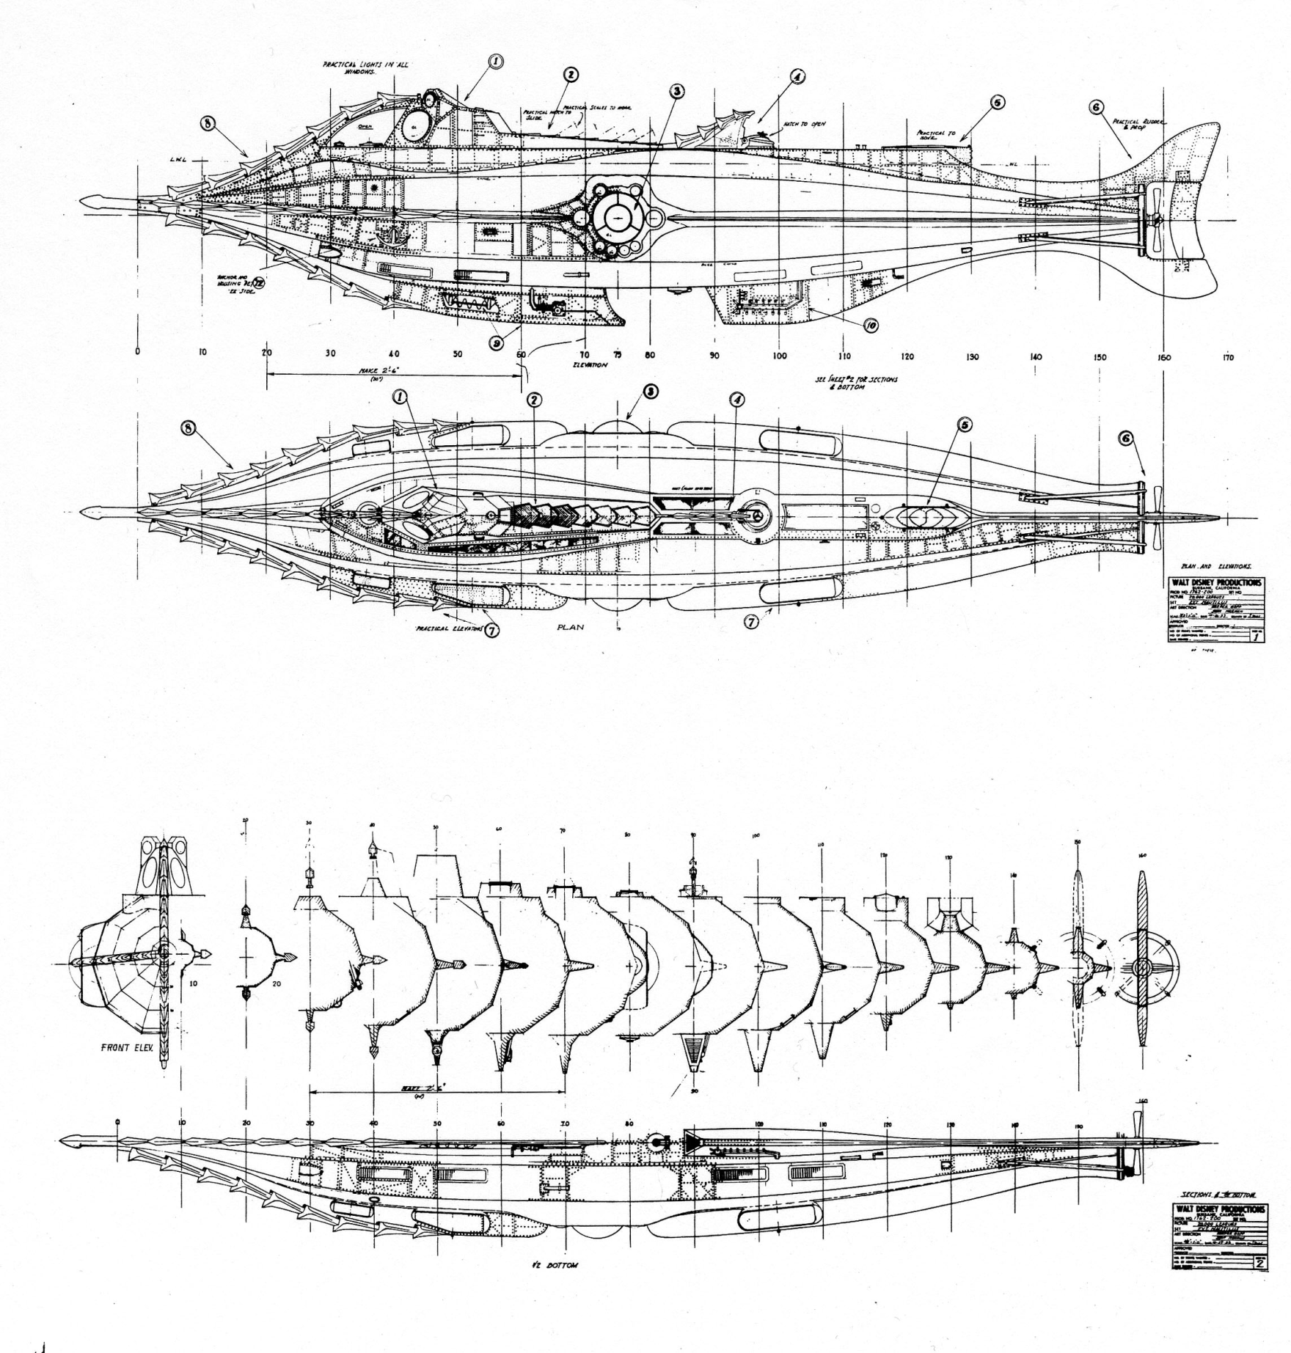
Want to actively create a blueprint of the future?

Take a moment to read about the SEERS Project 2012 then give us your predictions.

