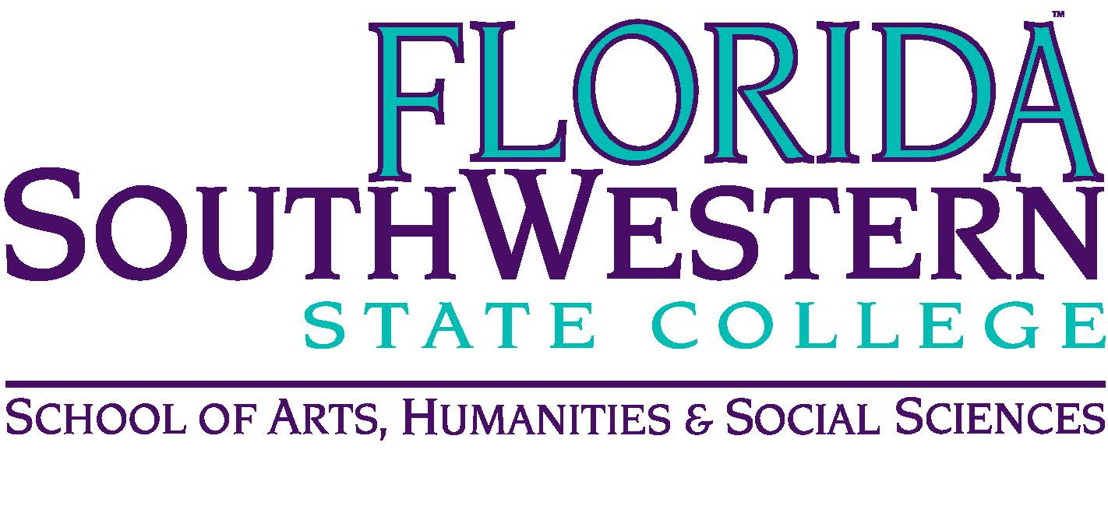
Department of Humanities and Fine Arts
Meeting Minutes
Date: August 15, 2018, 2:00 p.m.
Location: Edison/Lee campus
Chair: Dana Roes (Russell Swanson fill-in)
Minutes: Michael McGowan

 | Present | Absent | Excused
Brown | X
Chase, S | X
Chase, W |  | X
Doiron | X
Hoover |  | X
Lublink |  | X
McGowan | X
Mompoint | X
Pritchett | X
Roes | X
Sutter | X
Smith | X
Swanson | X
Molloy | X
Krupinski | X
Guests | Monica, Len, Dr. Teed

- Opening
  - Call to Order: 10:30 a.m.
  - Attendance taken
  - Minutes from August 2018
    - Adjusted, sent updated one
    - Office Hours issue: can’t have less than 30 minutes (per Dr. Teed), but 15 minutes is doable.

- Announcements:
  - Dr. Teed:
    - We’re working on getting registration issues solved.
    - She’s working on parking lot issues.
    - Let her know if you’re interested in developing a course using OER (online educational resources).
  - Photo Day today: in Photo Lab L-116.
  - For AFMs, reach out to them and check in.
  - FPD Travel Deadline: 9/14, 11/9, 3/1
  - FEE and NEH Humanities grant deadline: 10/17
  - September PD Friday: every month, 4th Friday
  - TLC Guest Speaker: Stephen Brookfield
  - FSW Publisher’s forum: drop in event (lunch, dessert provided) on 10/12.
  - 9/28 (Friday): TLC workshop by Stuart
  - 10/9: Edison Campus open house for Arts@FSW (see Wendy’s email and respond). Set up is probably at 2 pm until around 5-6 pm. (Event is for high school juniors and seniors)

- Information items
  - Website/brochure (Steve): photo day today, get bio to Steve
  - Music Update: everything’s going well, full classes, new pianos
  - Forms: Everyone does Forms 3 and 1 (goal setting and reviewing goals from final year) regardless of where someone is in their evaluation cycle
  - Continuing Contract Committees:
    - Elijah: Sarah, Wendy, McGowan
    - Ron: Tom, Dana, Stuart
    - Steve: Stuart, Tom, Dana
  - Assessment (Elijah)
    - The “Sent” Surveys (through 9/26): participate if you can
    - SACS recent review: FSW was criticized on the report that only collected data (but did well when they sent people to our classes).
    - The pre-and-post-tests aren’t sufficient anymore. So we need to amp it up a little, and we’ll do that through Focus Groups. We can either (a) have Joe test students in his office, which would require our help in advertising and motivating students to meet with Joe, or (b) visit one of our classes, which would be more invasive and time-consuming for us. Option (a) is hard because we need to get student volunteers. Option (b) is easier for us insofar as it lets us keep our class schedules on track, but it feels more invasive.
    - Russell proposed that we go the less invasive way: have students meet with Joe in his office. Then, if it doesn’t get us the results they need, we can rethink the Focus Group for next assessment cycle. Motion carried: everyone agreed to this, no one demurred.
    - Elijah also discussed the Gen Ed assessment with the professors who are teaching the specific classes mentioned in the Agenda for today.
- Discussion items
  - None.
- Next Meeting: Oct. 12, 2018 in L-119B.

ACTION INTEMS:
- Put suggestions in writing to Dr. Teed
- Get your Bio to Steve Chase for the website. And/or send him a link to your own websites. Deadline: 9/21!

