English Department Meeting—April 9, 2021
4-9-2021
Rebecca Harris, Shawn Moore, Ihasha Horn, Michael Barach, Brandi George, Jeremy Pilarski, Suzanne Biedenbach, Cara Minardi-Power, Amy Trogan, Jill Hummel, Leonard Owens, Marty Ambrose, Cate Gooch, Katie Waddell, Jason Calabrese, Sara Dustin, Scott Ortolano, Mark Massaro, David Luther, Eric Ivy, Laura Tichy-Smith, John Pelot, Mary Vaughn.

Not Present: Ellie Bunting, Mary Vaughn, Laura Tichy Smith, Mary Ambrose Thomas Wayne, John Pelot and Jennifer Grove.
Guest: Dr. Joseph Van Gaalen
Excused: Dr. Cara Minardi-Power

1:00 – 2:30 pm
I. Call to order by Dr. Amy Trogan
A. Vote to approve March notes.
B. Approved.

II. Assessment with Dr. Joseph Van Gaalen.

A. Dr. Van Gaalen: “Three assessments. One is an indirect survey; the other, direct, is represented by class assignment from 1101 and 1130. Meet expectations 5, 4, 3, etc. This is split up between students in 1130 and 1101. The goal is to see how they compare.”
B. SL0 1, SLO 2: The data is represented as a graph. Percentage scoring 3, based on different modalities. Huge differences with the smallest sample being 40. Discussion needed on 1130 and 1101 modalities. A lot of things going on that require thought and discussion.
C. Course Assessments: 111 course assessments.
1. No trend on modality. All over the map.
2. Blended means I am not an online student.
3. I am an instructor who does not want to teach online and am unfamiliar with best practices.
4. Question: ‘Was it a bit rushed?’ Blended shorter history than traditional and asynchronous. Numbers lower. 1130 online achieving higher numbers than asynchronous. So there’s something to be discussed in terms of modality. For example, defining Henry Glades and Clewiston. Clewiston, how should we define a high school instructor vs. faculty member. Needs are different.
D. 1102 Survey:
1. Everything in blue. Red indicates disagree. The red is 5 to 6%, 1101 to 1102 is expanded. Red indicates those who strongly agree. 60% agree with that.
39% agree with strong topics.
E. Dr. Trogan: Cara and I have agreed to meet and to plan on what we just heard. This is something we want to take a closer look at.
F. Dr. Van Gaalen: Modality.
1. It is a dangerous animal.
2. We are still experts in the field. Keeping that in mind, we want to dismiss the idea that the same surveys. There could be things that happen, right? Do we fix the assessment tool or fix something in the classroom? I use subtlety to know when a topic discussed in class is important. Hard to watch facial expressions in a live online class.
G: Dr. Trogan: Thank you for your hard work. Van Galen is OK with the report. Reports on Assessment on the assessment webpage.
F. Dr. Minardi-Power’s Notes: Final LAC Meeting/Gen Ed Review Session: the final LAC Meeting of the year is coming up. This is our college-wide review of the 20/21 academic year gen ed project, so it’s the one meeting that’s open to all, whether members of the committee or not. It will be held 11-12:30, Monday, May 3. The Zoom info is below (I’ll also send my customary email/Outlook invitation to committee members the week before which you can also forward to interested colleagues). This is a good opportunity for faculty to get a glimpse—as presented by Team AASPIRE—into the assessment process and to see how we gather, process, and use the data. As always, if you need to, feel free to direct faculty to reach out to Elijah Pritchett or Joe van Gaalen for additional details about any of the above information. https://fsw.zoom.us/j/87116918065
Meeting ID: 871 1691 8065
III. Syllapalooza
A. Dr. Trogan: Before I launch the second poll. Any more discussion to the competencies, Dr. Ortolano’s suggestion of a removal of a program, change Communicate to Think. Anything about the two changes? Currently, ENC 1102 is currently Think and Investigate. Doing so makes it consistent with the two sources we have. Tech, Essay would be Think and Investigate. Communicate and Analyze for Lit. Change those two to integral. Dr. Ortolano’s argument is that the competencies closer to Comp than Lit. Also, remove the second
B. Conversations:
Dr Ortolano: Yeah, basically my concern. More of a Comp.
Dr. Trogan: Do we feel comfortable?
Dr. Ortolano: Do we even need a supplemental learning outcome at all?
Dr. Trogan: No. The only that does is Lit 2000, unless we change that.
Dr. Ortolano: I am missing the terminology
Dr.Hummel: We have Learning and General outcome.
Prof. Horn: I am not sure if that would matter depending on the course.
Dr. Hummel: It’s been many moons since we had the conversation. This one is the lead, this one is the sidecar. Lit 2000 was changed to Think, and that was to be integral. Misunderstood the discussion. Change Think to supplemental.
Dr. Trogan. Not saying that we should do it that way. So, we could accept it and make Think as a supplemental? Based on this quote, we could accept it as just as secondary.
Dr. Hummel: A good idea to consider. Ongoing process. Trim these down to just have
the integral ones and just go with the ones we have now.
Dr. Trogan: Poll conducted. Will process this through curriculum committee.

C: Polls: Poll I
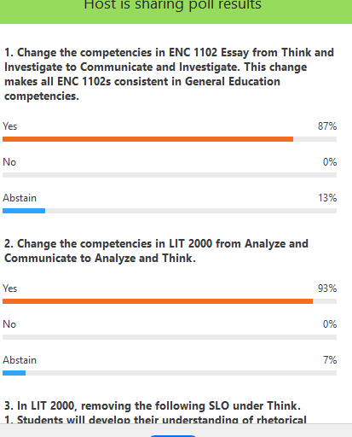
Poll II
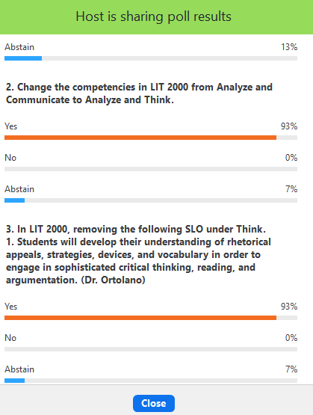

IV. Writing Center with Dr. Katie Wadell: All has gone well. Opened some doors. More documentation and professional development. Online tutoring has improved. I am advocating that tutoring remain partially online and getting that feedback from students. Next year, we will move back to regular options. Zoom will continue to be option. Way better than Tutor.com.
B. Conversations:
Dr. Bidebanch: IA with my 1130 has been excellent. Zoom workshop, three a week. Students got to know the IA’s and schedule. Some of them wish they could have weekend sessions. Other than that, my students have had a positive experience.
Prof. Massaro: Tutors online can provide transcripts of student submitted work. Transcripts helped me catch a student plagiarizing.
Dr. Waddell: All consultation documents live digitally. Archived. Only lived on the paper. Only digitally saved if Professors requested. Went to the writing center and some concern. Archiving those things. Collecting data in the field.
Dr. Trogan: Thank you for all your hard work. MLA 9 updates. OWL hopes to be ready in the fall but does not look like any major changes. Just clarification. The most
important thing is to use more inconclusive language. Rest seems like clarification.
We’ll see. They’re on top of it.
V. Dual Enrollment Update with Professor Jeremy Pilarski
A. Observations: Almost complete. Extension was given to some of the concurrent faculty.
B. GoReact: After discussing the use of the program with Dr. Trogan and Dr. Teed, we have decided not to renew the contract with GoReact. Although the program has good features, Zoom makes many of them redundant; furthermore, most concurrent faculty did not use the program.
C. MLA 9: Will be working with concurrent faculty on MLA 9 adoptions this fall.
VI. ENC 1130 with Dr. Bidenbach, Dr. Trogan, and Dr. Minardi-Power.
A. Introductions:
1. Dr. Bidenbach: Please consider teaching 1130. Anticipating more sections. Teaching two sections. 1130 is based off proven pedagogy. Developed at 14 years ago. A lot of data surrounding its success. Will post a link to the data. Many people mistakenly think it is developmental course.
B. Benefits:
1. Capped at 15 students.
2. Two courses taught by one instructor.
3. More hands-on.
4. Can see the big gains students make.
5. Small class size. Students get more support.
6. Do not have to do two semesters.
7. All material provides students help them succeed in Comp I.
8. Bond established with students.
C. Results
1.Data are new, and research is ongoing; however, students are doing better.
2. Online classes provided some challenges. Steps for keeping interaction going: Discussion Posts. Certain topics can lead to better feedback.
3. Grade distribution varies, but 25% is just being there (in-class activities).
4. Will be teaching 1130 ground in the Fall.
D. Prof. Lenny Owens: Had mixed results teaching it online. I think the course is better suited for ground.
E. Requests: Always looking for recruits to teach 1130. If you want an overload, ask Dr. Page.
F. Dr. Trogan: I enjoyed teaching 1130 and look forward to teaching it in the Fall.
VII. Textbooks:
A. Dr. Trogan: They are being distributed. We will be able to use the 1101 new editions and the Little Seagull. Lit 2000, 5th edition. They are being distributed. New Program, Access. Students pay a flat fee. Need to know by April 30th if we want to pilot it. Departmental decision.
B.
1. Dr. Harris: Students do not get to keep the book. Encourage them to keep the handbook. Students do not get to keep the book. Encourage them to keep the handbook. I can see why this can work in other areas. Most general resistance. I do not want these emails. I think it is an equity issue.
2. Dr. Trogan: I agree with everything Dr. Harris just said.
3. Dr. Hummel: We are fundamentally different from Business and Technology.
4. Dr. Harris: I can see it as a good idea for upper division courses.
5. Dr. Trogan: Dr. Teed has said that other departments have expressed interest. Any questions or comments? I think you make a good comment about upper division.
VIII. QEP Update:
A. Dr. Harris:
1. Things are rolling. Dr. Cameron and I are working together. External Reviewer. Steering Committee working. Final grades due April 30th. One with Pure and Applied Science and Humanities to get an idea what the new course will look like. Opportunity to learn about is on April 30. Our time is 11-12. Post to Canvas page if anyone wants to see it.
B. Dr. Trogan: Dr. Harris will be the new QEP director and leaving the faculty unit.
C. Dr. Harris: Proud to lead this department. Great working together. This is a dynamic department.
D. Develop new online shell for ENC 1101 and 1102. MLA needs updating. Let me know if you want to work on 1101. Stipend available.
E. Prof. Horn: Sustainability club needs some help. Also looking for some volunteers for
Creative Writing Club. Follow up from Creative Writing Committee, Textbook issues.
F. Dr. Ortolano: Last meeting for Community of Practice and Digital Pedagogy coming up.
Meeting adjourned at 2:30.
Notes by Prof. Jeremy Pilarski

