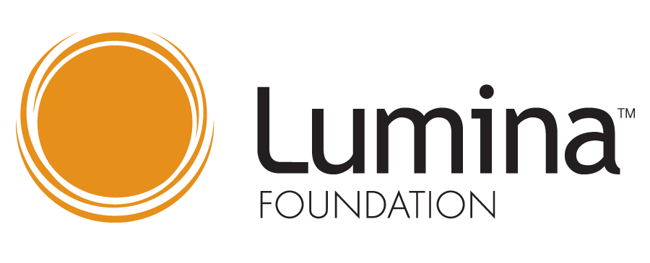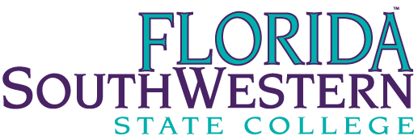

SWFL Talent Hub – FSW Action Team
  - Wednesday, September 9 at 2:30 p.m.
Kelli Dunlap | Present | Amber McCown | Absent
Dr. Christy Gilfert | Present | Dr. Debbie Psihountas | Present
Jessica Harber | Present | Dr. Tom Rath | Present
Brenda Knight | Absent | Whitney Rhyne | Present
Andrae Jones | Present | Dr. Matthew Sanchez | Present
Amanda Lehrian | Present | Dr. Norman Thomas | Present
Keith Martin | Present | Dr. Michele Yovanovich | Present
Dr. Martin McClinton | Present

With several new members joining this team, Whitney started the meeting by providing an overview and having everyone introduce themselves.
Overview
The FutureMakers Coalition aims to transform SW Florida’s workforce by increasing the proportion of working-age adults with post-secondary credentials. In support of this work, the FutureMaker Coalition, which is comprised of industry leaders, educators, and community organizations, applied and was awarded the Talent Hub designation, which is a Lumina Foundation award. The talent hub designation indicates that a community has shown the capacity and capability to significantly increase the number of residents with post-secondary credentials. 26 cities nationwide have received this designation. The Southwest Florida Community Foundation, FGCU, and FSW are the signatories on the grant. The stated goals for FSW are listed below.

  - Enrollment of 3% of the target group (adults with some college, but no degree) into an FSW associates degree program
    - Of this population, a 50% associate or certificate degree completion rate within 3 years of initial enrollment
    - Implementation of a completion scholarship at FSW for the students in this population.
  - Increase transfer enrollment of FSW graduated by 10%
  - Reverse transfer of AA with FGCU
  - Develop and implement record sharing agreement with FGCU to streamline transfer admissions
  - BS in Elementary Education at HG (cohort of 12 or more students starting Fall 2020)
  - Enrollment of 3% of the target stop out population into an FSW bachelor’s degree program
  - Develop shared recruitment materials and a joint enrollment activity plan

Reverse Transfer
Dr. Gilfert provided an update from a sub-group working on reverse transfer. FGCU and FSW have developed a joint reverse transfer application. FGCU has identified and shared a list of 148 students who met the criteria. Staff are reviewing the list to determine the next steps.
B.S. in Elementary Education at Hendry/Glades
This fall, FSW started offering the Bachelor of Science in Elementary Education at FSW’s Hendry/Glades Center. With the transition of classes to online, flex, and blended modalities, the tracking of Hendry/Glades specific students become more difficult. Amanda noted there are 20 unique students enrolled in the B.S. in Elementary Education courses offered at Hendry/Glades and 18 of those students are degree seeking. 17 of the students are Hendry/Glades specific.
Second Look Student Stop-Out Campaign
Whitney shared a few data points from a decade worth of FSW’s stop-out students that helped to inform this team’s work. Slides with more information are included with the meeting minutes.
From 2019 to 2009, 26,104 students stopped out of FSW. 12,558 or 32.5% were early transfers and attended another institution after departing form FSW. 1189 or 9.5% of FSW’s early transferred enrolled at FGCU. For the first round of outreach, this team narrowed in on 14,956 students who left FSW in good academic standing and had no other educational records found through the National Clearing House.
FSW was able to successfully deliver 10,724 students who stopped out targeted, second look communications starting in mid-June. FSW delivered a second look communication every other week through the end of July. On average, 20% of students opened the second look communications. From this work, 200 students who received our second look communications are enrolled in the fall 2020 semester.
Credentials/Next Steps
Whitney shared that IT was able to operationalized a program to compare students’ coursework with the current catalog term. Through this process FSW identified 16 students who had completed all coursework needed to graduate with their AA. Whitney successfully connected with six of those students to complete FSW’s re-admit application to update their catalog term and agree to FSW’s automatic graduation processes.
In reviewing students’ coursework to the current catalog term, we identified 2,597 students who are close to graduation (seemingly with one semester). Dr. Psihountas noted the possible use of Schultz, CARES funding for students in this group. Dr. Psihountas noted the challenge for students and advisors of only being able to note two academic programs limiting FSW’s ability to track/award credentials earned within programs (i.e. certificates within A.S. programs). Andrae noted that Danny in IT was working on a process to automatically graduate students for all programs they qualify for/completed. We would need to check with Danny to see if this had been operationalized. There was some discussion for the need to opt-out of the automatic graduation process.
Whitney provided the program breakdown of the 2,597 students close to graduation found in the table below. Dr. Psihountas was eager for the School of Business and Technology to reach out to this group of students.
AA General Studies | 2262
Paralegal Studies | 56
Criminal Justice Technology | 55
BAS Supervision and Management | 49
Bus Admin and Mgmt | 37
BS Nursing | 22
Early Childhood Education Prog | 18
BAS Public Safety Administrati | 15
Science and Engineering Tech. | 11
BS Elementary Education | 10

In trying to connect with students who have stopped out, we would prefer to get the students back on track with their academic goals prior to the students becoming a stop-out student. We have developed a survey titled “Exiting FSW” that will be disseminated each fall and spring to better understand and connect with students who are leaving FSW before completing a degree. The survey is found in the attached meeting slides.
The Office of Strategic Initiatives is hiring several Student Ambassadors to leverages their personal experiences as a student to offer encouragement and assistance to prospective and current adult-learners. In continuing the work to learn about and support stop-out students, we are utilizing data from pre-existing surveys and found that 11.5% of students who completed our first-term engagement survey during fall 2019 did not continue with us into the spring semester. In reviewing student’s stated usage of services, we found that students who continued at FSW utilized the Academic Support Center at higher rates then students who did not continue. And surprisingly, we found that students how did not continue with us into the spring semester utilized academic advising at a higher rate. Charts can be found in the attached slides.
Outstanding Balance/Potential Funding
At our last meeting, someone asked about the outstanding balances of FSW’s stop-out students. For FSW’s 26,104 stop-out students from 2009-2019, only 41 students have an outstanding balance. The total outstanding balance is $24,235.34.
The SWFL Community Foundation is working with potential donors interested in an incentive program for returning students. 55 of our stop-out students have earned 105+ credits that count towards their degree, and a gift of $25,000 would fund a minimum of 13 students full-tome to complete their bachelor degree. Additionally, we have 122 stop-out students who have earned 50+ credits towards their stated program and seemingly within one semester of graduation. A gift of $25,000 would fund 15 students full-time to complete their AS degree.

Minutes submitted by Whitney Rhyne

