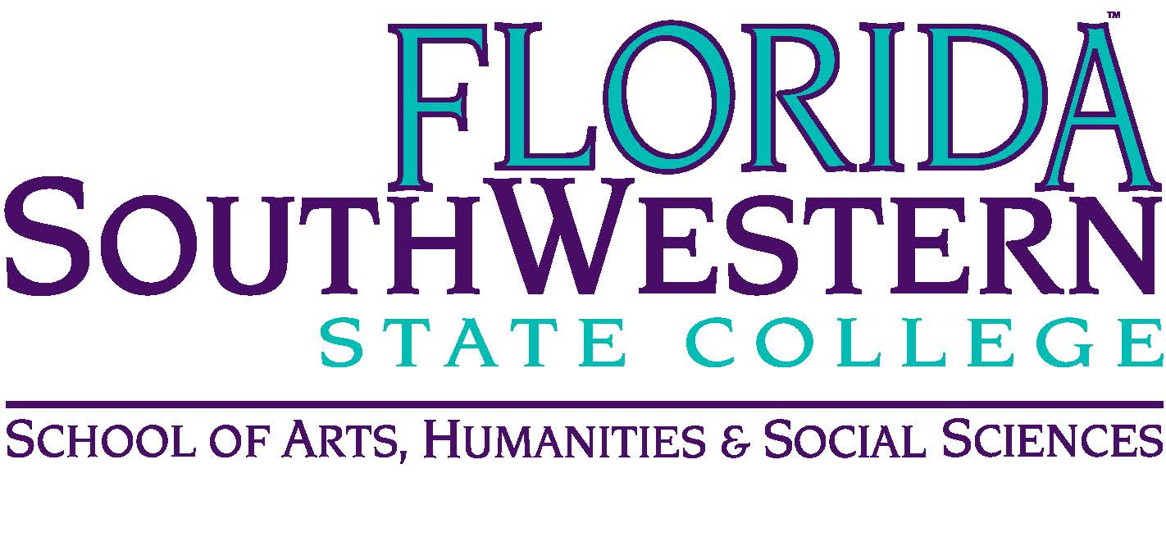
Department of Humanities and Fine Arts
Meeting Minutes
Date: October 12, 2018, 10:30 p.m.
Location: Edison/Lee campus
Chair: Dana Roes (Russell Swanson fill-in)
Minutes: Michael McGowan

 | Present | Absent | Excused
Brown | X
Chase, S | X
Chase, W | X
Doiron | X
Hoover | X
Lublink | X
McGowan | X
Mompoint | X
Pritchett | X
Roes | X
Sutter |  | X
Smith |  | X
Swanson | X
Molloy | X
Krupinski | X
Guests | Dr. Teed

- Opening
  - Call to Order: 10:30 a.m.
  - Attendance taken
  - Minutes from Sept. 2018 Approved
  - Teed
    - Parking not better
    - Attendance verification discussions are underway about how to make the process smoother
    - Voiced to Dr. Teed: (a) the accommodation process is slightly onerous. There should be a more efficient way to do it. (b) we prefer speed humps rather than speed bumps
- Announcements:
  - Dale’s Housewarming Party: Oct. 20 2018 at 6 pm at 1444 Byron Rd. Ft. Myers, FL. Refreshments provided
  - Russell and Symposium at 3 pm. Theme “Creativity”
  - Black Maria on Saturday (11/13) at 7:30 pm – proceeds go to human trafficking
  - Publisher’s Forum in AA-177 from 10-2 pm (today)
  - Neutrality in the Classroom: Tuesday, Oct. 16 from 3-4 pm
  - FPD Travel Deadline: 11/9 and 3/1
  - FEE Grants and National Endowment for the Humanities Grant deadline: 10/17
  - OER: need task course volunteer (Ellie Bunting is looking). Monica said she’d be interested.

- Information items
  - Myriam: one college, one book – Gen Ed advisory council promoting this initiative. There’s a survey for faculty, so when we receive it, do it. They’ve selected six texts, soon to be narrowed to three.
  - Steve: website/brochure is under construction. Steve needs more photos: Elijah, Tom, Stuart, Kelly, Dana. Also, Steve needs short paragraphs for a Bio. Also, keep the activities we do that are photographically interesting to Steve.
  - Ron: music update – see the handout for Fall 2018 performances (Ron highlighted Patricio Sanhueza Barria’s guitar recital on 10/24). We also got a major music collection donation, which prompted a discussion about the need for more storage (or redoing the shelves in the storage area we have)
  - Dana: Digital Arts update (certificate and new classes) – 141 is being converted to a Mac Lab. We’re hiring someone for next fall. Dana put 7 classes (e.g., web design, video/sound production, digital animation, etc.) on the books and created a certificate.
  - Stuart: theater update – working on “Wellesley Girl” (2016). Nov. 8-10, 15-17 in the Black Box theater. Funny, dramatic, timely.
  - Elijah: assessment update – we voted we were going to send students to Joe, and soon we’ll receive the email from them. We’ll get an email regarding the time and date for the meetings, so now it’s on us to get them to show up. We need to promote it. They’ll also send a sample of the questions we ask and we need to write back what changes we want. Don’t tell the students it has to do with the pre- and post-tests.
  - Mentoring: “Building Community Through College Mentoring” on Friday, 10/26, 1-3 pm – We can get certified to be a mentor. We can have lunch first at the PD Friday event near the TLC.
- Discussion items
  - Faculty Evaluation: Need to have interview by subcommittee before the third Friday of November.
- Next Meeting: November 9, 2018 at 10:30 a.m. in L-119B.

ACTION INTEMS:
- All: Do the “one college, one book” survey when emailed

