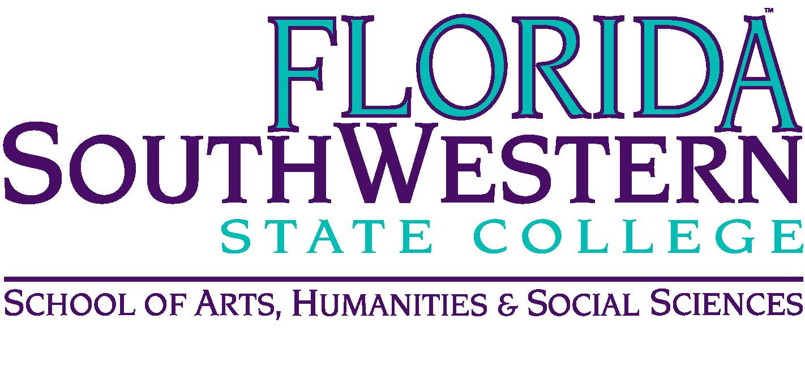
Department of Humanities and Fine Arts
Meeting Minutes
Date: February 12, 2021 - 10:00 a.m.
Location: Virtual/Online (Zoom)
Chair: Dana Roes
Minutes: Michael McGowan

 | Present | Absent | Excused
Brown | X
Chase, S | X
Chase, W | X
Doiron | X
Hoover |  |  | X
Lublink | X
McGowan | X
Mompoint | X
Pritchett | X
Roes | X
Sutter | X
Smith | X
Swanson | X
Molloy | X
Krupinski | X
Wurst | X
Harrington | X
Chowdhury | X
Gresens | X
Guests | Dr. Teed, Dr. Page, Andrae Jones, Rebecca Quimby,  Michael DeMoran, Len Olsen

- Opening
  - Call to Order: 10:00 a.m.
  - Attendance taken
  - Minutes from January 2021 approved
    - Len Olsen’s name was spelled incorrectly
    - McGowan will correct and reupload the minutes to the Doc Mgr.
- Special Guests: Dr. Teed and Andre Jones to talk about Pathways
  - “Guided Pathways” is about helping students explore and then narrow down their interests through a course map based on what they want to do
  - Note: only 33% of our incoming students end up graduating
  - Tracks vs. Pathways: tracking is following the tests from early childhood (e.g., 5th grade) whereas Pathways is asking what they want to do with their lives. “Tracks” are different than “tracking” and our “Pathways” idea is like different tracks for students.
  - For interested faculty, think about a course list by semester from the first course to the last, completing it within 2-3 years.
  - A conversation emerged between those of us who believed Pathways limits students’ ability to take what they want and those of us who believed Pathways helps students save money and time later (since credits above 60 are more expensive).
  - Implementation: working with the state, a 2-year program that we just started. Rollout is a multi-year plan, but there may be some aspects of the rollout that start this fall. We’ll be getting an advisor sometime (after the committee meets in around six months, or June [Andre couldn’t remember]).
  - As a department, we were concerned about programs that turn students into cogs in the job-machine rather than educated, learned contributors to society.
  - See their PowerPoint presentation for details.
- Announcements:
  - Summer and Fall Schedule: get fall preferences in today.
  - Modalities: all available for the fall
  - Myriam: new course on Latin America and Caribbean arts and culture. Tell your students!
  - Community of Practice: Moved to March 2, 11:30 a.m.
  - Mini-terms: for students who need help, suggest for them to move into mini-term B
  - Compliance Training – see the attachment Dana emailed us, and do the training ourselves if we haven’t yet.
  - New OBOC, Life on our Planet (David Attenborough)
  - Form 1 Due Today
  - Community College Survey of Student Engagement will be given from February 22 – March 14 and March 22-31.
  - State of the College: Today at noon: https://fsw.zoom.us/j/83158043691

- Information Items:
  - Assessment update (Elijah): two things: (1) Gen Ed assessment of Communicate and Evaluate. Might apply to 1-2 of our classes. Reach out to Elijah or Joe van Galen. Also, syllapalooza is going on so bring concerns to Elijah.
  - Professional Development Update (Sarah): check your email for PD funding; Sarah sent message out this morning from TLC account.

- Discussion:
  - Humanities Textbooks: due for renewal soon, so the HUM folks will arrange a separate time to talk about this.

- Next Meeting: 3/12/21 at 10:00 a.m.

