Portal Training
Budget and Encumbrance Queries

The following is a step-by-step guide on how to use the Portal to review your budgets and encumbrances.

Budget Queries
To perform a query on your budget you will want to click on the “College Resources.” In the “Office of Financial Services” section click on “Budget Queries.”

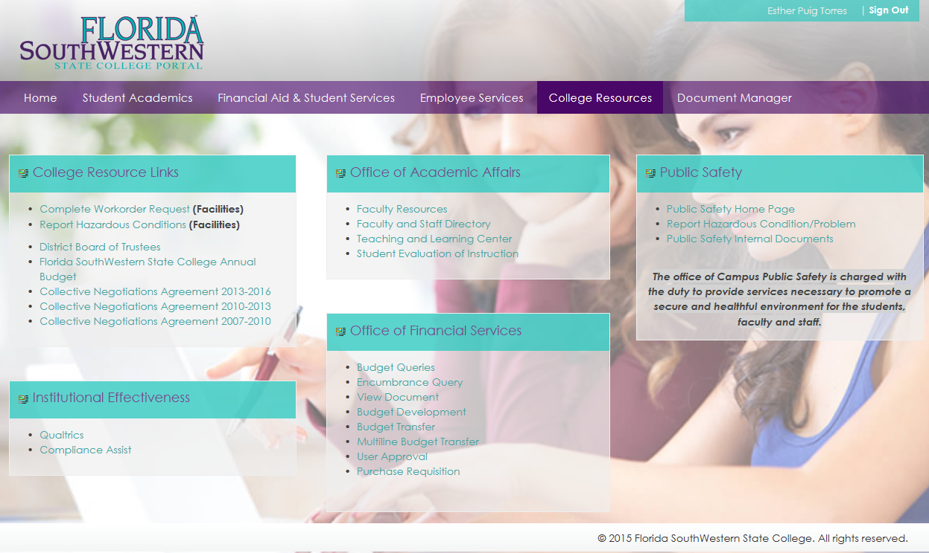

You will be able to create three types of queries:
- Budget Quick Query – this is a quick snapshot of what your budget looks like as of the day you do the query. It will show you only Adjusted Budget, Year to Date Expenses, Commitments and Available Balance. You can choose to look by Index or by Department (Organization Code).
- Budget Status by Account – this query will allow you to choose what you want to see such as Original Budget, Adjusted Budget, Commitment, etc. You will also be able to compare the current year figures to the previous year’s figures. Information is shown at the account code level.
- Budget Status by Organizational Hierarchy - similar to the Budget Status by Account however this query shows information at a department (organization) level.
Let’s first discuss the Budget Quick Query:
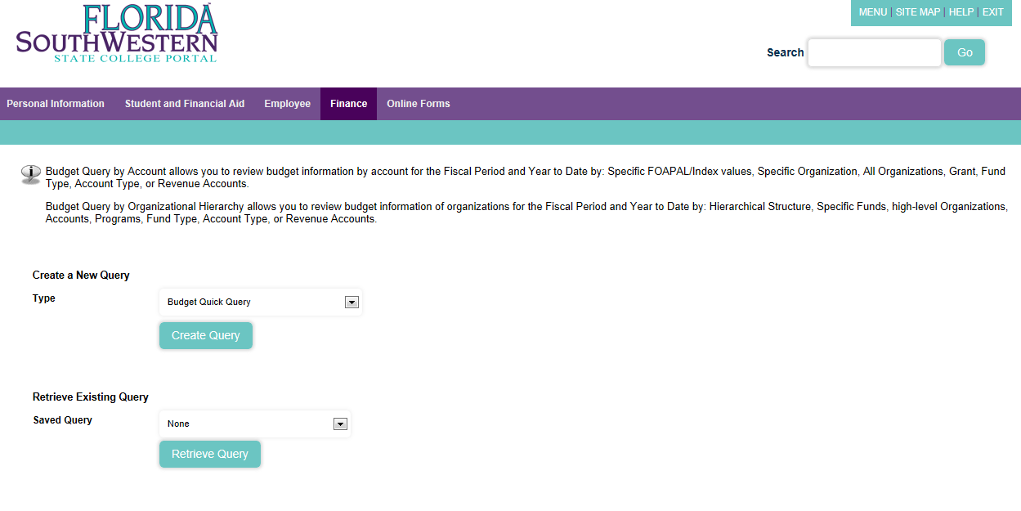

Once you select Budget Quick Query from the drop down menu the following screen will show:
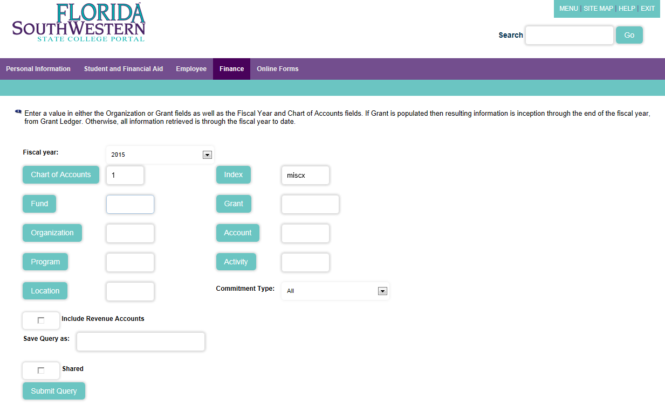
**If you enter your index please remember to hit “Submit Query” TWICE**

The following screen will then appear showing you your current budget, year to date expenses, current commitments and available balance.
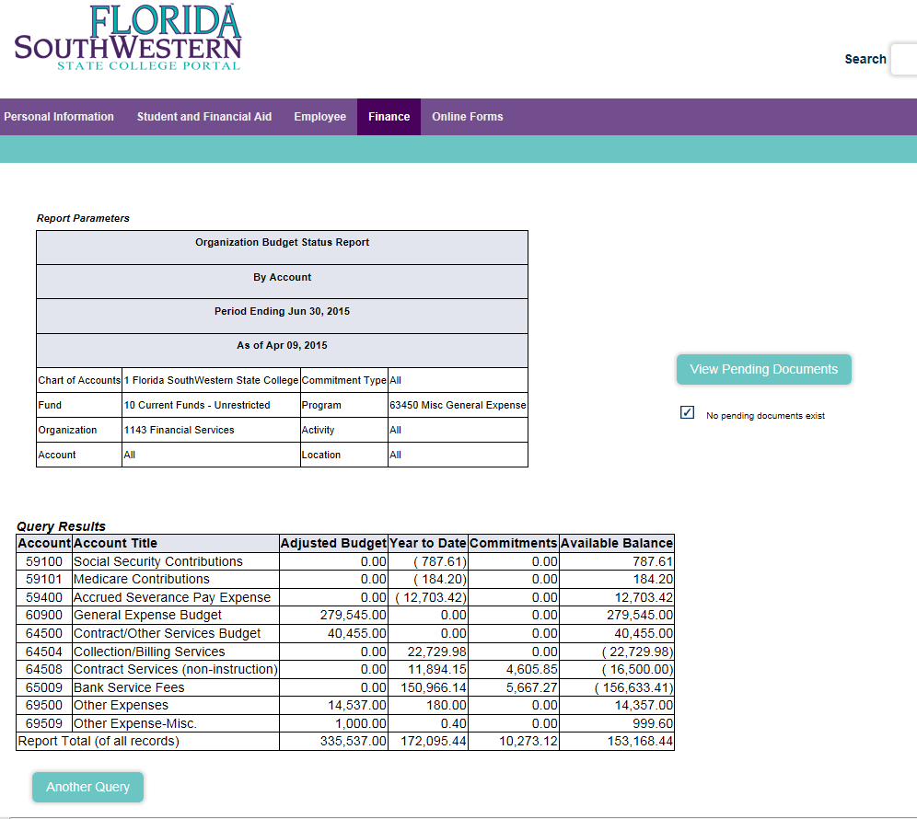

By clicking on the you will be able to see all documents that are pending for approval.

The next query is the Budget Status by Account query:
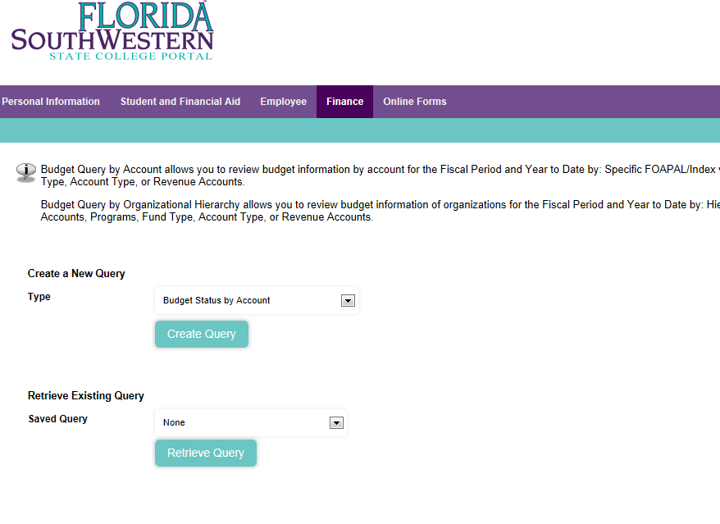

You will then be given options to check what you want to see on your report:
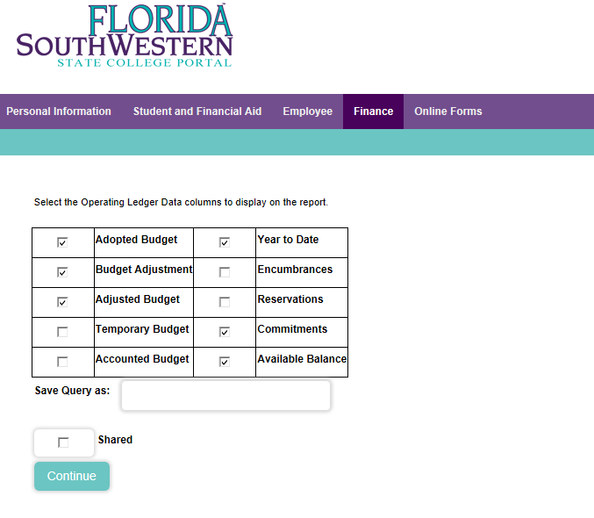
You may choose anything you want but it is recommended that you checkmark those that are shown in the previous screen shot. This will give you the information you need.

In the following screen you will select either your index or your department (organization code). You will also be given the option to compare the current year to the previous year. This is not required though. If you do choose to do this just use the dropdown boxes to choose the dates you want to compare.
Once you select hit “Submit Query” twice.
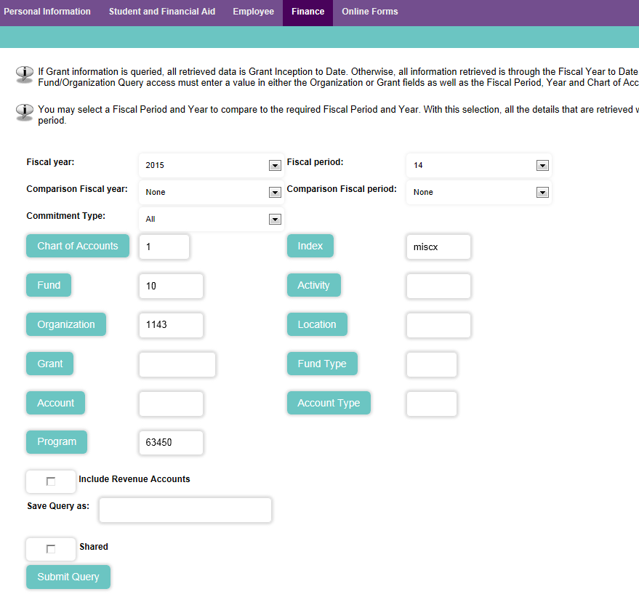

The information you selected will be shown as the following screen indicates. You will be able to “drill-down” to get the details behind the numbers by clicking on any number that is blue. You can also download the information to excel in order to perform additional calculations.
Download All Ledger Columns – will show all selections whether they are checked or not
Download Selected Ledger Columns – will show only the selections you chose with a checkmark
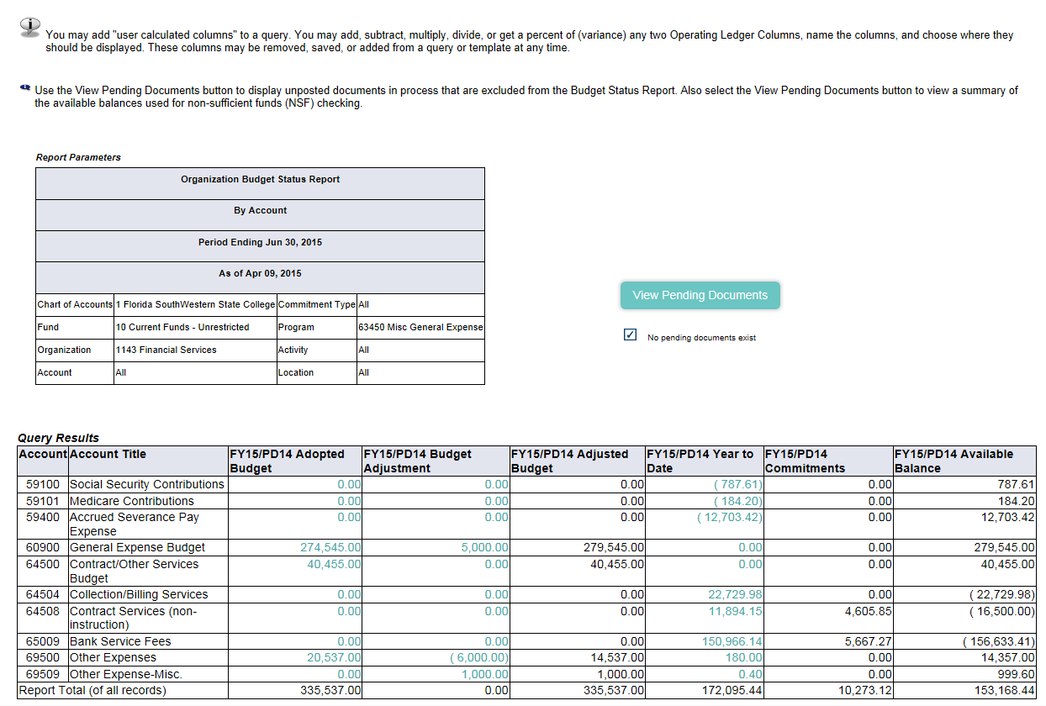

The final query is the Budget Status by Organizational Hierarchy. This will show information at an organizational level. It consolidates information based on hierarchies which are set in Banner. You are not able to drill down at this level but it will give you a good idea of the activity in each department.
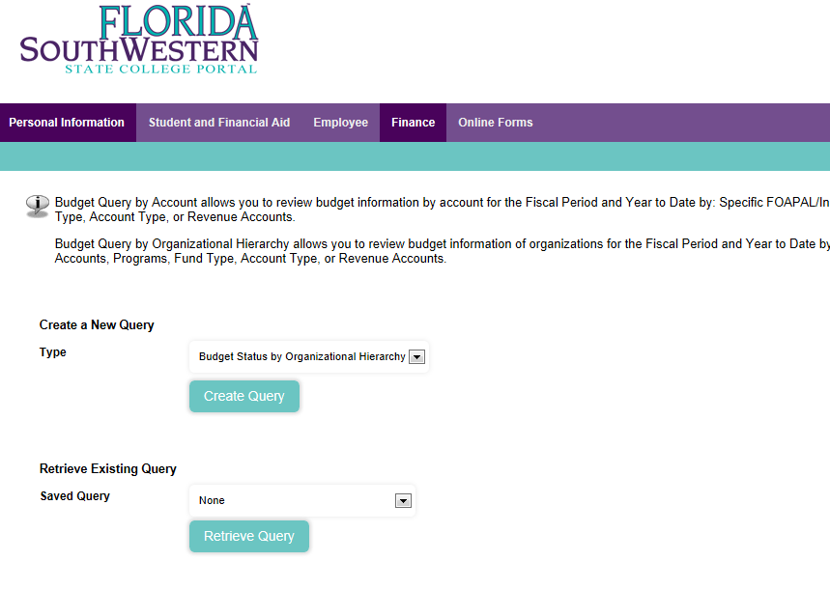
Click Create Query

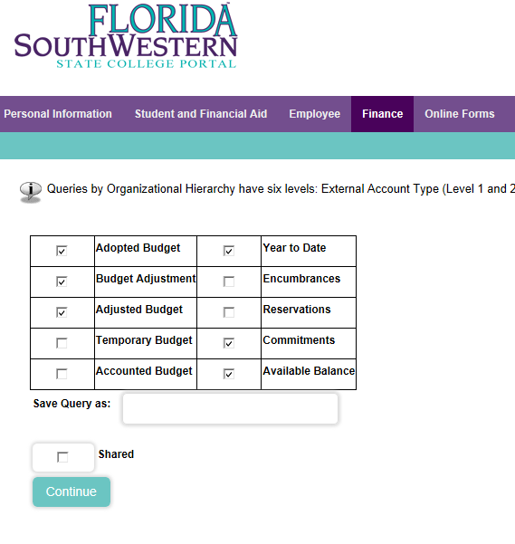
Make your selections

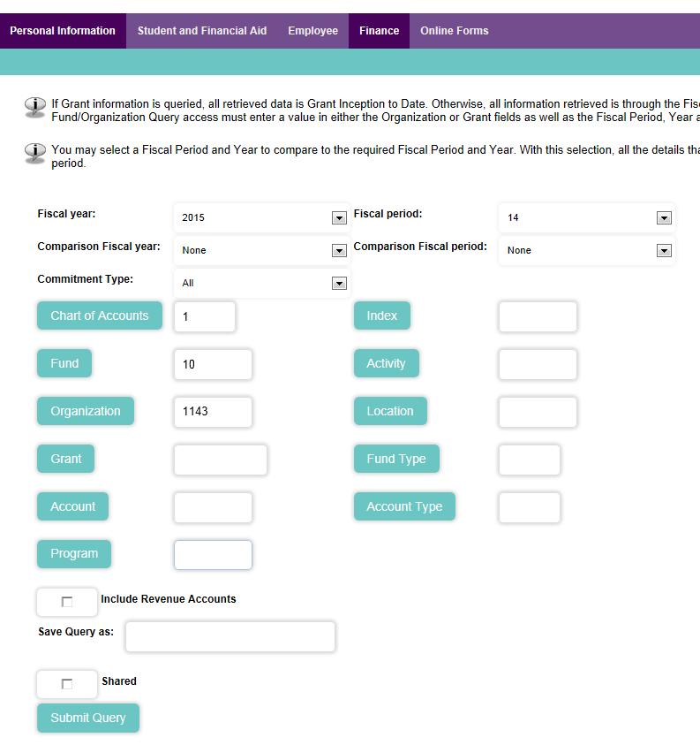
Choose Organization Code

The information you selected will be shown as the following screen indicates. You will be able to “drill-down” to get the details behind the organization numbers by clicking on any number that is blue. You can also download the information to excel in order to perform additional calculations.
Download All Ledger Columns – will show all selections whether they are checked or not
Download Selected Ledger Columns – will show only the selections you chose with a checkmark

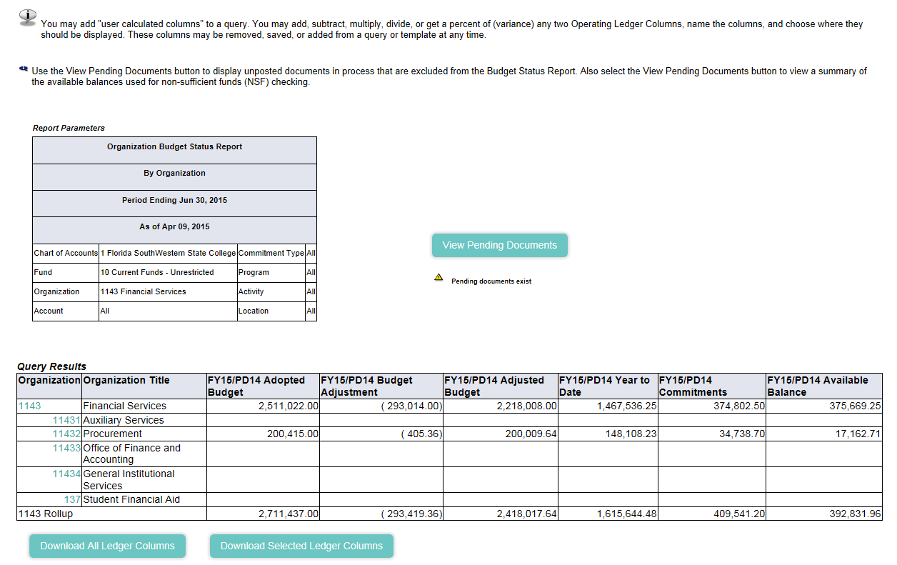

Encumbrance Query
To perform an encumbrance query you will want to click on the “College Resources.” In the “Office of Financial Services” section click on “Encumbrance Query.”

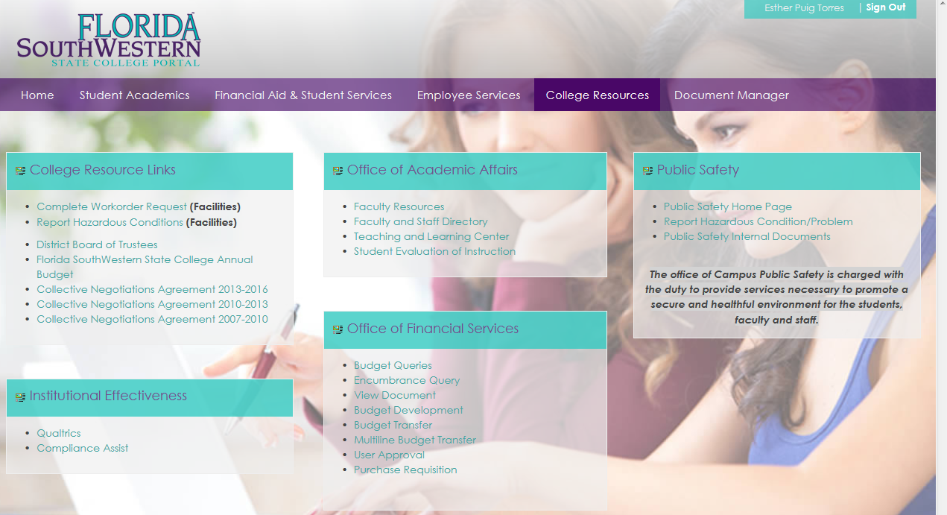

The Encumbrance Query allows you to view all Purchase Orders by account and salary encumbrance information for the whole department, for a specific index, or for a specific account code. You can generate the query from the information you enter on the following screen
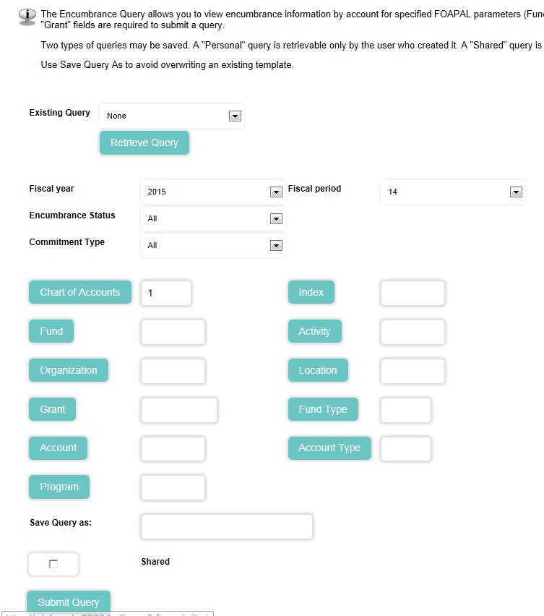
Enter Organization Code, Index, and/or account code

1 – To view the encumbrance information for a whole department, just enter Chart of Accounts “1”, the organizational code and submit the query.
2 – To view the information by index, enter the index code and Submit Query TWICE.
3 – To view the Purchase Order for a specific account, enter the index code, submit query, then, enter JUST the account code and submit query again.

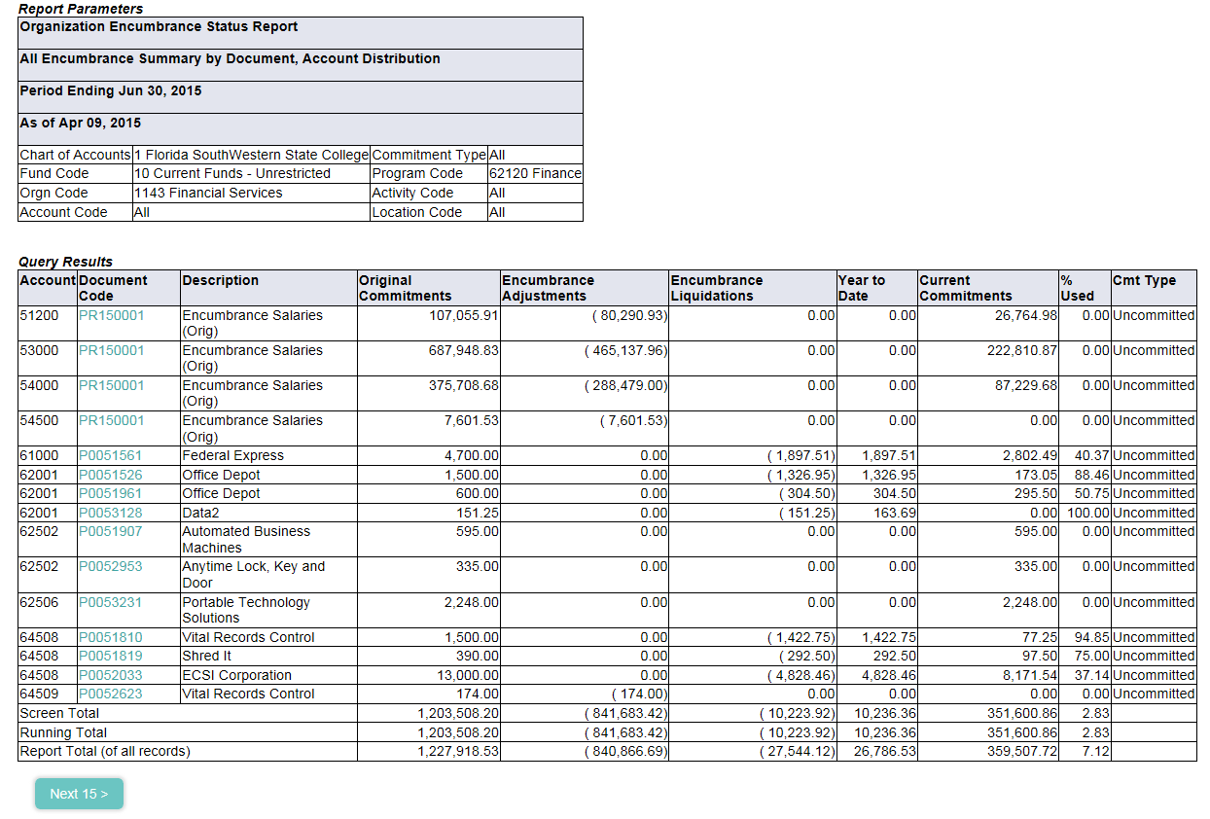

You will be able to “drill-down” to get the details for each Purchase Order by clicking on the number showing in blue.
To see all Purchase Orders, click “Next 15” on the bottom of the screen.

View Document
To view a specific document, go back to the “College Resources Tab” and click on “View Document” under the “Office of Financial Services” section

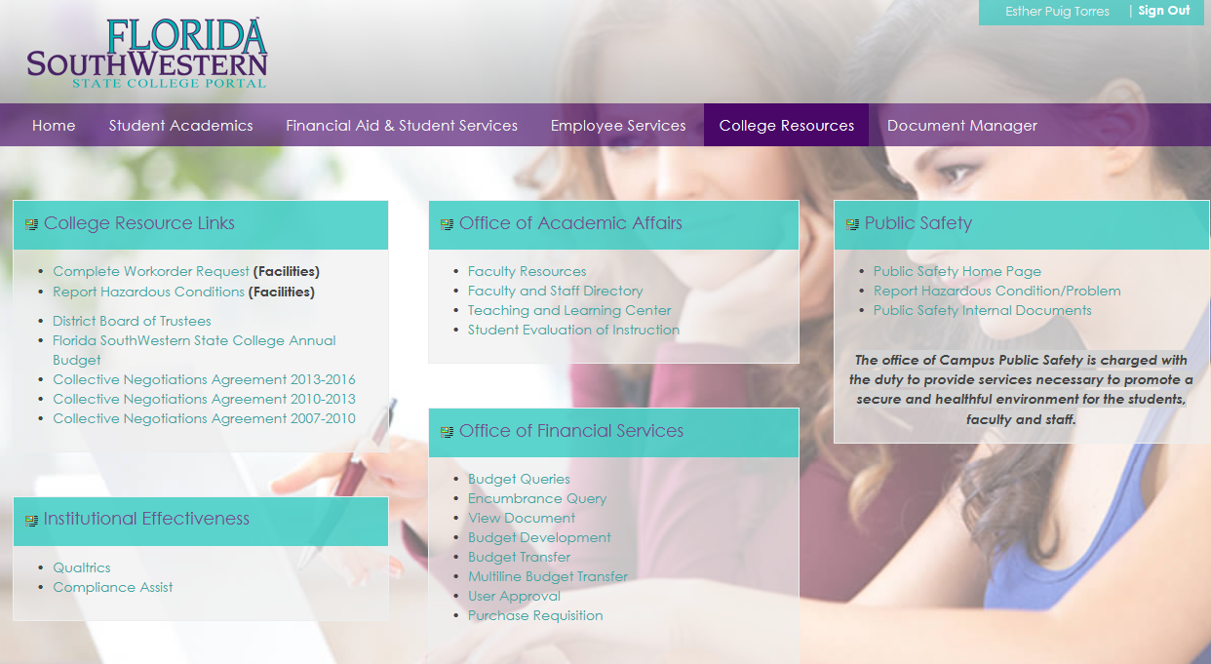

This option will provide you the details and approval history for any transaction (Requisitions, Purchase Orders, Invoices, Budget Transfers and Journal Entries)
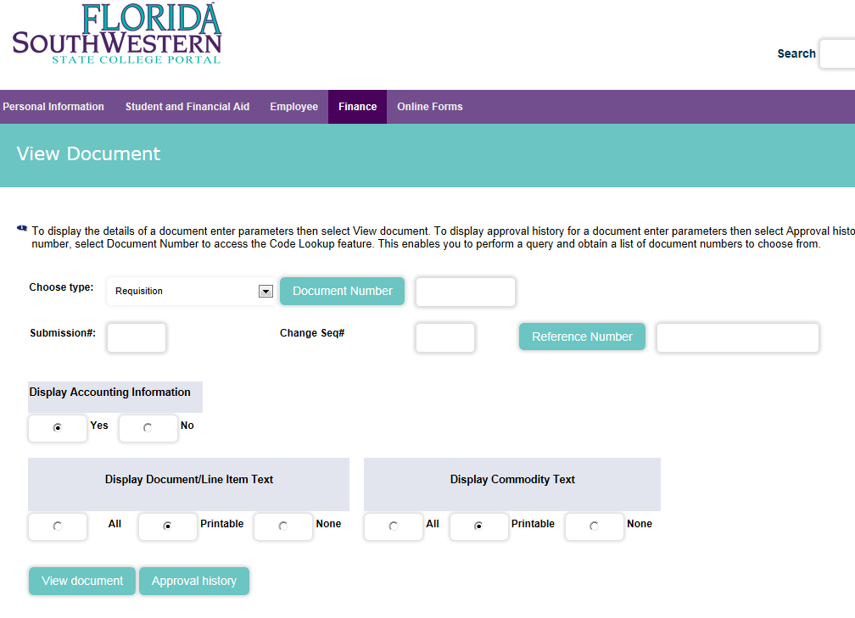
Enter Document Number*

Choose Document Type from drop down list

Click View Document for details or Approval History for list of approvers and approval status

*If you don’t know the document number, just click on “Document Number” to run a query. See Code Lookup below:

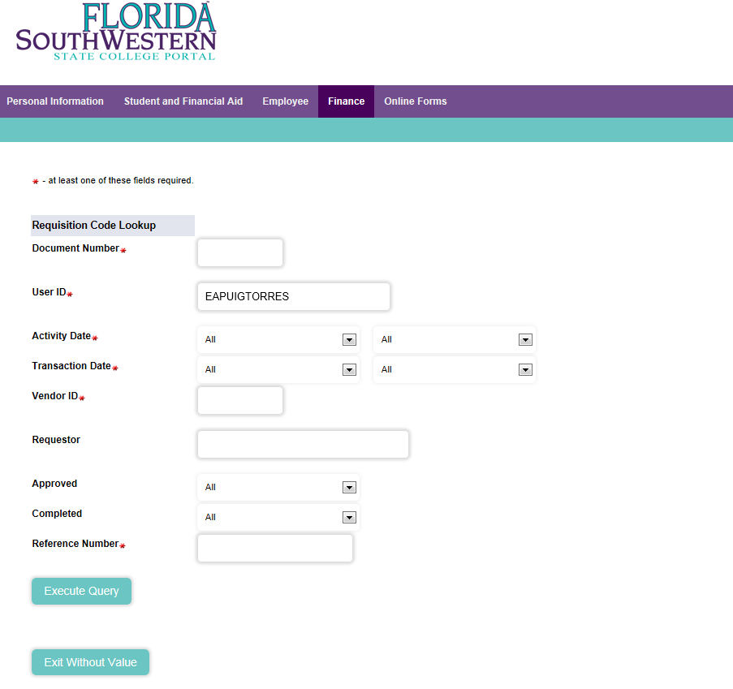
Select Month and Year or look them ALL
Enter user id who initiated the transaction

Budget Transfer
To do a Budget Transfer, go back to the “College Resources Tab” and click on “Budget Transfer” under the “Office of Financial Services” section
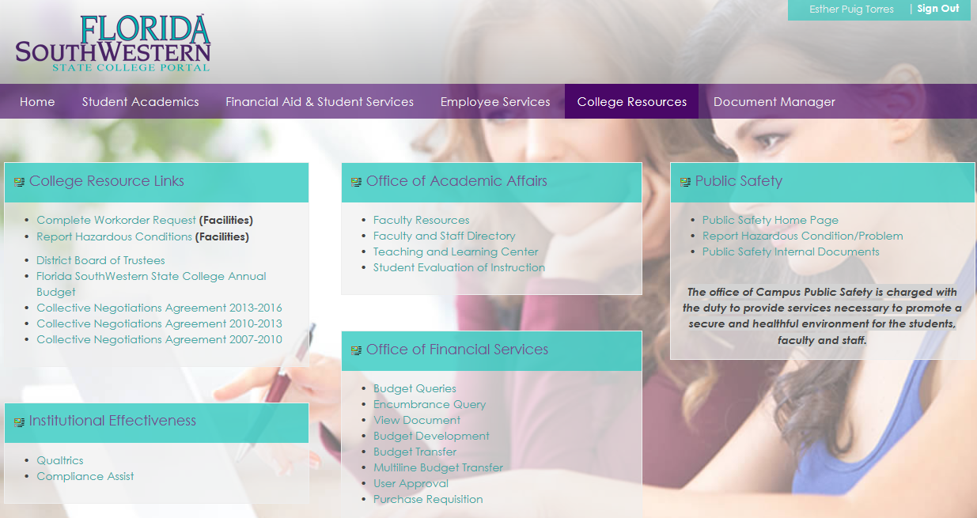

Budget Transfers are allowed within the same fund only, and they can be Permanent or Temporary (we generally process Temporary Transfers)
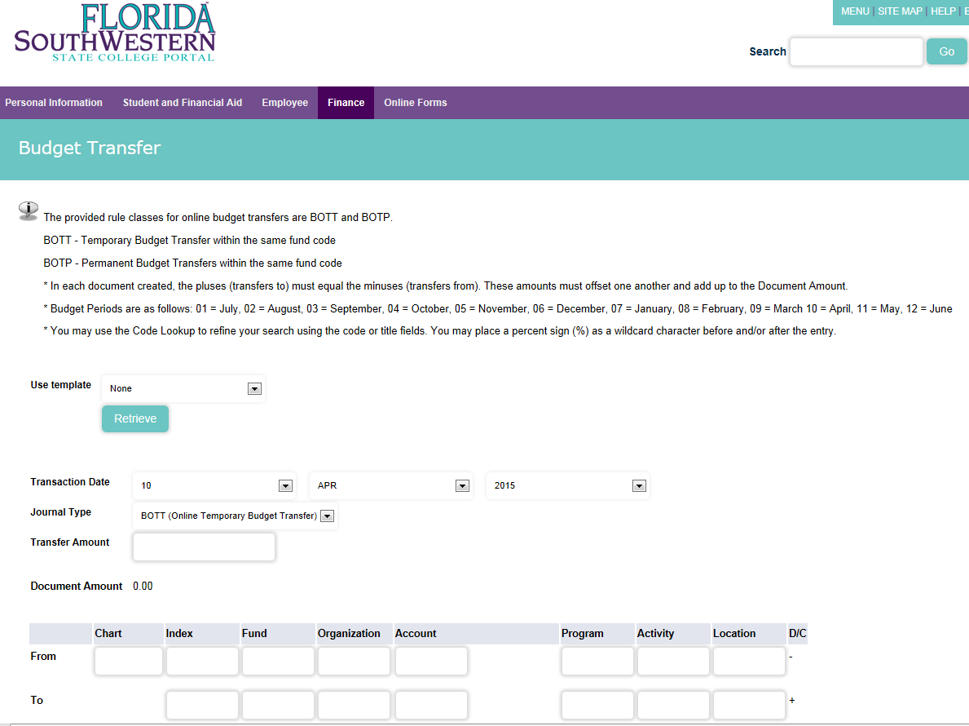
Enter Chart 1, Index and Account codes.
Select type of transfer and enter the amount
Select the date
Enter a description and select the budget period

Hit Complete, RE-ENTER JUST the account code on the top and hit Complete AGAIN

Multiline Budget Transfer
To do a Multiline Budget Transfer, go back to the “College Resources Tab” and click on “Multiline Budget Transfer” under the “Office of Financial Services” section

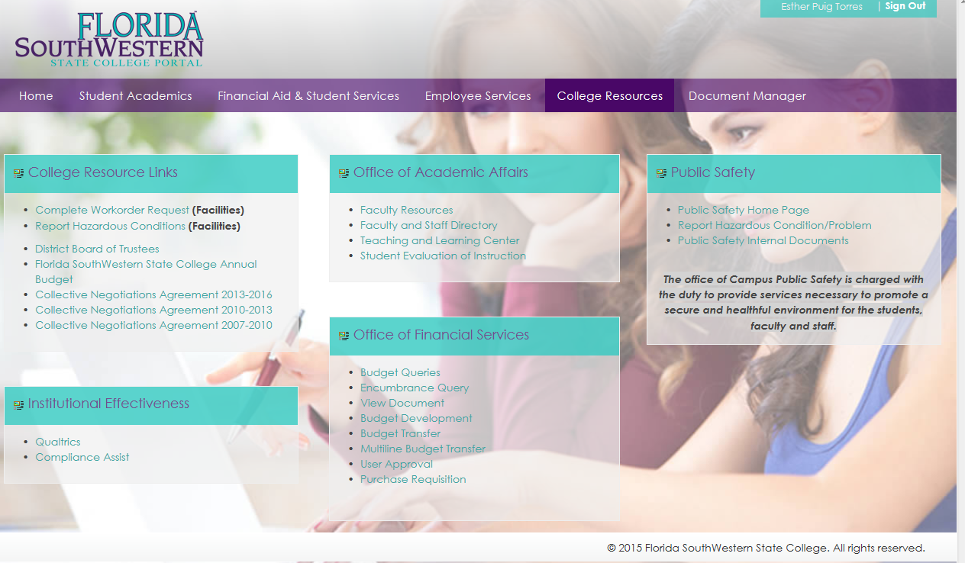

This option will allow budget transfers between different indexes and account codes within the same division, or different pooled accounts within the same index.
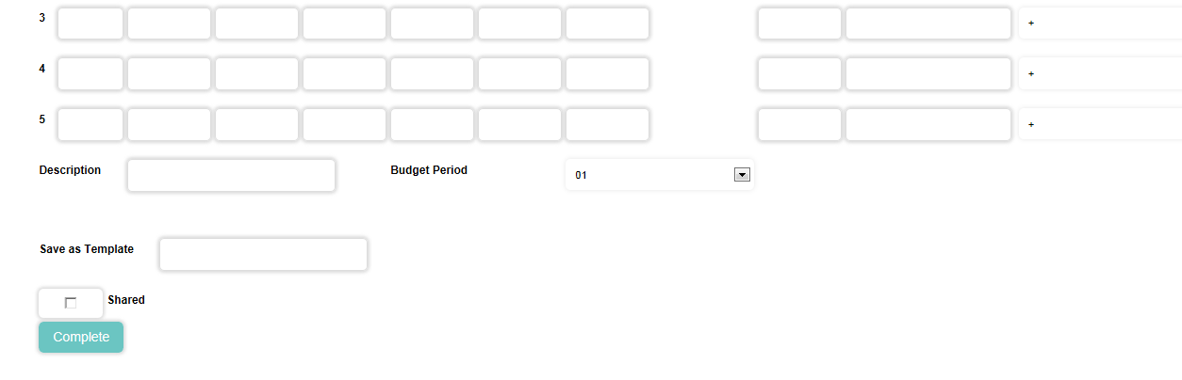
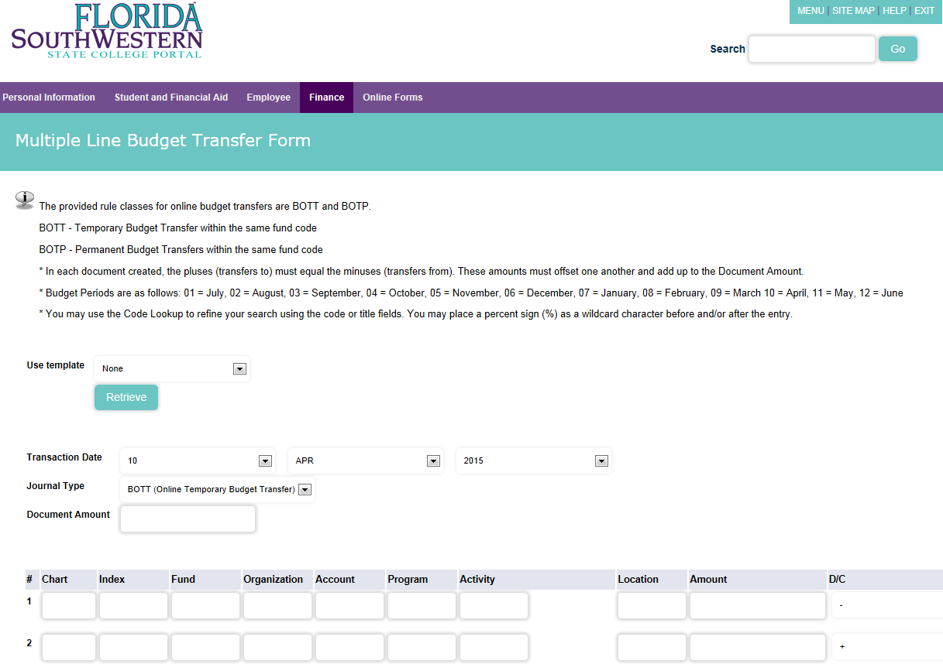
Document Amount should be the SUM of all the amounts entered below

Select From (-) or To (+) accordingly. The Plusses must equal the Minuses

Hit Complete, RE-ENTER JUST the account code on the top and hit Complete AGAIN

User Approval
For the “User Approval”, go back to the “College Resources Tab” and select the option under the “Office of Financial Services” section
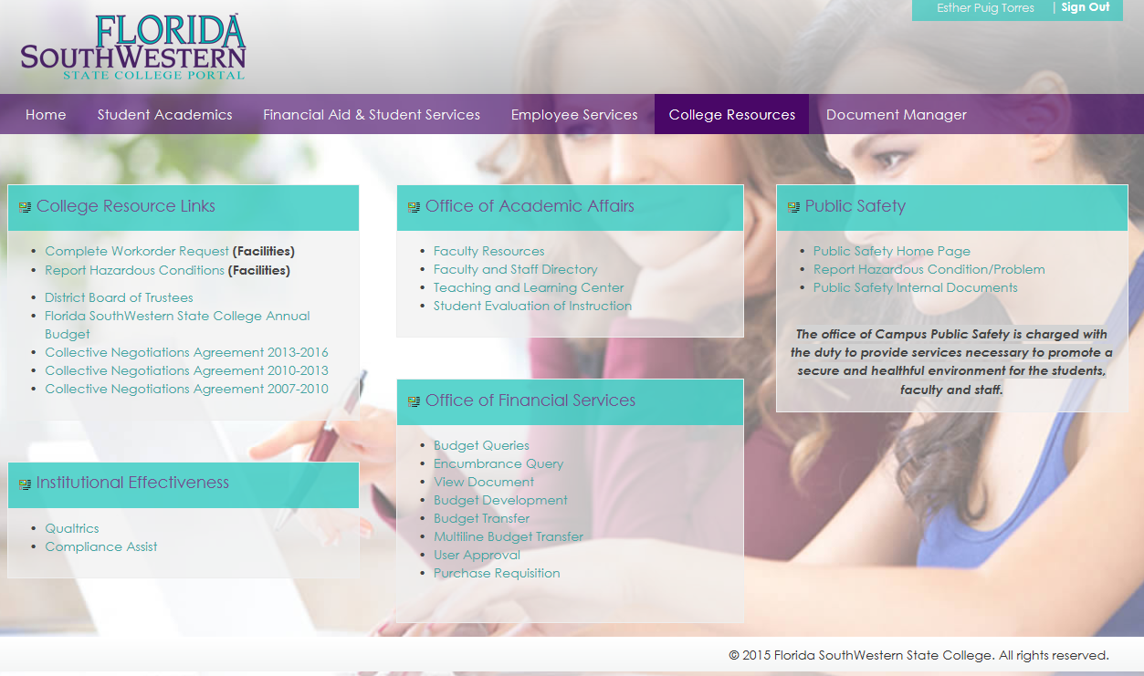

Budget Administrators go to this option to approve Purchase Requisitions and Budget transfers.
This could also be an option for users to disapprove Budget Transfers, Purchase Requisitions or other documents submitted, if additional entries or corrections are needed.
The user ID should populate with your information as you logged in the portal.
It shows the documents that are pending for your approval or the ones in your queue pending for others to approve.
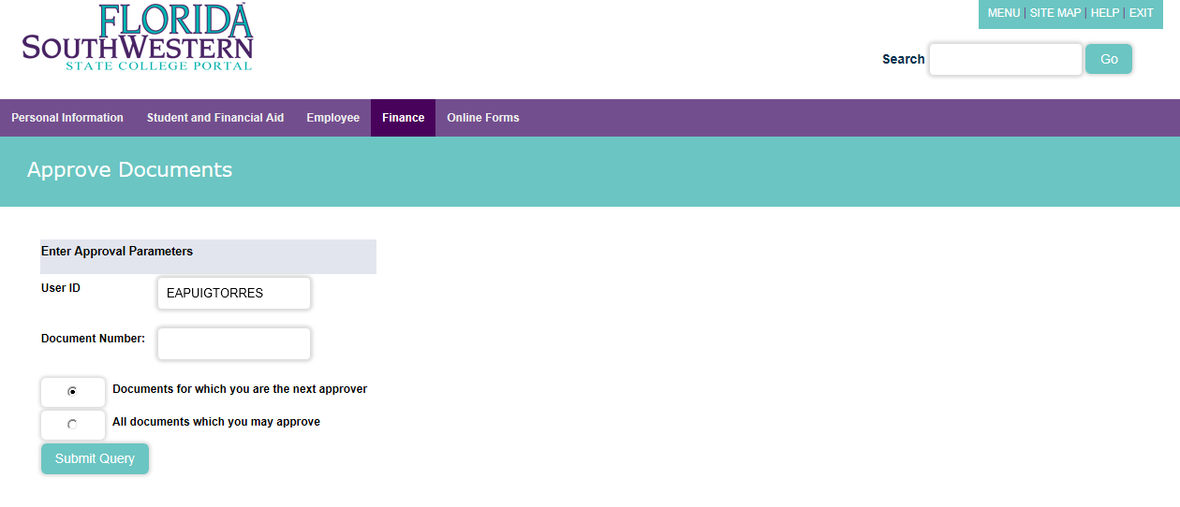
Select to view and approve documents pending for your approval.

Select to view documents in you queue pending for others to approve.

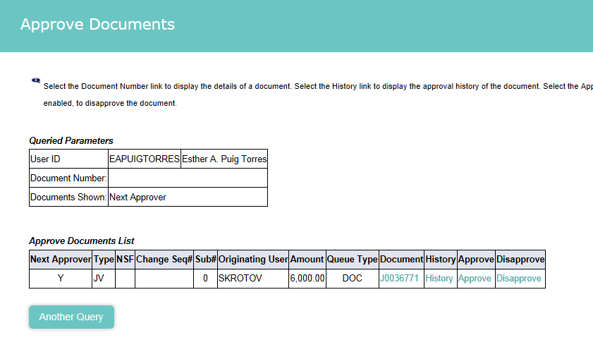
Click to view document submitted for approval

Click to approve or disapprove transaction

Click to view approval history

Please contact Esther Puig at x-6639 or e-mail eapuigtorres@fsw.edu for additional questions.

Thank you very much for your time

Office of Financial Services

