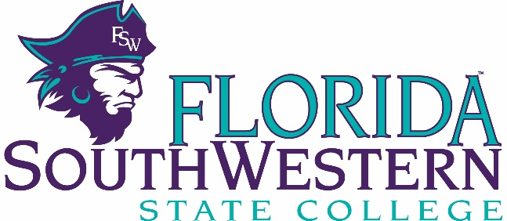

Student Government Association Campus Activities Board FSW Leadership Academy Advisor: Jessica Russell Advisor: Jessica Russell Advisor: Jessica Russell
Phone: 941.637.5634 Phone: 941.637.5634 Phone: 941.637.5634 E-mail: jrussell17@fsw.edu E-mail: jrussell17@fsw.edu E-mail: jrussell17@fsw.edu

FSW Newspaper Club Political Club S.A.L.T. Club
Advisor: Natala Orobello Advisor: Dr. Carol Roark Advisor: Alexandra Andrews
Phone: 941.637.5659 Phone: N/A Phone: 941.637.5653
E-mail: norobello@fsw.edu E-mail: croark@fsw.edu Email: Alexandra.Andrews@fsw.edu

Art Club Cultural & Fine Arts Club Student Nurses’ Association
Advisor: Brenda Hussey Advisor: Natala Orobello Advisor: Judith Sweeney
Phone: 941.637.5657 Phone: 941.637.5659 Phone: 941.833.5323
E-mail: bhussey@fsw.edu E-mail: norobello@fsw.edu E-mail: Judith.Sweeney@fsw.edu

Phi Theta Kappa (Honor Society) Military Appreciation Club Book Club
Advisor: Dawn Kulpanowski Advisor: Dr. Carol Roark Advisor: Wanda Day
Phone: 941.637.5658 Phone: N/A Phone: 941.637.5685
E-mail: drkulpanowski@fsw.edu E-mail: croark@fsw.edu E-mail: wday@fsw.edu

Club Serv Circle K International Multicultural Club Anime Club
Advisor: Blake Schmidt Advisor: Penny Oliva Advisor: Cleve Price Advisor: Angie Rademaker
Phone: N/A Phone: 941.833.5330 Phone: N/A Phone: 941.637.5620
E-mail: bschmidt@fsw.edu E-mail: penny.oliva@fsw.edu Email: vprice@fsw.edu Email: Angela.Rademaker@fsw.edu

Contact the Office of Student Engagement
Jessica Russell, Assistant Director of Student Engagement
E-mail: jrussell17@fsw.edu Phone: 941.637.5634 Office: Bldg. O Room 102

