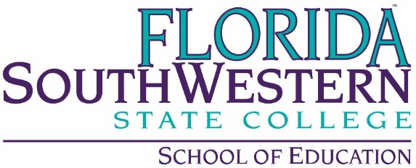
ECE Department Meeting
November 13, 2019
1:30 p.m., U-210

Present: Kathie DiLascio, David Koehler, Elizabeth Perdomo, Kelly Roy, Laura Osgood, Barbara Trube, Jenna Thompson, Joyce Rollins, Julia Kroeker

- Approval of 10/9/19 minutes: David Koehler moved to accept the minutes of the 10/9/19 ECE Department Meeting as distributed. Laura Osgood seconded the motion. The motion was carried and the minutes of the 10/9/19 ECE Department Meeting were approved as distributed and placed on Document Manager.

- Discussion of Policies for Syllabi: the group discussed the following:
  - Policies to be identified on each syllabi for work turned in late. Kelly Roy will send out the policy to be included in Spring 2020 syllabi.

- Follow-up on General Education Outcomes: Julia Kroeker suggested the group go over one or two today. CHD 1220 outcomes that are currently on the syllabus were discussed. The following suggestions were made:
  - Have a one-page table with current general education competencies
  - Course outcomes, learning outcomes, module outcomes

- Recruitment/Advising Report: David Koehler reported he is concerned AS ECE students may be taking coursework they do not need. Students do not seek him out for advising sessions.
  - Registration numbers: Kelly reported the numbers for Spring 2020 look good. We will be opening additional sections.
  - It was suggested to add “Instructor or Advisor Approval” to certain AS ECE sections to help students register for correct course. It was also suggested that students should have to take ENC 1101 and/or other general education requirements first.

- Field Placements: Elizabeth Perdomo reported that she is waiting to hear from Lee County regarding fingerprinting.

- Pop-Up Play: Julia Kroeker reported that there were 53 children registered. The event was moved to FSWC-Lee due to rain early in the day.

- Other Business: Barbara Trube would like to work on rubrics for courses she teaches.

The meeting was adjourned at 2:50 p.m.

/kdl

