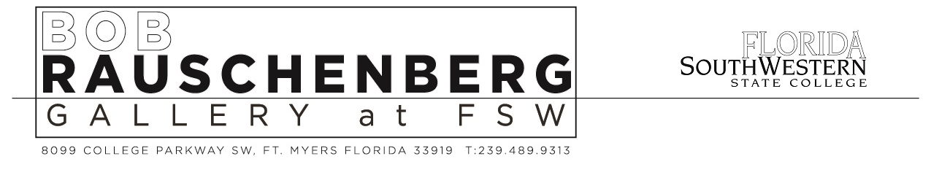

Dan CAMERON: ArtSPEAK@FSW Lecture on Arturo Vega & Pedro Friedeberg
In conjunction with EMPIRE: An Arturo Vega Retrospective exhibition.
Wednesday, December 7th at 6pm in the Bob Rauschenberg Gallery at FSW

Fort Myers, FLORIDA: In conjunction with our EMPIRE: An Arturo Vega Retrospective exhibition, the Bob Rauschenberg Gallery at Florida SouthWestern State College is pleased to announce that the internationally-renowned New York-based curator and cultural critic Dan Cameron will be presenting a “one-off” ArtSPEAK@FSW lecture on Wednesday evening, December 7th at 6pm on Arturo Vega and noted Mexican artist/designer Pedro Friedeberg.

Dan Cameron (b. 1956, New York) most recently served as Curator and has just returned from opening the 13th International Cuenca Biennial in Ecuador. As an independent curator, he has organized international exhibitions since the 1980’s for institutions including Fundación Caixa/Barcelona, Museo Nacional Centro de Arte Reina Sofía/Madrid and elsewhere. In 2003, he was the Artistic Director of the 8th Istanbul Biennial, and in 2006, Cameron was Co-curator of the 5th Taipei Biennial and founded the Biennial Prospect New Orleans, where he worked until 2011. From 2012 to 2015, Cameron was Chief Curator at the Orange County Museum of Art in Newport Beach, California. From 1995 to 2005, he was Senior Curator at the New Museum, New York, where he developed group exhibitions and individual shows dedicated to the artists David Wojnarowicz, Xu Bing, Los Carpinteros, William Kentridge, Carolee Schneemann, Christian Marclay, Doris Salcedo, José Antonio Hernández Diez and others. Over the last four decades, Cameron has published hundreds of texts in art books, exhibition catalogues and major magazines, and has given countless lectures at museums and universities around the world.

According to Dan Cameron, “I have been thinking about Arturo Vega’s relationship to Pedro Friedeberg and the small but by all reports amazing psychedelic scene in Mexico City in the late 1960’s/early 1970’s.” As his ArtSPEAK@FSW lecture will illustrate, “Friedeberg is the closest Arturo had to an artistic master, and the dialogue between their oeuvres is pretty amazing.”

More about us: The Bob Rauschenberg Gallery was founded as The Gallery of Fine Art in 1979 on the Lee County campus of Florida SouthWestern State College/FSW (then Edison Community College). On June 4th 2004 the Gallery of Fine Art was renamed the Bob Rauschenberg Gallery, to honor and commemorate our long time association and friendship with the artist. Over more than three decades until his death, the Gallery worked closely with Rauschenberg to present world premiere exhibitions including multiple installations of the ¼ Mile or Two Furlong Piece. The artist insisted on naming the space the Bob Rauschenberg Gallery (versus the “Robert Rauschenberg Gallery”) as it was consistent with the intimate, informal relationship he maintained with both our local Southwest Florida community and FSW.

This event is open to the public, free of charge.

For additional information, please contact us at:
Tel: (239) 489-9313
Web: www.RauschenbergGallery.com

This presentation is sponsored in part by the Department of State, Division of Cultural Affairs, the Florida Council of Arts and Culture and the State of Florida.

