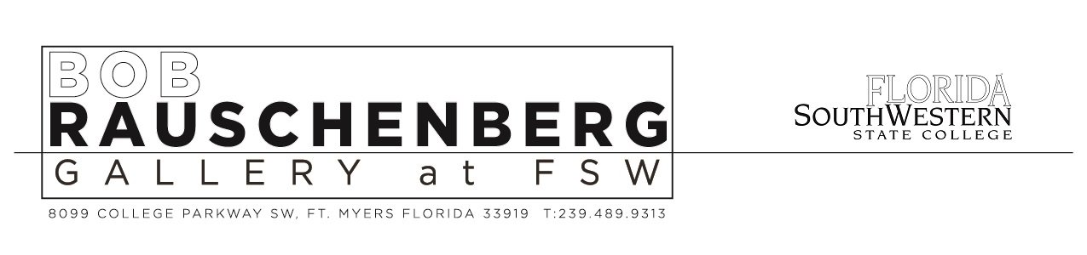
Florida SouthWestern State College

Artwork Loan Agreement

Period of Loan: to

Purpose of loan:

Exhibition Period: to Exhibition Location:

Artist’s name:
Title of work:
Date of work:
Medium:
Dimensions: H: W: D:
Approx. weight: lbs.
Value of work: $

If more than one work is being loaned, attach list of artwork with the above listed
Information listed for each piece of work.

Name of Lender:
Address of Lender:
Lender’s telephone number: Email:
Credit Line:

Photographs provided: ☐ Yes ☐ No Permission to reproduce photos: ☐ Yes ☐ No
Contact name and address for copyright clearance:
Arrival date of shipment:

Insurance: artwork to be insured by FSW: ☐ Yes ☐ No
If yes, what is total value of the loaned artwork:

If no, name and policy number of Lender’s insurance carrier:
Name of person(s) doing condition check upon arrival and departure:

See following pages for Loan Conditions
Florida SouthWestern State College
LOAN CONDITIONS

1. Under the terms of this agreement, the District Board of Trustees, Florida SouthWestern State College, FL (“FSW or College”) will exercise the same care in respect to all artwork on loan as it does in the safekeeping of its own property.

2. Objects lent to College for exhibition or extended loan shall remain in its possession for the time specified in the loan Agreement. Loans will be returned only to the Owner or Lender, or to his or her authorized agent or representative. The College retains the right to determine when, if, and for how long objects borrowed will be exhibited and retains the right to cancel the loan upon reasonable notice to the Lender.

3. Objects lent to the FSW will be insured by the College at the written valuation provided by the Lender subject to the provisions of paragraph four below. However, the College and/or its insurer reserve the right to substantiate the value of any artwork that is damaged prior to settling a claim with the owner of the art. This insurance contains the usual exclusions for loss or damage due to war, invasion, hostility or war-like action, insurrection or civil commotion, confiscation by public authority for risk of contraband or illegal transportation or trade, seizure or destruction under quarantine or customs regulations, pollutants, nuclear reaction, nuclear radiation, radioactive contamination, wear and tear, gradual deterioration, repair/restoration, inherent vice, etc. The Lender agrees that, in the event of damage, recovery shall be limited to such amounts, if any, as may be paid by the insurer, hereby releasing the District Board of Trustees, Florida SouthWestern State College, FL, its officers, employees and agents from any liability for any and all claims arising out of such loss or damage.

4. If the Lender elects to insure the objects on loan to FSW with his or her fine arts insurance, the College accepts no responsibility and Lender agrees to waive and release District Board of Trustees, Florida SouthWestern State College, FL, its officers, agents, employees from any claim loss or for damage to artwork, except in cases involving negligence by the College and its employees and agents. Prior to shipping, the College must be supplied with a certificate of insurance naming the District Board of Trustees, Florida SouthWestern State College, FL as an additional insured. If insurance is waived by the lender, the Lender agrees to release and hold harmless the College from any liability for damages to or loss of the loan property.

5. Objects will be returned only to the Lender of record or to a location mutually agreed upon in writing by the College and the Lender of record. If legal ownership of the item(s) shall change during the period of the loan, whether by reason of death, sale, insolvency, gift or otherwise, the new owner may, prior to its return, be required to establish his or her legal right to receive the item(s) by proof satisfactory to College.

6. Attributions, dates and other information shown on the face of this loan agreement are as given by the Lender. Any valuations shown are those stated by the Lender and are not to be considered as appraisals by College. If Lender fails to indicate a value, FSW may set a value for the purposes of this agreement which FSW believes to be an accurate estimate of the value. The value set by College shall not be considered an appraisal. The fact that an object has been in the College's custody shall not indicate any endorsement by the College.

7. In the event that any item(s) is offered as a gift to the FSW, it is understood that unless the College has been notified in writing to the contrary, the gift is outright and unconditional.

8. Unless Lender has indicated to the contrary on page one, except for photographs loaned to FSW, Lender hereby grants to FSW right to photograph, sketch, and/or reproduce the fine art(s) for the publicity purposes in connection with the exhibition only. In addition, unless indicated to the contrary, College may make slides of the fine art(s) for educational purposes only. No slides or photographs of fine art(s) will be used or made available for commercial use.

9. The Lender certifies that the objects lent are in such condition as to withstand ordinary strains of packing and transportation and handling. A written report of the condition of objects prior to shipment must be sent by the Lender to the College. Otherwise, it shall be deemed to be received in the same condition as when leaving the Lender’s possession. Condition records will be made at the College upon arrival and departure.

10. The College bears the risk of loss of the artwork in transit, but only if the artwork is professionally packed i.e. adequately and securely packed by professional packers in such a manner as to withstand the normal hazards associated with such transits. If not, then the Lender bears the risk of loss in transit. Any special instructions for unpacking and repacking shall be included. Objects will be returned in the same or similar manner as received.

11. College accepts this loan with the understanding that the Lender has full authority to make the same. In receiving or surrendering imported objects, the College requires that the Lender comply with all governmental regulations. If the Lender has knowledge of special conditions governing the item(s), such as copyrights, lien, etc., he or she shall inform the College accordingly.

12. If the College’s efforts to return the objects within a reasonable period following the termination of the loan are unsuccessful, then the objects will be maintained at the Lender’s risk and expense for a maximum of 180 days. If after 180 days the objects have not been claimed, then and in consideration for maintenance and safeguarding, the Lender/Owner shall be deemed to have made the objects an unrestricted gift to the College.

13. This Agreement contains the entire understanding between the parties with respect to the exhibition of the artwork(s) and may only be modified by a written document signed by both parties hereto. This Agreement shall be interpreted in accordance with the laws of the State of Florida.

I have read the Loan Conditions and accept them. This loan agreement cannot be altered, changed, waived or otherwise affected except by written consent from the District Board of Trustees, Florida SouthWestern State College.

Signed: ______________________________________ Date: __________________ Lender or authorized agent

Signed: ______________________________________ Date: __________________
Dr. Gina Doeble, CPA, Senior Vice President/Chief Operating Officer
District Board of Trustees, Florida SouthWestern State College

