Academic Calendar Committee
Minutes
April 16th, 2021
Attendees: Anthony Valenti, Sabine Eggleston, Julissa G. Roland, Kelsea R. Livingstone, Brenda Knight, Danielle Orlovic, Bonnie Lawler, April Fleming, Martin McClinton
Excused: Susan C. Bronstein, Martin Tawil
- Overview of Academic Year
Several options for the 2022-23 were presented. The Committee recommended:
Fall 2022 Faculty workdays: 8/15/2022 – 12/15/2022
Spring 2023 Faculty workdays: 1/5/2023 – 5/5/2023
Summer 2023 Semester days: 5/15/2023 – 8/5/2023
(possible Fall 2023 Faculty workdays: 8/14/2023 – 12/15/2023)

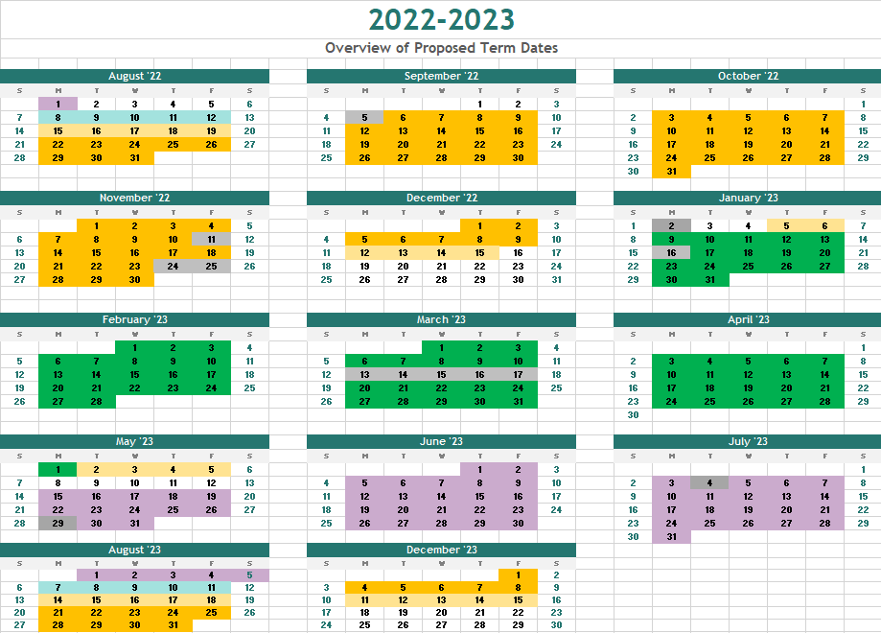

- Fall 2022 Semester. The following dates were discussed and recommended
Fall Semester | Full Term | Session A | Session B
First Faculty Workday | 8/15/2022
Last Faculty Workday | 12/15/2022
First Day of Class | 8/22/2022 | 8/22/2022 | 10/13/2022
Last Day of Class | 12/3/2022 | 10/6/2022 | 12/3/2022
First Day of Exams | 12/5/2022
Last Day of Exams | 12/10/2022
Holiday 1 | 9/5/2022 | 9/5/2022 | 1/0/1900
Holiday 2 | 11/11/2022 | 1/0/1900 | 11/11/2022
Holiday 3 | 11/24/2022 | 1/0/1900 | 11/24/2022
Holiday 4 | 11/25/2022 | 1/0/1900 | 11/25/2022
Holiday 5 | 11/26/2022 | 1/0/1900 | 11/26/2022
Holiday 5 | 11/27/2022 | 1/0/1900 | 11/27/2022
Study Day | 9/6/2022 | 9/6/2022 | 1/0/1900
Study Day | 11/23/2022 | 1/0/1900 | 11/23/2022
Total Faculty Workdays | 85
Class Session by Day
Fall Semester | Full Term | Session A | Session B
Mondays | 14 | 6 | 7
Tuesdays | 14 | 6 | 7
Wednesdays | 14 | 7 | 6
Thursdays | 14 | 7 | 7
Fridays | 13 | 6 | 6
Saturdays | 14 | 6 | 7
Sundays | 13 | 6 | 6

- Spring 2023. The following dates were discussed and recommended. Spring break is suggested for the week of March 13
Spring Semester | Full Term | Session A | Session B
First Faculty Workday | 1/5/2023
Last Faculty Workday | 5/5/2023
First Day of Class | 1/9/2023 | 1/9/2023 | 3/1/2023
Last Day of Class | 4/24/2023 | 2/23/2023 | 4/24/2023
First Day of Exams | 4/25/2023
Last Day of Exams | 5/1/2023
Holiday 1 | 1/16/2023 | 1/16/2023 | 1/0/1900
Holiday 2 | 3/13/2023 | 1/0/1900 | 3/13/2023
Holiday 3 | 3/14/2023 | 1/0/1900 | 3/14/2023
Holiday 4 | 3/15/2023 | 1/0/1900 | 3/15/2023
Holiday 5 | 3/16/2023 | 1/0/1900 | 3/16/2023
Holiday 5 | 3/17/2023 | 1/0/1900 | 3/17/2023
Holiday 7 | 3/18/2023 | 1/0/1900 | 3/18/2023
Holiday 8 | 3/19/2023 | 1/0/1900 | 3/19/2023
Total Faculty Workdays | 81
Spring Semester | Full Term | Session A | Session B
Mondays | 14 | 6 | 7
Tuesdays | 14 | 7 | 6
Wednesdays | 14 | 7 | 7
Thursdays | 14 | 7 | 7
Fridays | 14 | 6 | 7
Saturdays | 14 | 6 | 7
Sundays | 14 | 6 | 7

- Summer 2023
Summer Semester | Full Term | Session A | Session B
First Faculty Workday
Last Faculty Workday
First Day of Class | 5/15/2023 | 5/15/2023 | 6/27/2023
Last Day of Class | 8/5/2023 | 6/21/2023 | 8/5/2023
First Day of Exams
Last Day of Exams
Holiday 1 | 5/29/2023 | 5/29/2023 | 1/0/1900
Holiday 2 | 7/4/2023 | 1/0/1900 | 7/4/2023
Holiday 3 |  | 1/0/1900 | 1/0/1900
Summer Semester | Full Term | Session A | Session B
Mondays | 11 | 5 | 5
Tuesdays | 11 | 6 | 5
Wednesdays | 12 | 6 | 6
Thursdays | 12 | 5 | 6
Fridays | 12 | 5 | 6
Saturdays | 12 | 5 | 6
Sundays | 11 | 5 | 5

- The Registrar’s office, Academic Affairs and HR will move forward on building out the Calendar using these dates and present to Committee for final recommendations in the Fall 2021.

