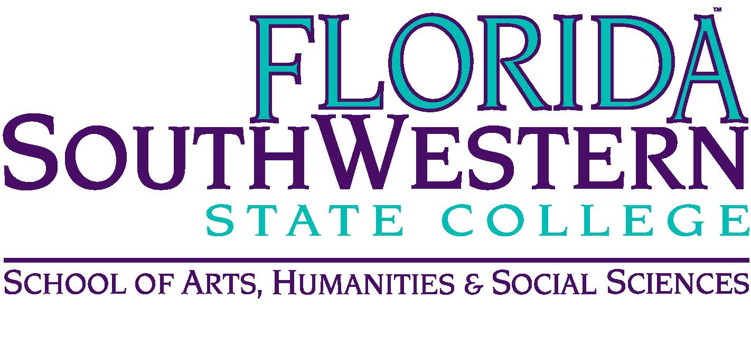
Department of Humanities and Fine Arts
Meeting Minutes
Date: April 13, 2018, 2:00 p.m.
Location: Edison/Lee campus
Chair: Dana Roes
Minutes: Michael McGowan

 | Present | Absent | Excused
Brown | X
Chase, S | X
Chase, W | X
Doiron | X
Hoover | X
Lublink |  |  | X
McGowan | X
Mompoint |  | X
Pritchett | X
Roes | X
Sutter | X
Smith | X
Swanson | X
Molloy | X
O’Neil | X
Guests

- Opening
  - Call to Order: 2:05 p.m.
  - Attendance taken
  - Approved Minutes from February 2018

- Information items
  - Upcoming Events:
    - April 6-25: “Am I Next” art exhibition
    - April 16: Percussion Studio Recital (7 pm, L-126)
    - April 17: Concert Band Concert (7:30 pm, Barbara Mann)
    - April 18: FSW Faculty Recital (3 pm, J-117/118)
    - April 18: Symposium (Russell): “Sapience” (3-5 pm)
    - April 20: Assessment (Elijah): meetings with J. v. Gaalen (see Elijah’s schedule for when we need to show up)
    - April 20: Digital Pedagogy Open House (9:30-11:30)
    - April 21-2: Fine Arts Scholarship Auditions (L-126)
    - April 24: Jazz Ensemble Concert (7:30 pm, Barbara Mann)
  - Other updates:
    - Website: Steve: www.schase01.wixsite.com/arts-fsw
    - Faculty Lines: we’re getting another Lee Humanities full time professor, and we’re getting a Digital Media faculty member and a Mac-lab.
    - Title IX Update – check if we’ve done the updated training
    - FERPA and ADA – coming out in the fall, look for it then
    - Canvas
    - Theater stuff: Stuart says this show was popular/accessible, and they set a record on box office ($3500).
    - Toga party went really well
    - Textbooks that have been changed for fall 2018: HUM 2020, PHI 2010, REL 2300
- Discussion items
  - Hoovey Awards: discussion about whether to sustain the Hoovey Awards. Dale said there’s money available. Send nominations to Dale, who needs student’s name, reason for the award, and book suggestion (earlier the better). Date suggested: 4/25 at 3:30 pm in the Library. Dr. Teed said we have $500.
  - Next year’s goals: none mentioned
  - Up for Continuing Contract next year: Ron, Steve, Elijah
- Next Meeting: next fall!

ACTION INTEMS:
- Dana needs Summer 2018 Syllabi

