Can love between two people ever be an abomination?

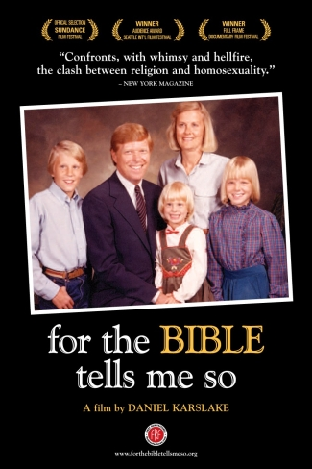
The Rush Library & the Multicultural Task Force present a

FREE SCREENING

of the award winning documentary film

for the BIBLE tells me so

WHEN: Friday, January 21st
@ 6PM

WHERE: the Rush Library Auditorium

A Rush Library Film Series Event

