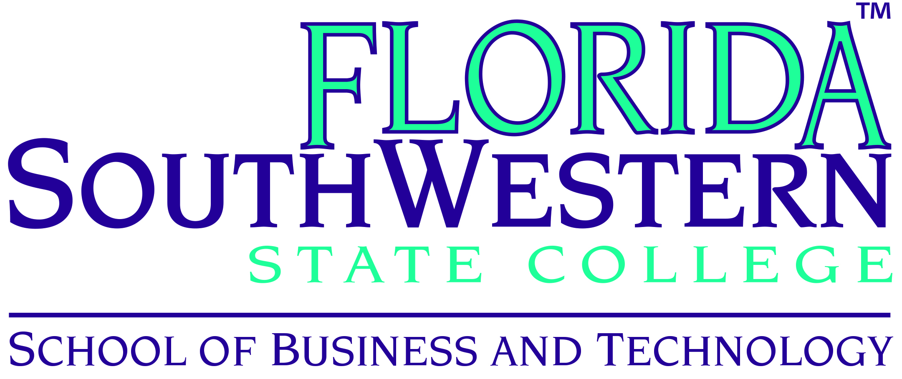

Report to Advisory Steering Committee Members
School of Business and Technology Advisory Steering Committee Meeting
October 29, 2015 at 5:30 PM on Thomas Edison Campus U 102

I want to thank you commitment to the School of Business Technology (SoBT) and your willingness to serve on the SoBT Advisory Steering Committee. From all reports, the meeting was a success and its activities established a good foundation for the new direction we hope to take workforce advisory input in the future. Please see in this report a narrative of our discussions and our anticipated outcomes which we soon will meet.

Meeting Narrative

Welcome and Self-Introductions:
Dr. John Meyer, Dean of the School of Business and Technology welcomed attendees with self-introductions around. He gave on overview and orientation of the proposed new direction for Advisory Committee activities, membership, and the guidance the Committee provides, with the Committee first providing strategic direction and with more focused industry input garnered afterwards.

School of Business and Technology Overview:
Dr. Meyer explained that this semester the Coordinators of Retention and Student Success have been presenting the programs to first year students enrolled in SLS 1515, a college skills class required of all FSW first time in college students. In the School of Business and Technology there are different ways students can earn college credit. One is through pursuing College Credit Certificates (CCC) for which students are not required to test or complete general education courses. CCC courses are embedded in their related Associate of Science (AS) degree and count as required credits to that degree. The CCC prepares students for a workforce credential and enables the student to transition to the degree. The AS degree is a workforce specific degree and the Associate of Arts (AA) degree transfers to a bachelor’s degree. In 2013, AS degrees were enabled to articulate into bachelor’s degrees as well.

The Bachelor of Applied Science (BAS) in Supervision and Management Program leads enrollment in bachelor’s degrees offered at FSW. The program participates in Global Business Strategy Simulation (Glo-bus) competition. FSW student groups consistently are in the top position compared to other colleges throughout the world. The BAS in Public Safety Administration prepares students for workplace advancement in the Public Safety field, and we have a one-of-a-kind agreement with Florida State University to articulate into their Master’s in Criminal Justice Studies.

In order to better respond to workforce demand, SoBT has proposed a Bachelor’s degree in Information Systems Technology and four areas of concentration in Supervision and Management program. The areas of focus include Accounting, Entrepreneurship, Health Services Administration, and Retail Management and Marketing. Each focus area includes four electives.

SoBT has new CCCs including Information Technology Support Specialist and Intermodal Freight Transportation. The college is exploring the possibility of an airframe and power plant program based at Punta Gorda Airport. Western Michigan University, the number two pilot training program in the country, is exploring pilot training at Punta Gorda Airport which, in turn, will lead into the need for airplane mechanics. SoBT also has plans to begin an Engineering Technology Support Specialist certificate using Trade Adjustment Assistance Community College and Career Training Grant Program (TAACCCT) funds if approved. The demand for this position has been studied and analyzed in the five county areas included in FSW’s region. The purpose is to establish centers of excellence and to drive programs to the campuses.

Additionally, Adrian Kerr, Director of Corporate Training at FSW, leads the state in quick response training by a factor of 2 to 1. FSW has secured 20% of the State of Florida’s annual allotment in this area. Adrian has also secured $600,000 for Cheney Brothers quick response training, the highest per capita training grant for Southwest Florida.

Purpose of Steering Committee:
The School of Business and Technology is required by state statute to have an advisory steering committee composed of members of industry. Advisory committees are useful for maintaining macro guidance and to assist FSW in integrating into the community.

Steering Committee Goals and Anticipated Outcomes:
Dr. Meyer asked why an agency would want to work with FSW on the advisory steering committee. Comments included that being involved on the advisory committee may bring an economic return by adding qualified employees and would have a positive result of involving communication between industry and education. One suggestion was that in order to increase industry participation on the advisory committee, FSW could use marketing for more exposure. People like to be involved in success stories. They are more likely to join to be included in future accomplishments. Another suggestion was that FSW needs to demonstrate how personal involvement would help.

A discussion followed regarding internships. Dr. Meyer commented that the Florida State Frameworks does not include internships in the student learning outcomes. The School of Business and Technology would like to add an internship as a final course to the curriculum of programs. The Paralegal Studies Program includes an internship course which fits the framework. A suggestion was made to include a special project instead of an internship in which the company could get exposure to the student’s skills. The School of Business and Technology’s core mission is education but also has a goal to provide quick training through college credit certificates. There is a large need for the workforce to have skills and certificates produce what the workforce needs. Through internships, employers will provide feedback on how the education has prepared the students.

Input was given that internships can bridge the gap between the workforce and education and that it is possible to introduce internships as alternative assignments. As mentioned before, the Florida State Frameworks for AS degrees are so prescribed that there is no room to add anything else. The exploration of externships or volunteering was introduced. Through a project over several weeks that the student could be graded on could be marketed internally and would give the student exposure. Student volunteers could explore different areas of an agency or company to see what they are interested in.

The suggestion for the normal trajectory of internships to occur at the end of the degree program was made. Midrange may work out as well because students would already have the basics. In one committee member’s experience with interns, the staff of the agency has benefited as much as the student. The agency could end up hiring the student to help pay for their education. Another committee member commented that through donations they were able to embed interns in companies last summer. Dollars could be redirected to match workforce need. Internships benefit the students, economic workforce, institution, companies, and the community. Nonprofits could also be an option as well as companies.

Suggestions for Future Meetings:
- Material in advance
- Communication in between meetings
- Bring suggestions about how to supervise interns
- Think about what agencies or companies should expect in an internship program

Adjourn:
Dr. Meyer thanked all members for participating and the meeting was adjourned.

Again, thank you for your support. We will be in touch soon.

Regards,

Dr. John Meyer,
Dean, Business and Technology
Florida SouthWestern State College

