Learning Assessment Committee Meeting
2/3/2017
12:00 – 1:00
AA-177 (Lee Campus); E-105 (Charlotte Campus);
G-109 (Collier Campus)

Members Present: Eric Seelau, Amy Trogan , Joe Van Gaalen, Marius Coman, Caroline Seefchak, Megan Just, Barbara Miley, Jane Charles, Richard Worch, Fernando Mayoral, Allison Studer, Lisa McGarity, Colleen Moore, Tom Donaldson, Sarah Lublink, John Connell, Elijah Pritchett, Jennifer Patterson, Eric Fay, Eileen DeLuca, Marty Ambrose, Katie Paschall, Rebecca, Harris

Members Absent: Margaret Kruger

- A. Trogan called meeting to order (12:02pm)
- A. Trogan presented Dec. 2, 2016 meeting minutes. J. Connell motioned to approve minutes. C. Seefchak seconded the motion.
- J. van Gaalen presented the latest information on Course-level assessment.
  - 95 Course level assessments under analysis from Fall 2016; this is up 61% from Fall 2015, where 59 course level assessments were completed
  - Estimated completion data for course level studies: Week of March 20, 2017
  - Speech & Foreign Languages, Social Sciences, and Academic Success are complete as of Feb 1, 2017. Other programs and departments are in various stages of completion.
  - New reporting outreach emails include highlight features
  - J. van Gaalen reminded LACs to spread the word to departments to let the Office of Academic Assessment know if details of SLOs so that they can be reported with data in assessment reports for clarity and convenience.
- J. van Gaalen presented the latest information on GenEd assessment.
  - QR Calibration Meeting: Feb. 22, 1pm
    - Lee: U-202B, Collier: M-120A
  - CT Calibration Meeting: Feb. 22, 2pm
    - Lee: U-202B, Collier: M-120A
  - Alternative Calibration Meetings for those with schedule conflicts
    - Feb. 22, 9am & Feb. 23, 2pm
  - Packets will be provided at this time or will be sent in advance.
  - E. DeLuca asked if enough scorers were ready for the study. J. van Gaalen reported in the affirmative.
- A. Trogan noted data holiday newsletter was a big hit and very well received.
- A. Trogan reported content is coming together for the February newsletter. Newsletter will promote “Developing Effective Research Assignment Guidelines” upcoming workshop as well as feature two of the newer members to the LAC that have not yet been highlighted. A. Trogan reported that Newsletter Subcommittee is planning a full newsletter for February and April and mini-newsletters for March and May.
- A. Trogan reported the latest plan is to set up a discussion form on the LAC Canvas page to allow non-Subcommittee people to see what is currently in the planning stages for the next newsletter.
  - R. Harris suggested “transdisciplinary” be featured as a term of focus for the upcoming newsletter to highlight its use in the newest General Education Competencies.
- A. Trogan reported that plans are moving along in the Assessment Workshop (Assessment 101 asynchronous). Participants are making progress and there are some completers.
  - E. DeLuca suggested a pacing chart of some kind (J. Charles suggested checkpoints). E. DeLuca suggested J van Gaalen’s office could put together some kind of timeline calculated figure.
- A. Trogan asked about the new “Data-licious” workshop facilitated by J. van Gaalen. J. van Gaalen reported that while attendance was low it was well received and created thoughtful and thorough discussion.
- A. Trogan reminded committee regarding upcoming professional development:
  - Feb. 16, 2pm: Developing Effective Research Assignment Guidelines featuring Heron, Wisely, Jester, and Trogan; E. DeLuca reminded LAC that this workshop was spawned from the first year of the new GenEd study model (AY 2014-2015).
  - New Faculty Seminar today (Feb. 3, 2017). A. Trogan reported she will push the formative/summative assessment notions with new faculty.
- A. Trogan presented the Assessment Certification proposal where a series of workshops could be offered yearly and, much like the model of the Cornerstone Modules, act in unison to create a professional development track modeled on assessment. Track will include:
  - Assessment 101
  - Rubrics 101
  - Developing Effective Research Assignment Guidelines
  - It’s Data-licious: Tasty Data-driven Tidbits to Improve Student Writing and Presentations
  - Connecting the Classroom to Careers
  - Formative/Summative Assessment
  - Introduction to Effectiveness and Compliance Assist at FSW
  - General Education Feedback
- A. Trogan reported that the above track would be followed as shown below in the figure:
  - 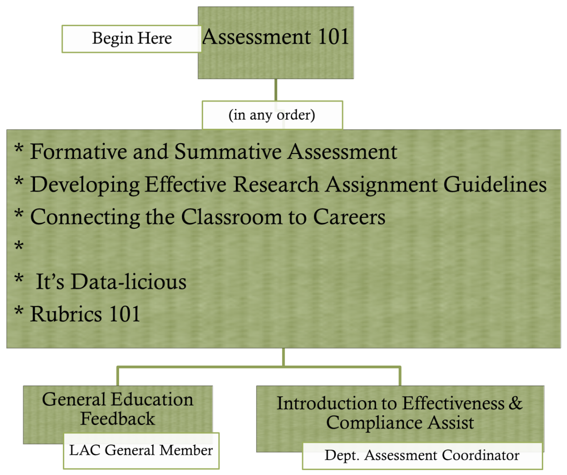
  - In this vein, E. DeLuca suggested placing completers names on the Assessment webpage
  - R. Harris suggested a “who to talk to” page on the assessment page with regarding to completers (e.g. “If you want to be…” and provide links to completers names and what their focus was)
  - E. DeLuca suggested a book to be awarded to completers of training
- In new business, E. DeLuca suggested the beginning of mapping acquisition of the General Education Competencies through any example program at FSW to see what competencies and how often students encounter them in a given program. E. DeLuca also suggested LAC members begin thinking on rubrics and the potential for multiple rubrics based on types of assignments seen in General Education assessment studies to be incorporated in the first assessment plan of the new competencies.

R. Harris motioned to adjourn. S. Lublink seconded.

