Academic Calendar Committee
Minutes
September 19th, 2022
Attendees: Susan C. Bronstein; Anthony Valenti; Sabine Eggleston; Julissa G. Roland; Joycellen Rollins; Danielle Chandonnet; Bonnie Lawler; April Fleming; Amanda E. Sterk
Absent: Brenda Knight; Martin Tawil; April M. Falso
- Overview of Academic Year
Based on the AY2022-23 calendar, the 2023-24 calendar was presented. The Committee recommended:
Fall 2023 Faculty workdays, 8/14/2023 – 12/14/2023; semester days, 8/21/23 – 12/2/23; finals 12/4/23 – 12/9/23
Spring 2024 Faculty workdays, 1/4/2024 – 5/3/2024; semester days, 1/8/24 – 4/22/24; finals 4/23/24 – 4/29/24
Summer 2024 Semester days, 5/13/2024 – 8/3/2024

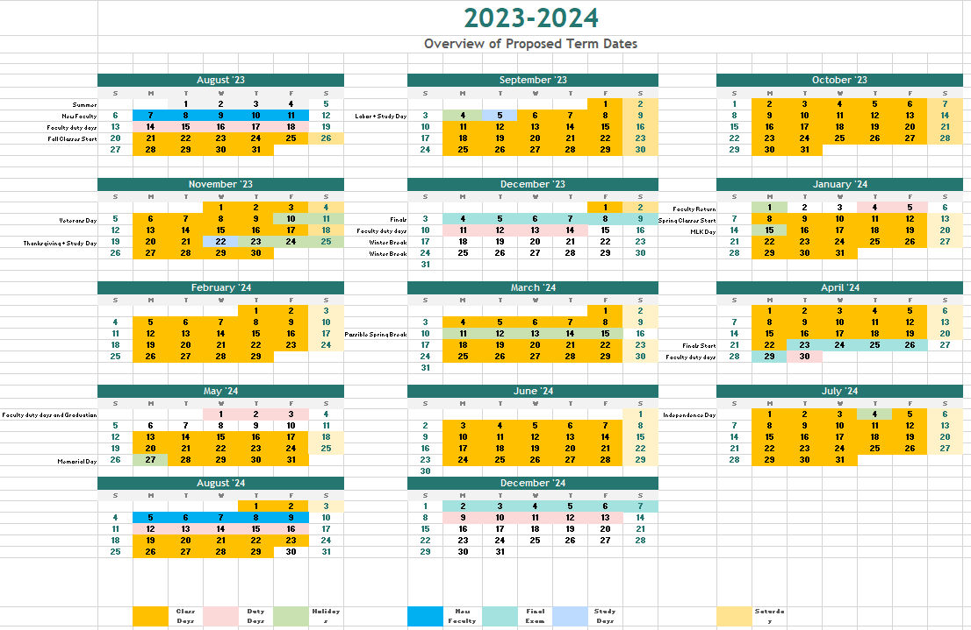

- Fall 2023 Semester. The following dates were discussed and recommended.
August 16th is recommended date for Convocation.
There was discussion of the timing of the Tuesday Study Day. One faculty member had requested a date later in the semester when it would be advantages for midterm exams to have a study day. The representative from the School of Education noted that may of their classes met Session A and Session B, so the Tuesday between session would not be helpful to those students. Dr. McClinton asked that this item be further discussed with faculty through faculty senate to see if there was a desire for a later Tuesday study day; if there was, this should be considered for the 2024-25 AY.
Fall Semester | Full Term | Session A | Session B
First Faculty Workday | 8/14/2023
Last Faculty Workday | 12/14/2023
First Day of Class | 8/21/2023 | 8/21/2023 | 10/12/2023
Last Day of Class | 12/2/2023 | 10/5/2023 | 12/2/2023
First Day of Exams | 12/4/2023 | Last Day of class | Last Day of class
Last Day of Exams | 12/9/2023 | Last Day of class | Last Day of class
Holiday | 9/4/2023 | 9/4/2023 | 1/0/1900
Holiday | 11/10/2023 | 1/0/1900 | 11/10/2023
Holiday | 11/11/2023 | 1/0/1900 | 11/11/2023
Holiday | 11/23/2033 |  | 11/23/2033
Holiday | 11/24/2023 | 1/0/1900 | 11/24/2023
Holiday | 11/25/2023 | 1/0/1900 | 11/25/2023
Study Day | 9/5/2023 | 9/5/2023 | 1/0/1900
Study Day | 11/22/2023 | 1/0/1900 | 11/22/2023
Total Faculty Work Days | 85

- Spring 2024. The following dates were discussed and recommended. Spring break is suggested for the week of March 11.
May 3rd is recommended for Commencement
The date for State of the College is to be determined
Spring Semester | Full Term | Session A | Session B
First Faculty Workday | 1/4/2024
Last Faculty Workday | 5/3/2024
First Day of Class | 1/8/2024 | 1/8/2024 | 2/29/2024
Last Day of Class | 4/22/2024 | 2/22/2024 | 4/22/2024
First Day of Exams | 4/23/2024 | Last Day of class | Last Day of class
Last Day of Exams | 4/29/2024 | Last Day of class | Last Day of class
Holiday | 1/15/2024 | 1/15/2024 | 1/0/1900
Holiday | 3/11/2024 | 1/0/1900 | 3/11/2024
Holiday | 3/12/2024 | 1/0/1900 | 3/12/2024
Holiday | 3/13/2024 | 1/0/1900 | 3/13/2024
Holiday | 3/14/2024 | 1/0/1900 | 3/14/2024
Holiday | 3/15/2024 | 1/0/1900 | 3/15/2024
Total Faculty Work Days | 81

- Summer 2024
Summer Semester | Full Term | Session A | Session B
First Day of Class | 5/13/2024 | 5/13/2024 | 6/25/2024
Last Day of Class | 8/3/2024 | 6/19/2024 | 8/3/2024
Holiday 1 | 5/27/2024 | 5/27/2024 | 1/0/1900
Holiday 2 | 7/4/2024 | 1/0/1900 | 7/4/2024

- The Registrar’s office, Academic Affairs and HR will move forward on building out the Calendar using these dates and preparing the document for the Board of Trustees.

