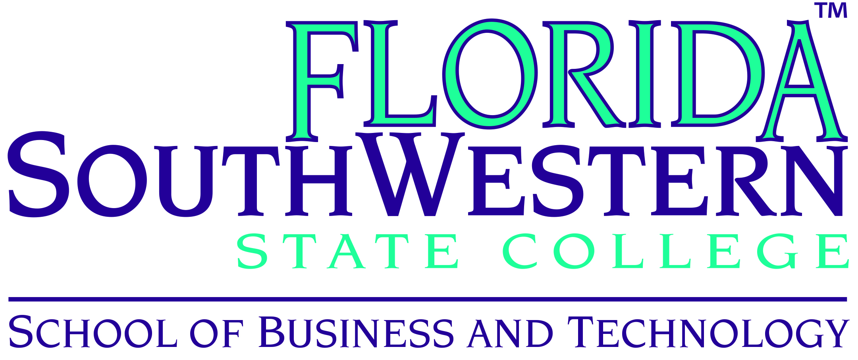

School of Business and Technology Department Meeting
August 18, 2015 at 1:30 PM on Thomas Edison Campus J 103

 | Present | Absent | Excused
Staff
Jill De Valk | X
Lisa Dick | X
Kelly Eakins | X
Mark Morgan | X
Al Nault | X
Charlene Wolfe | X
Michelle Zamniak | X
Other Staff
Jackie Beard | X
Adrian Kerr | X
Tammy Pagano | X
Adjunct Faculty
Jim Babcock | X
Lincoln Barton | X
Bernardine Carter | X
Scott Hammond | X
Linda Hanwacker | X
Karen McKenzie | X
Guests
William Shuluk
Jane Charles
Dr. Joseph Van Gaalen
Allison Studer
George Manning
Wendy Athens

 | Present | Absent | Excused
Administration
Dr. John Meyer, Dean | X
Dr. Thomas Rath, Associate Dean | X
Program Coordinators
Andrew Blitz | X
Mary Conwell | X
David Hoffman | X
Dr. Richard Worch | X
Faculty
Leroy Bugger | X
Vincent Butler | X
Alisa Callahan | X
Michael Engdahl | X
Dennis Fahey | X
Matthew Hoffman | X
Deborah Johnson | X
Tim Lucas | X
Michael Nisson | X
James Stewart | X
William VanGlabek | X

Welcome:
The meeting convened at 1:30 PM with a welcome from Dr. John Meyer.

Dr. Meyer discussed the initiative of adding an airframe or airplane mechanic program based on the Charlotte Campus which is in close proximity to the Punta Gorda Airport. Western Michigan University is exploring the possibility of moving their airline pilot program to Punta Gorda Airport due to Florida’s climate. The airplane mechanics program is a post-secondary adult technology and would have a seamless articulation to an associate’s degree with 24 credit hours going towards the degree.

Regarding the Perkins Grant for 2015-16, the Workforce Innovation & Opportunity Act (WIOA) replaced the Workforce Investment Act of 1998 (WIA). The application has been submitted with an award of approximately $555,000. The funding for the Perkins Grant will not be distributed until a new form from the Federal Department of Education has been submitted to the state. The form is not available yet so requests that professors have submitted for the 2015-16 Academic Year will be delayed until further direction from the FLDOE.

The TAACCCT Grant/XCEL-IT Program is in mid-cycle and Coordinator Tammy Pagano and Jackie Beard have ramped up efforts. A budget modification of approximately $400,000 is pending with the addition of an Engineering Technology Support Specialist CCC.

Other Business: The windows in K Building have been replaced during the summer. Dr. Douglas Nay has retired and moved to New Jersey. Professor Al Suleh is working for private industry but has remained as an adjunct professor.

Library Updates:
Dr. Thomas Rath introduced two of the FSW librarians, Bill Shuluk and Jane Charles. Bill discussed the resources available for helping students with their research. Many faculty members are now including directives in their syllabi to use library databases in their assignments. Single point authentication of library resources is now available in the CANVAS shells. Bill wanted to remind everyone to contact the library for research instruction for classes. Dr. Worch and Professor Fahey regularly use the librarians to assist their classes. Jane Charles mentioned that the research guides are great tools for students to use because they direct students to the best databases.

Dr. Rath also mentioned that the School of Business and Technology would like to implement open source resources for the curriculum for one course per program. He also asked if a SoBT faculty member would be available to serve on the Library Advisory Board.

Assessment Updates:
Dr. Rath introduced Dr. Joseph Van Gaalen, Director of Assessments and Allison Studer who replaced Crystal Revak. They will provide assistance with student learning outcomes and achieving the goals. Dr. VanGaalen and Allison will check assessments and provide assistance with updating rubrics, the more specific, the better. Dr. Rath mentioned that SOBT is committed that all common course assessments in CANVAS ties to student learning outcomes for a true cycle of reporting. Through the use of rubrics, data will be collected and rubrics will be re-engineered to refine results.

David Hoffman commented that the BAS in Supervision and Management students participate in the GLO Bus competition in which they compete against thousands of students throughout the world. Groups in Professor Hoffman and Professor Fanslau’s classes have regularly reached #1 in the world.

Introductions:
Dr. Rath introduced the following full-time faculty members: Dr. James Stewart who is a faculty member in Computer Science, Dr. Tim Lucas who replaces David Oliver in Business & Management, and Dr. Michael Engdahl who is a temporary full-time faculty member for Business. There is also currently an open search for a professor in computer science.

Adrian Kerr, Director of Corporate Training discussed the activities within the last year. Corporate Training provides non-credit or quick response training for companies. The state offers $10 million to companies each year which pays for 100% of training. Last year FSW ended up receiving 30% for training the following companies: Hertz, Gartner, Dreamweaver, and Cheney Brothers.

Dr. Rath mentioned that Charlene Wolfe will be retiring from FSW on August 31, 2015 after 35 years of service. Jill De Valk will replace Charlene, working with grants and providing support for Dr. Rath. Al Nault will replace Jill as an instructional assistant. Sandra Mink is the student assistant for SoBT and she is enrolled in the BAS Supervision and Management Program. Tammy Pagano is the Coordinator and Jackie Beard is the Student Enrollment Specialist for XCEL-IT.

FSW Online Updates:
George “Randy” Manning is the new Instructional Designer for SoBT and Marilyn Goby is also assisting on a part-time basis. Wendy Athens commented that SoBT faculty members have added video support in the form of lectures to the CANVAS shells in the past year.

Department Updates:
- Portal email – check CANVAS and portal email daily and respond within 24 hours
Remind students to check their email regularly
- New phone system – contact Lisa Dick if you need instructions
- Do not purchase materials on your own
- Future Accreditations – Business and Accounting – ACBSB
- FERPA – No grades via email or texting – contact students through CANVAS
- Textbook adoption for 2016-17 before winter break
- Create assessments instead of using publisher exams – can be compromised
- All instructors should be CANVAS 101 trained – contact Dr. Rath
- Faculty please report on committees you serve in Department Meetings
- Submit your Bios
- Requesting faculty portfolios to showcase as resources
- Two-year plans are available on the website
- New incomplete grade process – please contact Dr. Rath
- Do not sell any of your textbooks – if you received from the publisher, the book belongs to FSW
- Refer students to Lisa Dick or Michelle Zamniak regarding waiting lists, or getting into a class

Breakout Sessions by Program:

Business and Accounting Breakout Meeting
August 18, 2015

A regular meeting of the School of Business and Technology was called to order by Dr. Thomas Rath, Associate Dean, at 1:00 PM on the Thomas Edison Campus. Upon conclusion of the meeting, breakout sessions were held. These minutes are for the breakout session that began at 3:20 PM in J 103 for the AS Accounting, AS Business Administration, and BAS, Supervision and Management degree program.
The following members were present: Professor David Hoffman, Dr. Timothy Lucas, Professor Karen McKenzie, Professor William Van Glabek, Professor Leroy Bugger, Professor Alisa Callahan, and Dr. Michael Engdahl.
Professor Hoffman encouraged all to work with Dr. Melissa Rizzuto on portfolios.
SoBT CANVAS shell branding was discussed. Home pages should have a common look and feel and there should be consistency within course shells.
The recent CANVAS email reply issue was discussed. All issues should now be fixed.
Google Mail with the bucs.fsw.edu extension was discussed. K. Eakins will post instructions within the SoBT Community of Practice on forwarding Google mail to portal email for those affected.
Professor Hoffman announced the Glo-Bus top national ranking for Summer 2015 MAN 4915 Capstone Students. The idea of a faculty team was presented and discussed as a possibility.
APA format was discussed. Professor Hoffman met with Monica Moore, Director of Academic Support Programs (writing center) to prepare the Center for SoBT students. The need for consistency in instructor expectations for APA was further discussed. The FSW library resources webpage now links to the preferred online APA resource- The Owl at Purdue Online Writing Lab.
CANVAS master courses were discussed. There are presently no master courses for elective courses and an invitation to create these was presented to attendees.
Instructors were reminded to not roll over master courses, to not shuffle the quiz/test answers in courses with a common final, to remain consistent with assignment due dates (no late work), and to put syllabi on proper, updated forms.
Professor Hoffman gave a brief overview of the Early Alert and Student of Concern process within the portal.
Professor Hoffman called for volunteers for a proposed business club.
The concept of open source courses was discussed. Professors Bugger and Engdahl accepted the invitation to research the implementation of this for the SoBT.
The meeting adjourned at 4:18 PM.
(Minutes recorded by K. Eakins 8/18/15)

Computer Science and Drafting Program Break out meeting minutes M. Zamniak
August 18, 2015
Information Technology (Networking and Programming) Programs
Architectural Design and Construction and Civil Engineering Programs
Professor Andy Blitz, Program Coordinator
Full Time: Dr. James Stewart, Professor Vincent Butler, Professor Deborah Johnson and Dr. Tom Rath dropped in toward the end of the break out
Adjuncts: Linda Hanwacker and James Babcock
Minutes: Michelle Zamniak

Basic Computer Assessment
To document computer literacy for success in CGS 1100, possible other courses CGS 2811, and CTS 1133
Would identify the area where student may need to catch up for entry level courses
Blitz demo the government site that has the free test
Introduction of initial assessment based on Johnson’s concern with removing the prerequisite
*Vote was taken on the Northstar Digital Literacy for CGS 1100 unanimous decision from all present to add this Digital Literacy exam to CGS 1100 courses
Jackie Beard would like the link for Excel-IT snacks

Gold Standard Industry Certification Articulation Update
MZ explained the articulation process and handed out the current Certification to FSW course match for the Computer Science Faculty to review. MZ will send to all electronically and push the effort to finalize a faculty approved articulation of Gold Standard Industry certifications for the 2015-16 Academic year
Email Vote will be taken after faculty has opportunity to review

CANVAS Shells
A heated conversation was had about Babcock’s ground section of CGS 1000 and not having the appropriate materials to teach as an adjunct. He has been working with Johnson. Rath confirmed that all communication goes directly to Blitz for support. WE MUST ADOPT TEXTBOOKS EARLIER (RATH).
CGS 1000 has been re-developed by Johnson and will be discussed further at the adjunct meeting
Email sent to address Professor Babcock’s concerns by MZ to RATH and L. Dick
Dr. Rath and Professor Blitz are addressing his other concerns about text book and learning resources.

BAS Public Safety Administration, Criminal Justice,
Crime Scene, and Paralegal Studies Meeting Minutes
August 18, 2015

In Attendance: Dr. Richard Worch, Mary Conwell, Dennis Fahey, Lincoln Barton, Matt Hoffman, Mike Nisson, Bernie Carter, Albert Nault, and Mark Morgan

Two Year Plans: Faculty members would like to be involved in the process of the two year plans of the programs.

Spring 2016 Schedule: The schedule has been distributed to the full time faculty of the law and public safety programs for them to select their courses for spring. Some members expressed the opinion that full time faculty should have the majority of the workload while adjuncts fill in the gaps and night courses.

Textbook Adoption: Faculty will review current textbook adoptions in the next couple of months. Dr. Rath commented in the department meeting earlier that he wanted the textbook adoptions for 2016-17 completed before the end of the year break.

Open Source: Matt Hoffman commented that within the academic year, the Family Law course curriculum could be developed using open source materials. Also, developing paralegal courses using open source materials is a great way to eliminate the need for textbooks to help the affordability for students.

