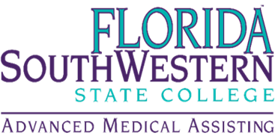
AMA Advisory Board Meeting
July 16, 2025
12:00pm – 1:00 pm
Florida SouthWestern State College
Zoom - https://fsw.zoom.us/j/83686644154?pwd=6oyaTrFvJjl0cotasYTOS0iUL1ocao.1

AGENDA TOPICS

Welcome and Introductions! Cass Allbritten
- AMA Program Overview
  - Vision & Mission
  - Goals & Objectives
  - Admission Requirements
  - Curriculum Overview
  - Certifications
  - Accreditation

- Advisory Board Roles & Responsibilities
- Closing remarks
- Questions/Comments
THANK YOU FOR YOUR SUPPORT!

