Library Advisory Board Meeting
When: 1/6/2026
Time: 1:00 pm

Attendees: Richard Hodges, Peter Van Leeuwen, Steven Kolberg, Laura Price, Malvina Herman, William Shuluk, Thomas Rath, Victoria SanFilippo, Krista Biasella, Rozalind Jester, Jane Charles, Christy Gilfert, Heather Stahl, Hope Goodwin, Mary Myers, Martin McClinton, April Fleming, Rebecca Harris, Anthony Valenti, Brian Page

Library Services:
Dr. Hodges:
-New Resources
-Mango Languages (allows people to enroll in a course or just lessons for learning new languages)
Victoria:
-promoted at national education fair
-similar to Duolingo, good for students
-app available for use
-students can establish their account through library web page and start using
Dr. Hodges:
-Prep Step
-includes nursing, workforce and many other testing materials

eReserves:
-started as result of pandemic
-makes sense to have digitized textbooks so students will have access whenever needed
-students can check out these resources and use for 3 hours at a time
-128 books in collection
-196 checkouts in Fall 2025
-consistently reaching out to faculty for most current editions that the library scans in house
-requested the members of board reach out to the professors about this resource

Collection Management:
-Print books not being checked out much
-large decline
-library is focusing more on acquiring eBooks instead of print as they are the preferred format for students

Ask-A-Librarian (Chat Service)
-connecting FSW students with FSW librarians
-chart shows Wednesdays are the busiest
-12pm to 1pm is the busiest hour
-October busiest month
-students can use this service with any device
-hours for chat are 10am-7pm Mon-Thurs

Library Liaisons:
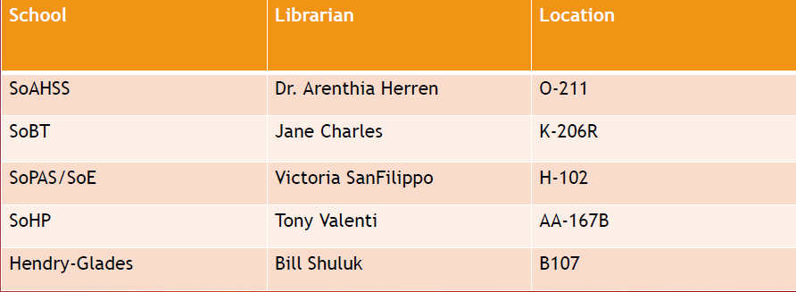

Embedded Librarian (IDS 2891 Capstone)
-assists students in learning more in depth information literacy
-Fall 2025 (34 sections; Approx. 680 students)
-Spring 2026 (60 sections; Approx. 1300 students)
Librarians spend over half of their time with students and aiding in instruction
-also provide workshops and research guidance
-course has been quite successful
-faculty value librarian’s input as it relates to the course

Digital Commons@FSW
Krista Biasella:
-is now the Archivist for the library
-overseeing the implementation of the repository
-focusing on archives and special collections
-670 items uploaded to site; over 4,000 downloads
-spans internationally
-showed chart/list of Publications Collections
-showed examples of a digitized Windjammer publication from 1960’s, yearbooks and more
-uploaded all of FSW’s college catalogs
-met gentlemen from Kaiser, sent her digitized photos that his father took from the 1960’s.
-requested that people reach out to her if they have items for archiving
-working with Steven Kolberg with the Holocaust Community
-Museum of Medical History collaboration
-working with Professor Sauer to get his impressive rock collection presented
-will be traveling to Lee Memorial & Gulf Coast Hospital to gather medical archival information
-Is now collaborating with the Rev’s Institutes
-700,000 items in the archive and hundreds of antique working cars
Thomas Rath:
-reach out to him or George Harvey about artifacts at Labelle and Collier Campuses

Brainfuse (Online Tutoring):
-been able to schedule all tutoring with Brainfuse
-Fall 2025 stats (1,525 appts booked, 1,211 in-person, 314 online)
Laura:
-feedback shows students either love or hate the scheduling system
-jump in fall semester of students using their drop off service for essays
Dr. Hodges:
-Heather has done a lot in revamping peer tutoring
-usage has increased as well
Heather:
-fliers have been beneficial in reaching students
-table events to get the resource out there
-also attends orientations presenting this resource

Renaissance Fair 2026
-Library wans to be a part of this
-asked for any suggestions on what we can do to engage students and be involved

Bill:
-AI becoming a critical component in higher ed
-all library databases include AI
-valuable tool for our students
-want to put the information on the radar
Jane:
-want to minimize wrongful use of AI and increase learning
-make sure it’s used efficiently
-recommended a podcast related to the matter

Dr. Hodges:
-One of our great tutors Joseph Herrera passed away December 2025
-moment to honor him

Meeting adjourned

