Banner 9 Finance Budget Instructions
This document provides a step-by-step guide on how to use the Banner 9 Finance Admin module on the portal.

Contents
Available Balance 1
Budget Queries 3
Budget Status by Account……………………………………………………………………………………………………………4
Budget Status by Organizational Hierarchy…………………………………………………………………………………7
Budget by Quick Query……………………………………………………………………………………………………………….8
Mutli Year Query……………………………………………………………………………………………………………………..….9
Encumbrance Query………………………………………………………………………………………………………………….10
Saved Queries 12
Pending Documents 12
View Document 13
Budget Transfer 16
Multiline Budget Transfer 18
User Approval 20
Delete Finance Template 22
Contact Us 24

Available Balance
To perform a query on your current available balance, you will need to select Banner 9 – Production on the Portal’s Banner 9 tile, and bookmark it for easier future access.
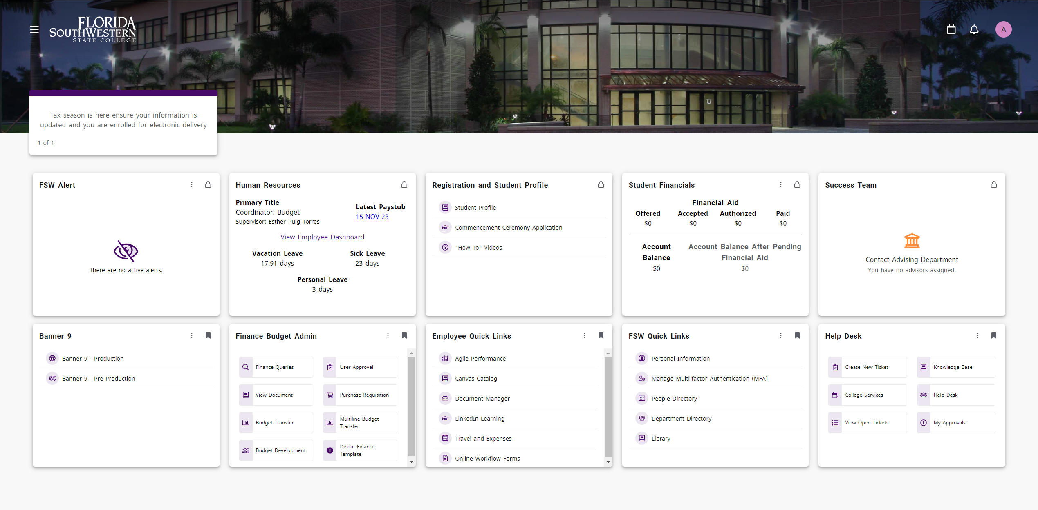
Enter FGIBAVL in the search box to access the Budget Availability Status screen.
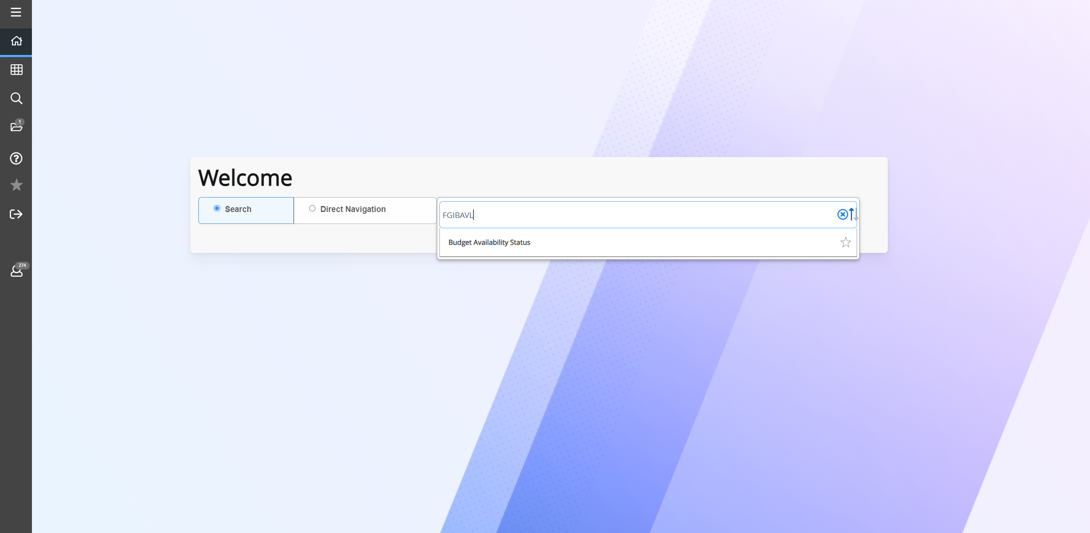

Enter the values for the following parameters: Chart, Fiscal Year, Index (this populates the fund, organization, and program information), Commit Type (both), and Account (we recommend using 60500 to retrieve an overall view of your budget).
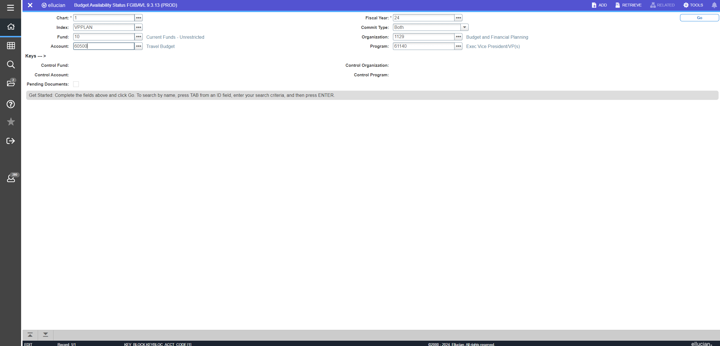
The screen below provides a summary of your budget. The account column lists the budget pooled accounts, title column lists the title of the corresponding budget pooled accounts, adjusted budget column lists the total between your original budget and transfers that have posted, YTD activity column lists expenses that have posted as of query, commitments column lists total encumbrances, available balance column lists your real-time available balance as of query, and pending documents column shows checkmark(s) if you have pending requisitions and budget transfers. Pending requisitions and budget transfers are reflected in the available balance column.
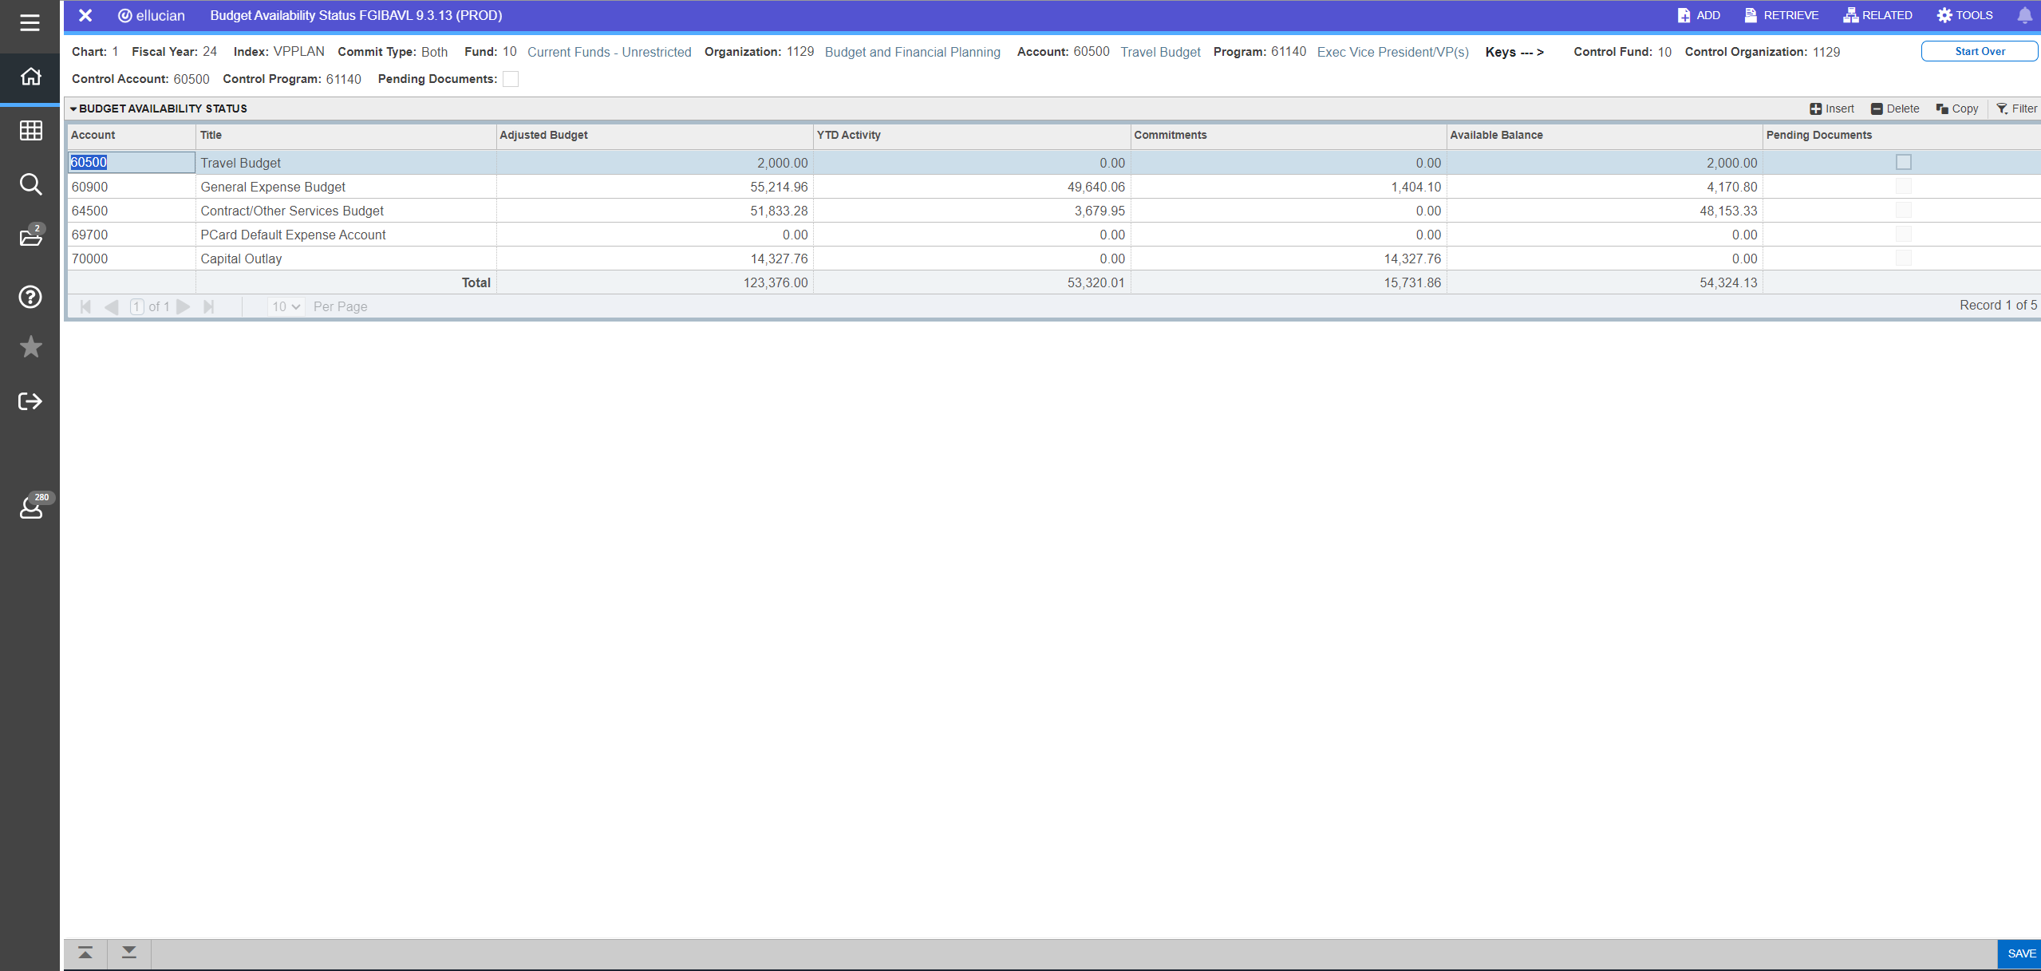

Budget Queries
To perform a query on your budget, you will need to select Finance Queries on the portal’s Finance Budget Admin tile.
Select either New Query icon to choose the type of query you will perform.
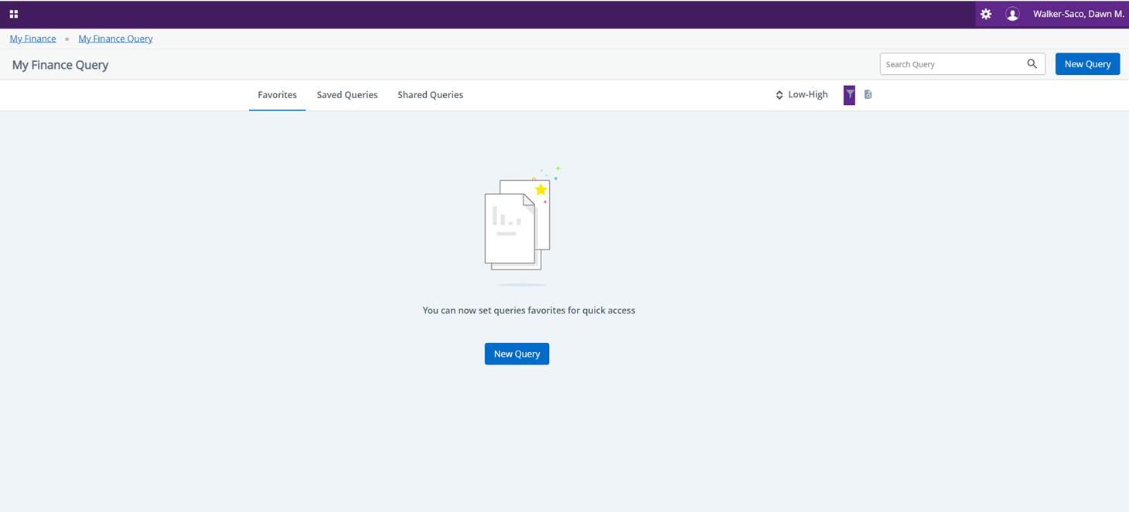
You will be able to select the query type from the Query Type drop-down menu.
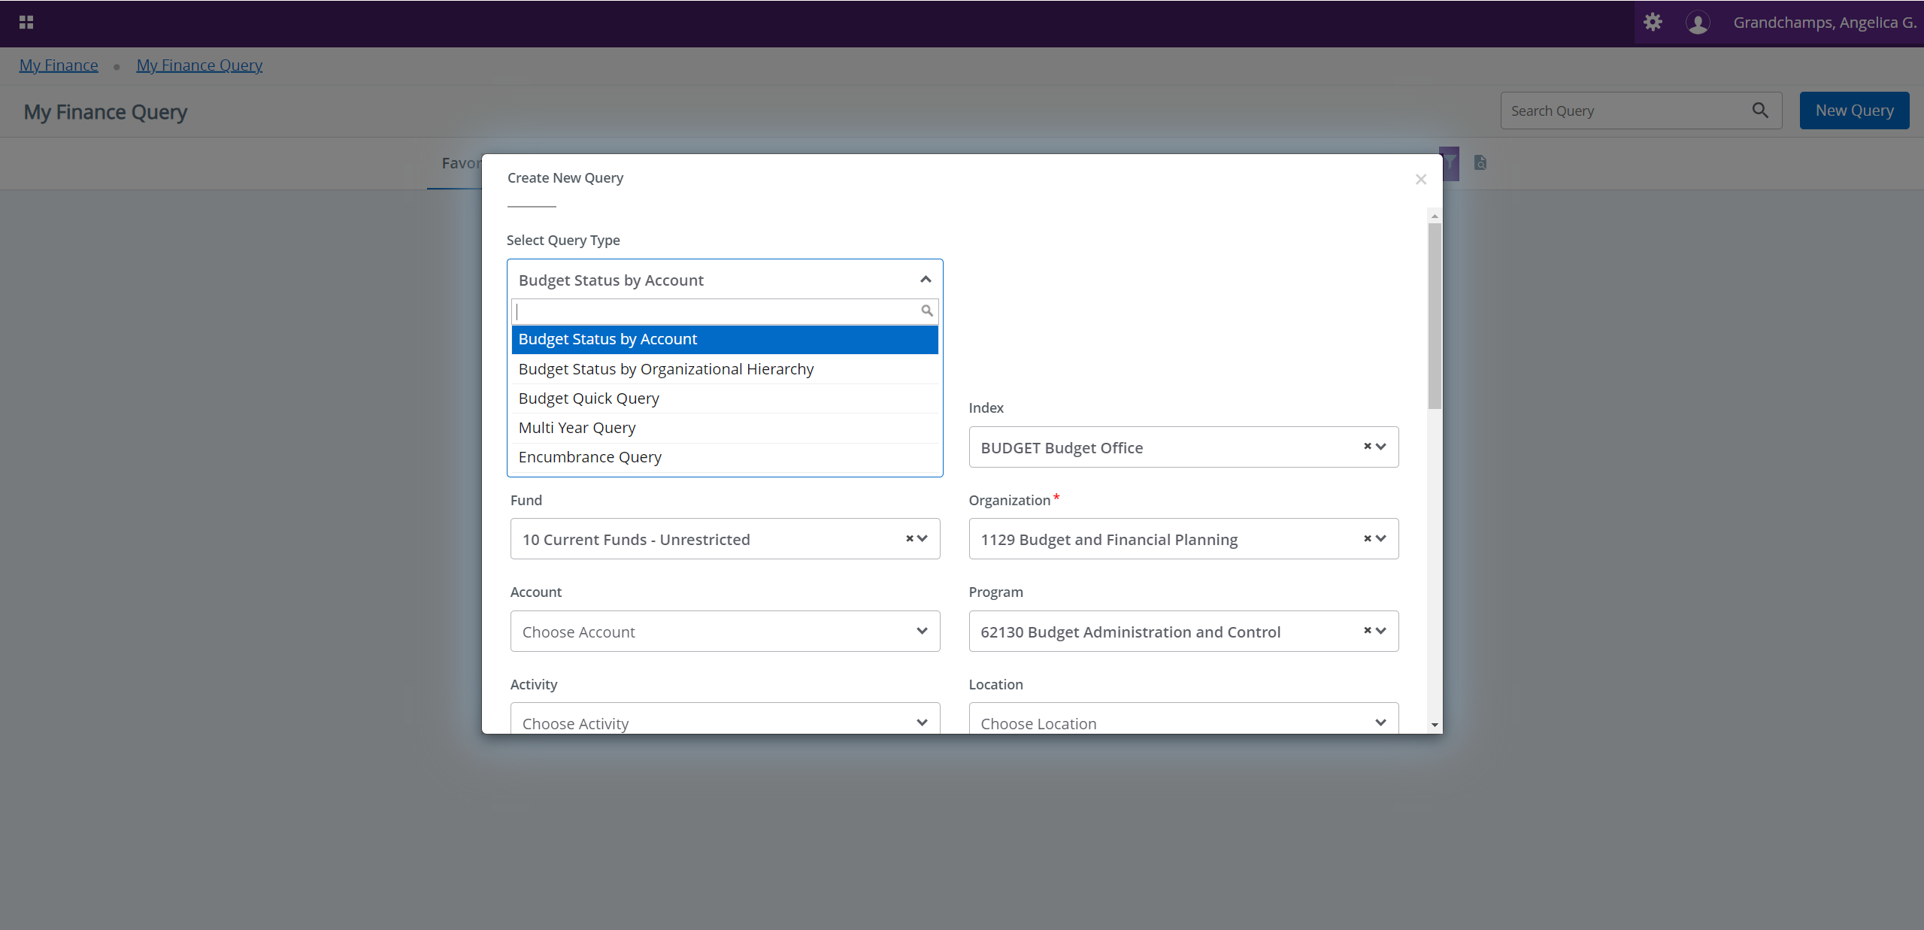
There are five types of queries you may select from:
- Budget Status by Account – allows you to choose what you want to see, such as your adopted budget, budget adjustment, adjusted budget, etc.
- Budget Status by Organizational Hierarchy – is similar to Budget Status by Account, but the information shows at a department (organization) level.
- Budget Quick Query – allows you to view a quick snapshot of your budget as of the day you perform the query. You may enter your index or department code (organization code).
- Multi Year Query – allows you to view data between different months and years. Best used for grants.
- Encumbrance Query – allows you to view all salary encumbrance, purchase orders, and travel encumbrance for the department or for a specific index.
To perform a Budget Status by Account query, enter values for the chart and index parameters to populate the fund, organization, and program, then select all for the commitment type value.
If your department or program collects revenue, you may click the include revenue accounts box to view your revenue.
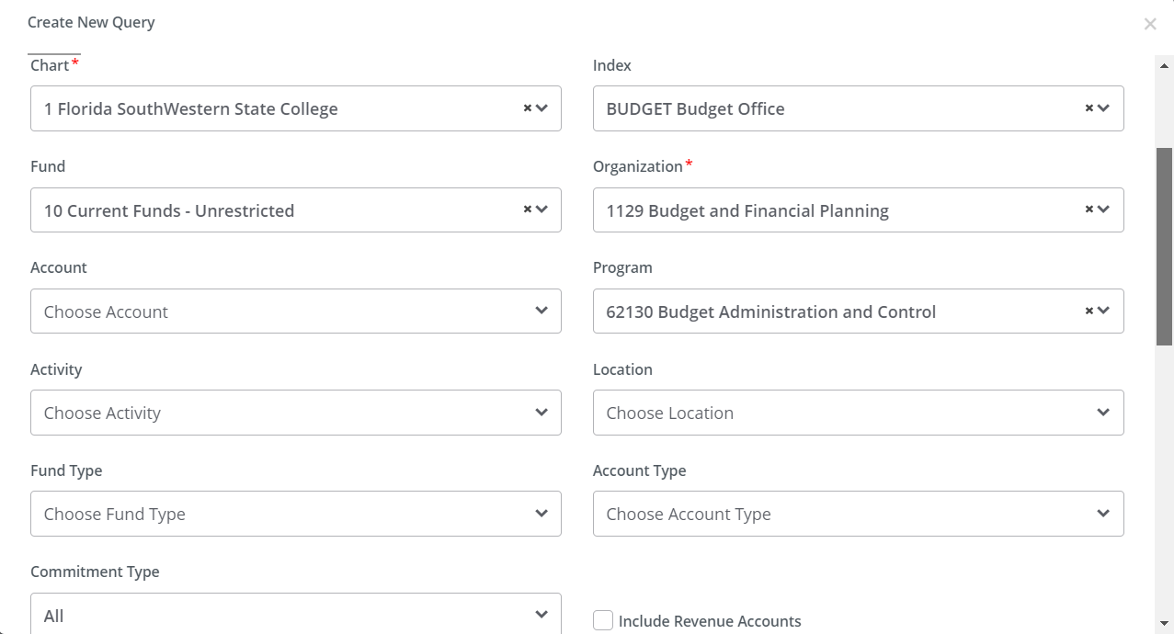
Enter the fiscal year and fiscal period you want to query. You may also compare fiscal years by entering values in the comparison fiscal year and comparison fiscal period fields.
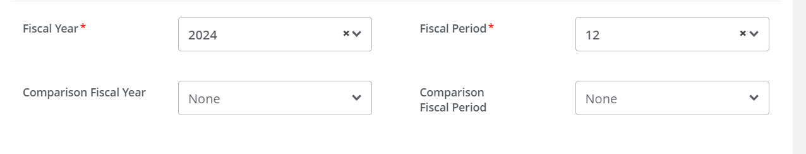
Select the recommended parameters to be included in your operating ledger, then click submit to view results. You may edit as needed.

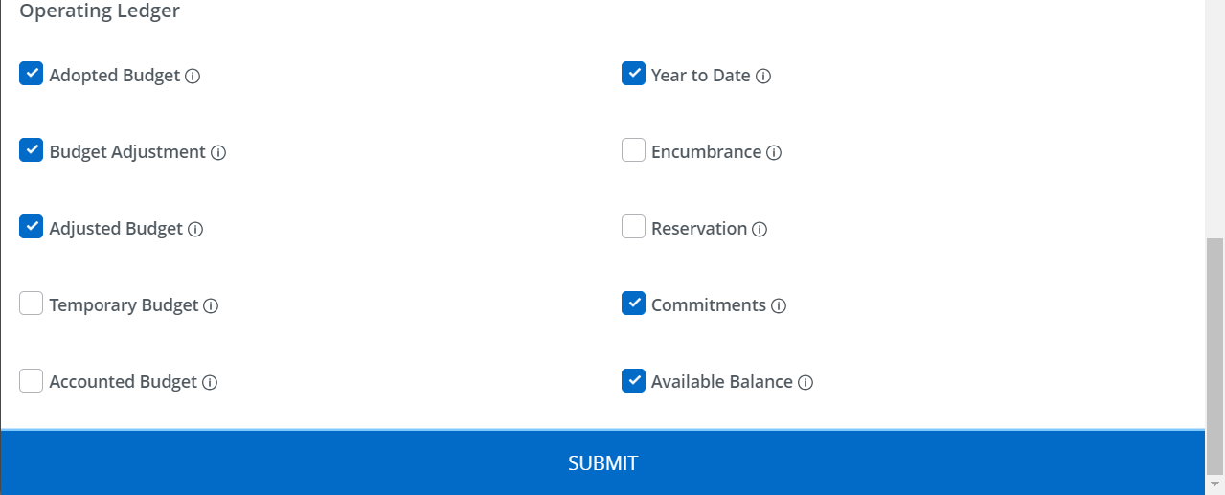
To edit a query, select ; to save, select ; to start over with a new query, select . You may also compute between two columns by selecting , or download the ledger by selecting .
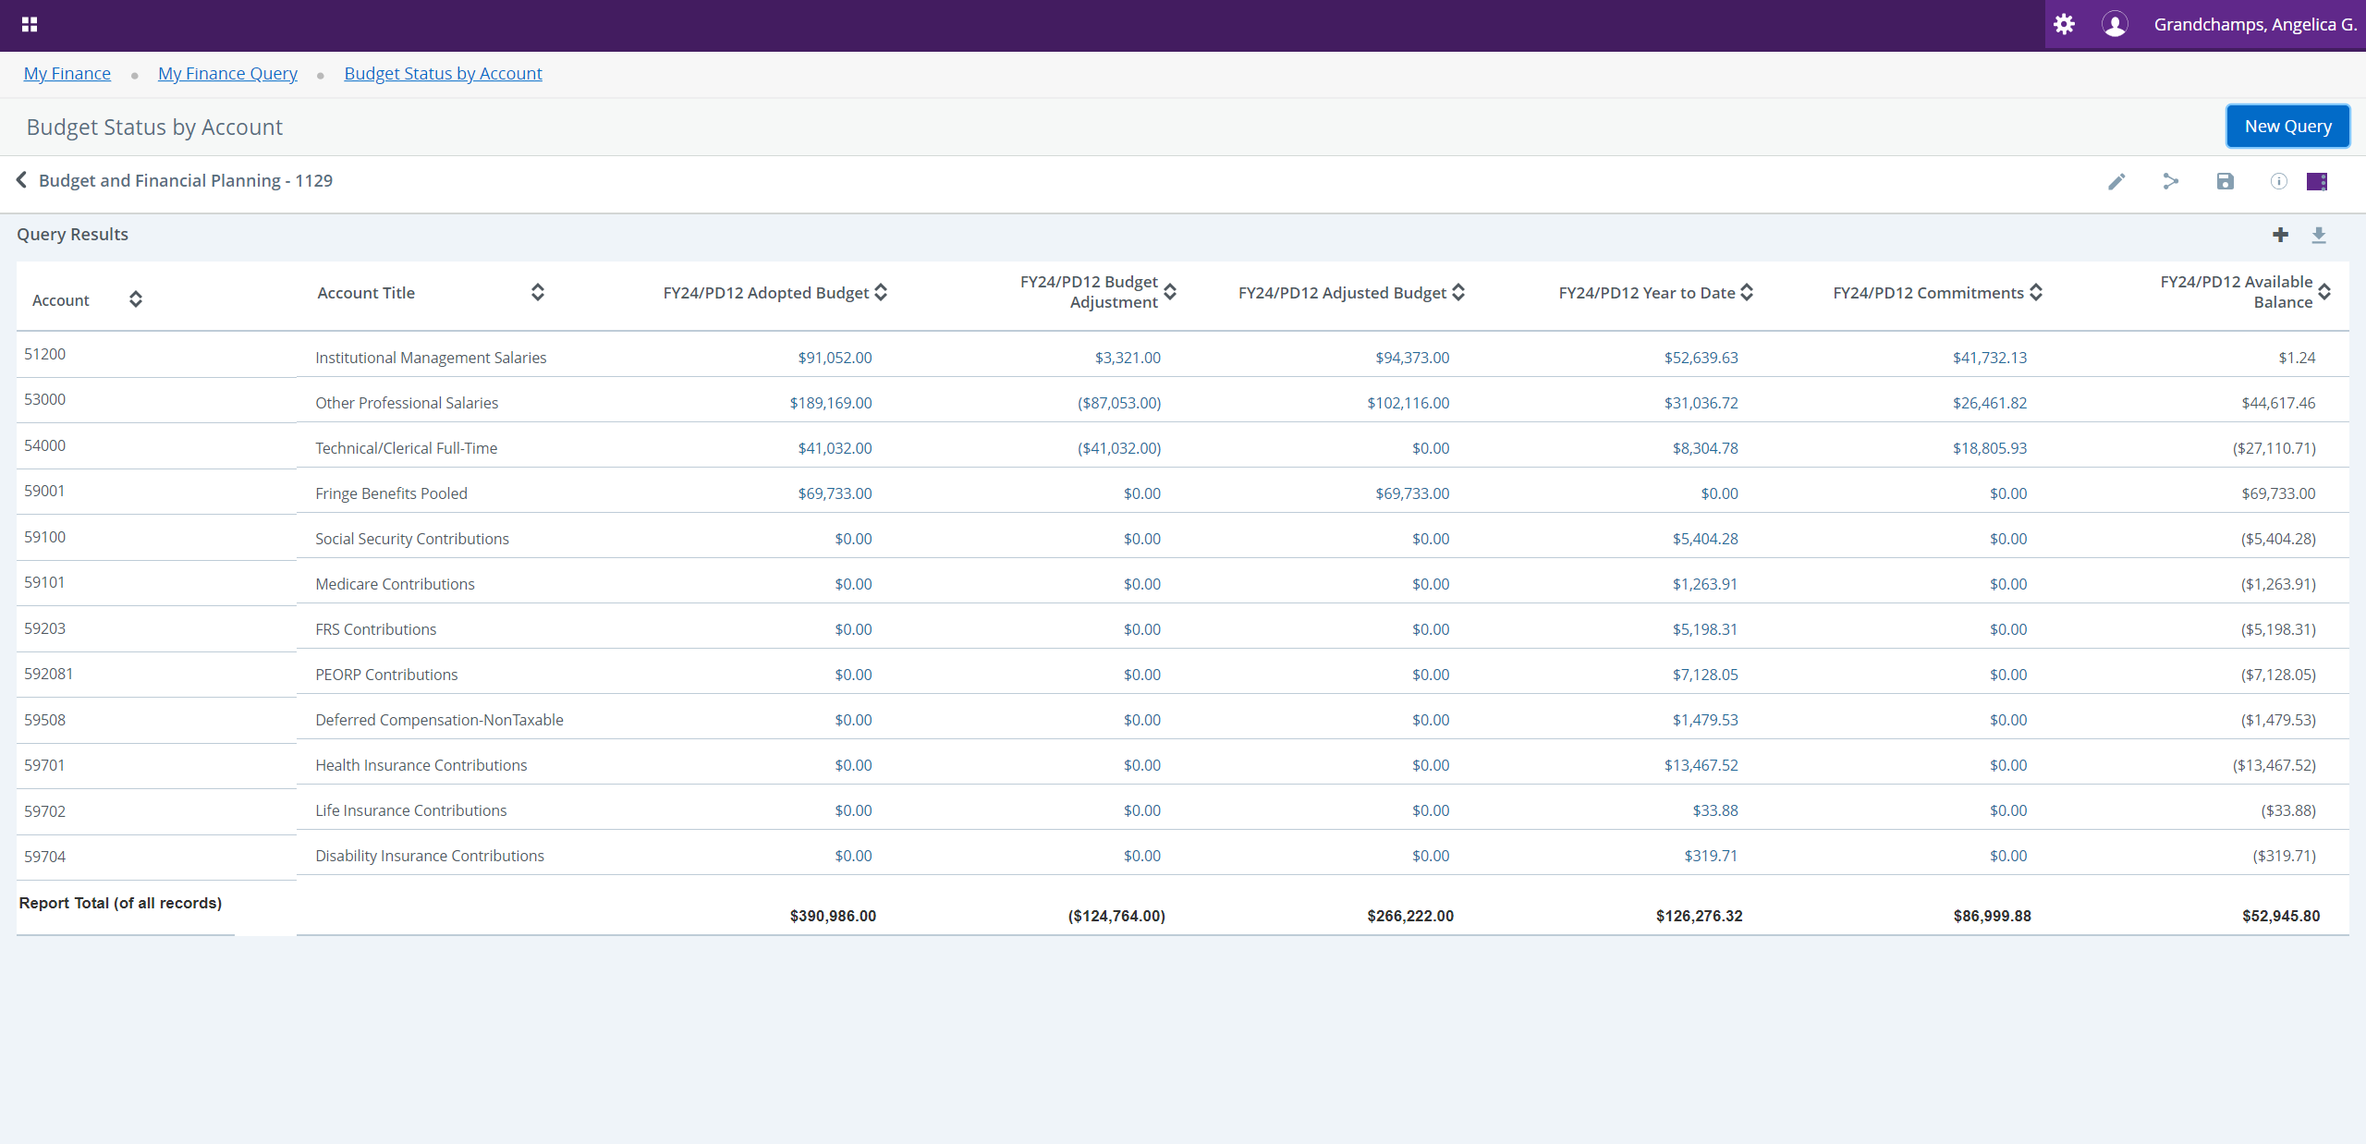
To perform a Budget Status by Organizational Hierarchy query, enter values for the chart and organization parameters, select all for the commitment type value, then click submit.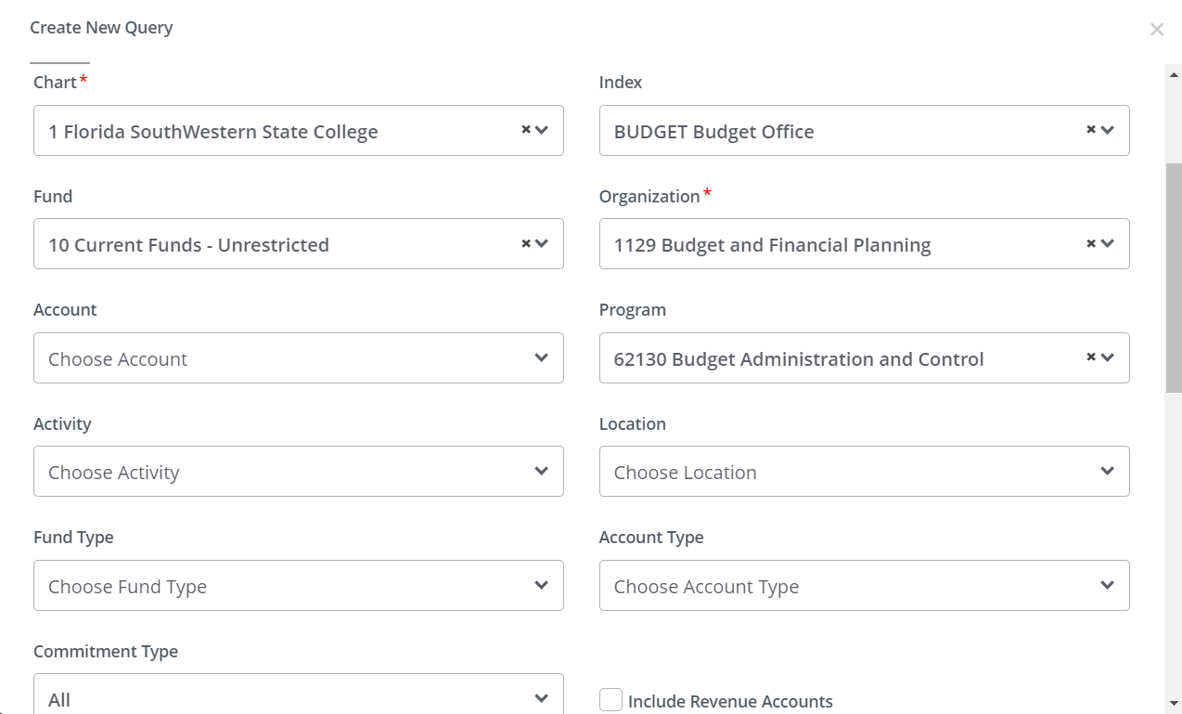
Enter the fiscal year and fiscal period you want to query. You may also compare fiscal years by entering values in the comparison fiscal year and comparison fiscal period fields.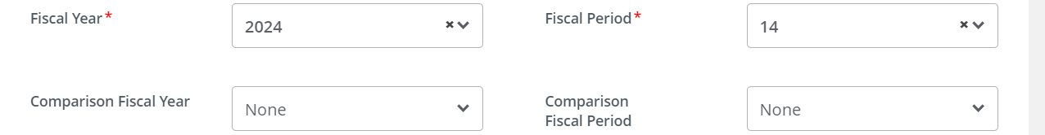
Select the recommended parameters to be included in your operating ledger, then click submit to view results. You may edit as needed.
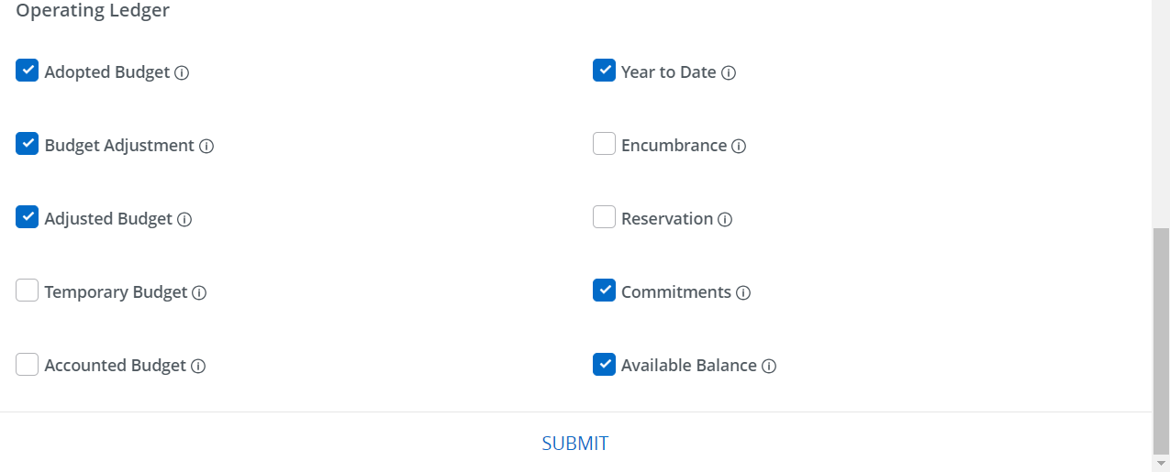
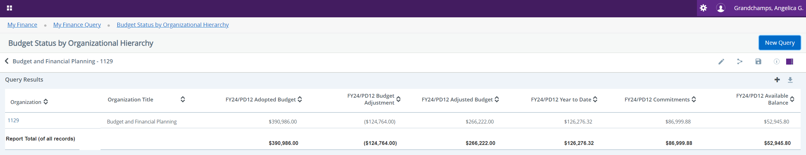
To perform a Budget Quick Query, enter values for the chart and index parameters to populate the fund, organization, and program, then select all for the commitment type value. Enter the fiscal year, then click submit to view results.
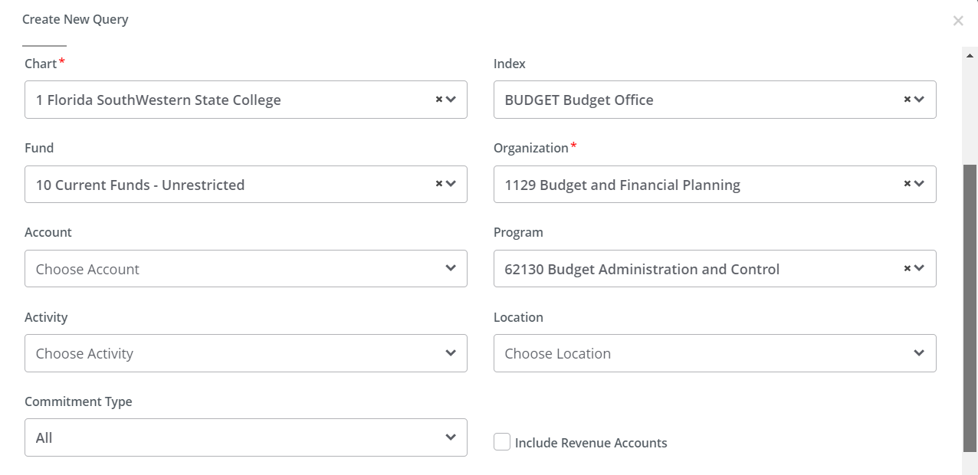

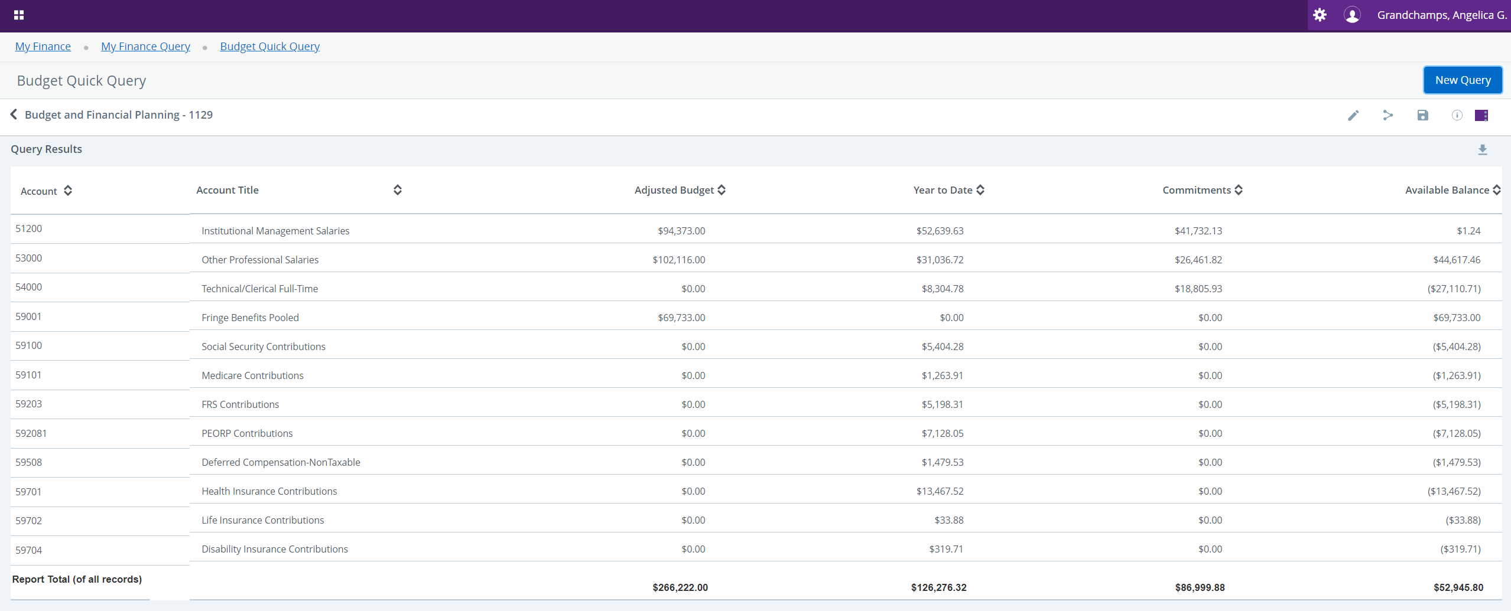
To perform a Multi Year Query, enter values for the chart and index parameters to populate the fund, organization, and program.
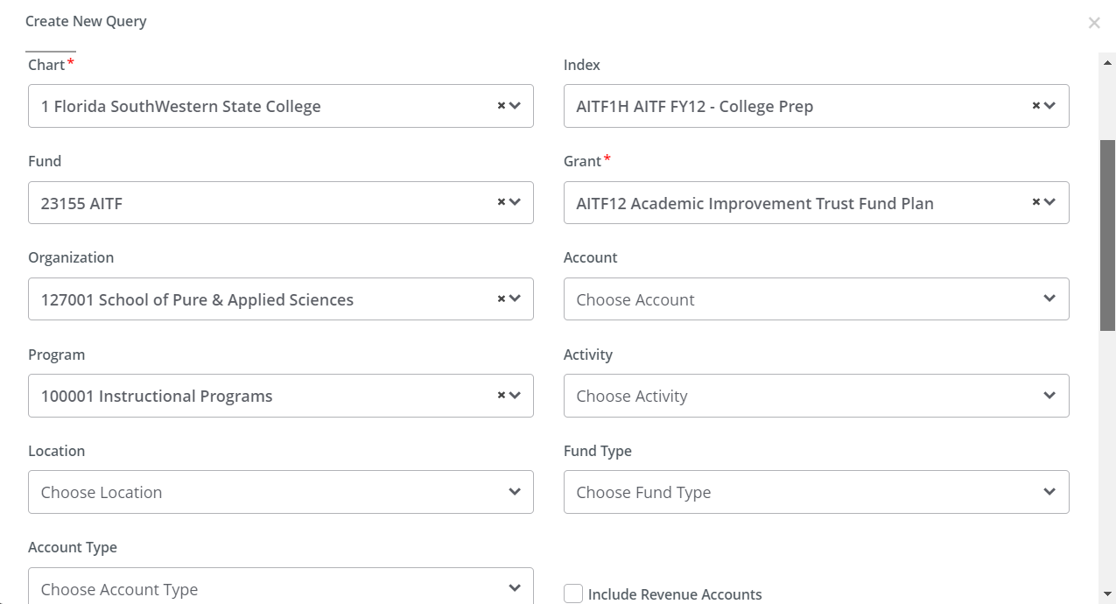
Enter the months and years you want to query.

Select the recommended parameters to be included in your operating ledger, then click submit to view results. You may edit as needed.
To perform an Encumbrance Query, enter values for the chart and index parameters to populate the fund, organization, and program.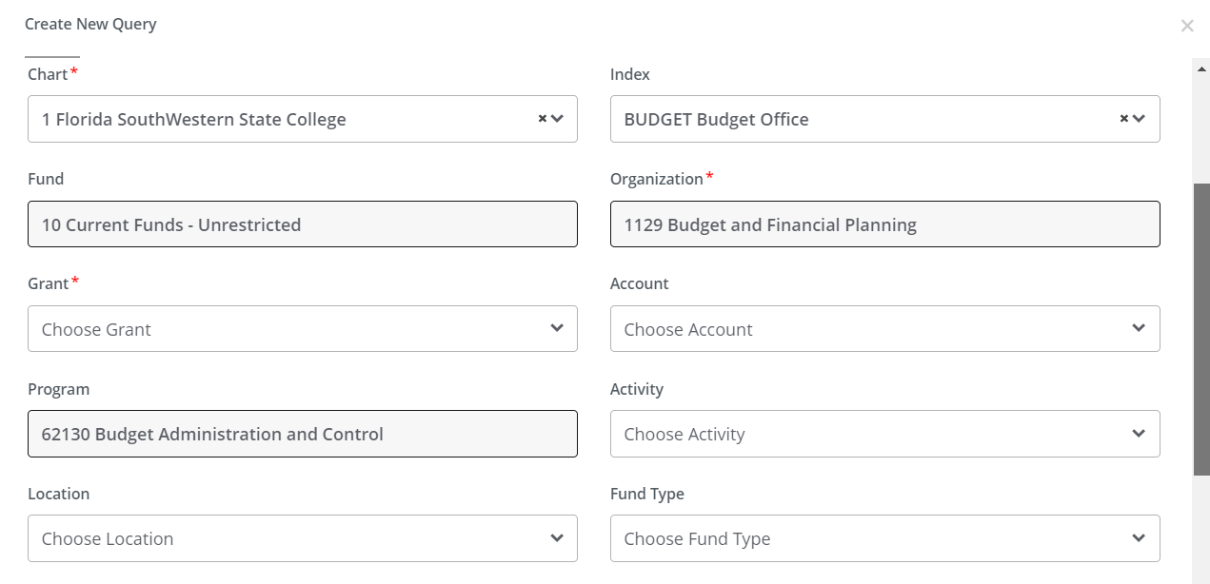
Select all for the commitment type and encumbrance status values, enter the fiscal year and fiscal period you want to query, then click submit to view results.
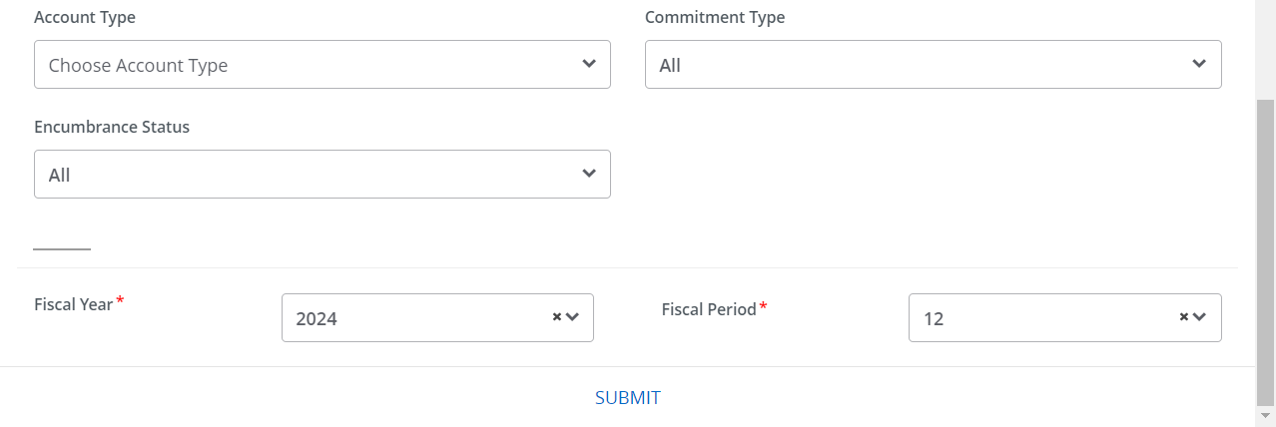
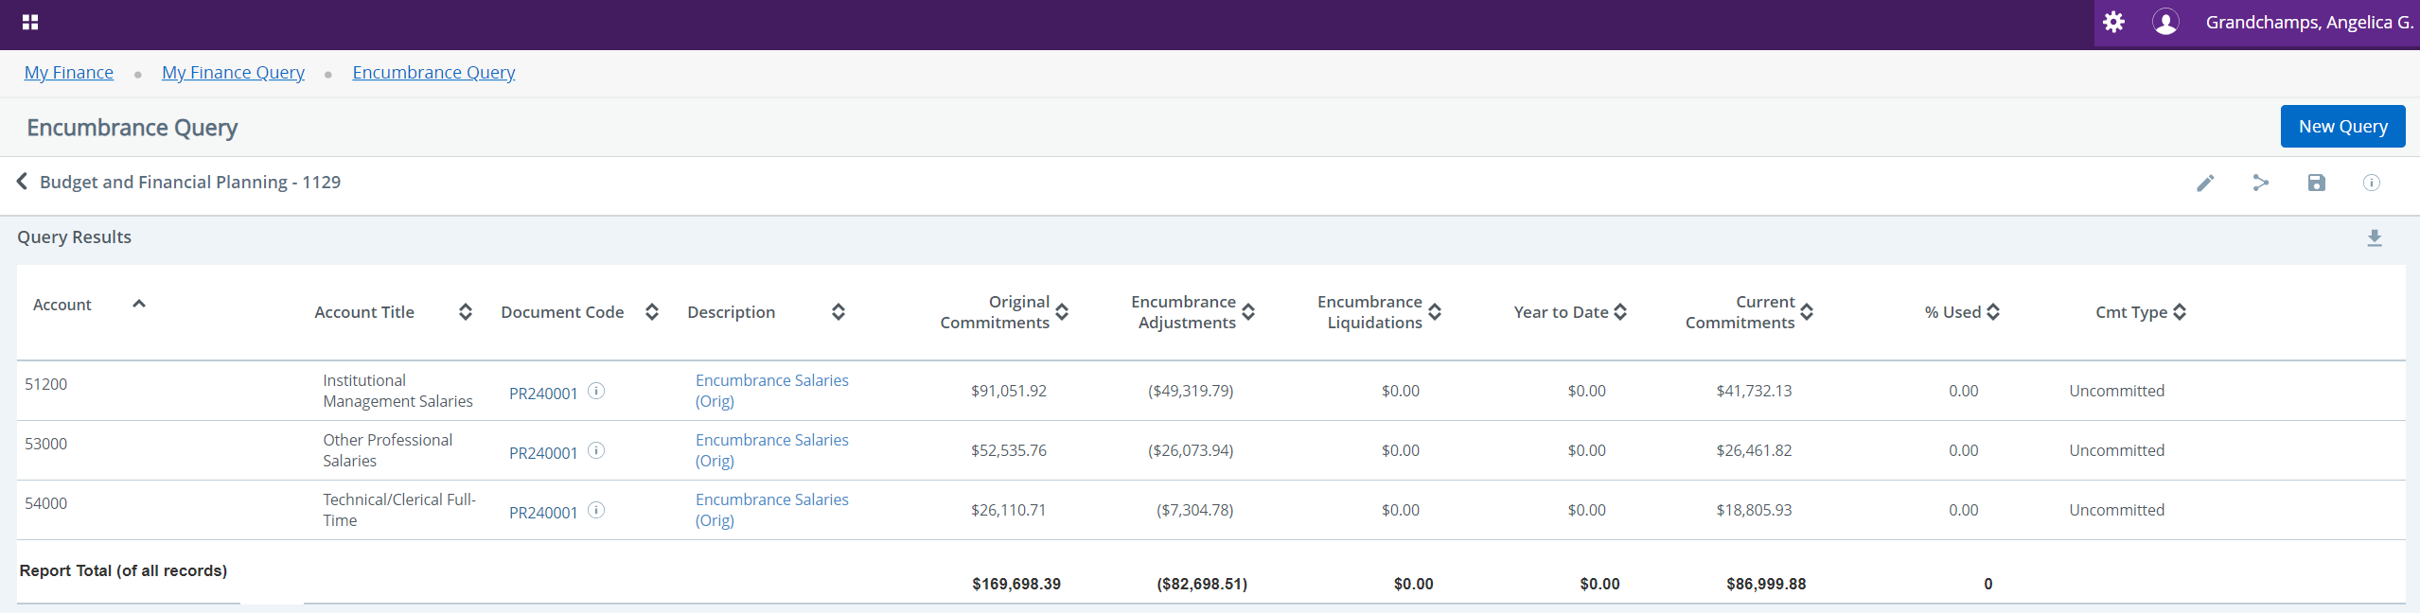

Saved Queries
To view a list of your saved queries, go back to your FSW dashboard, then select Finance Queries on the portal’s Finance Budget Admin tile. Saved queries as also known as finance templates.
Your My Finance Query dashboard prompts you to the Favorites tab. 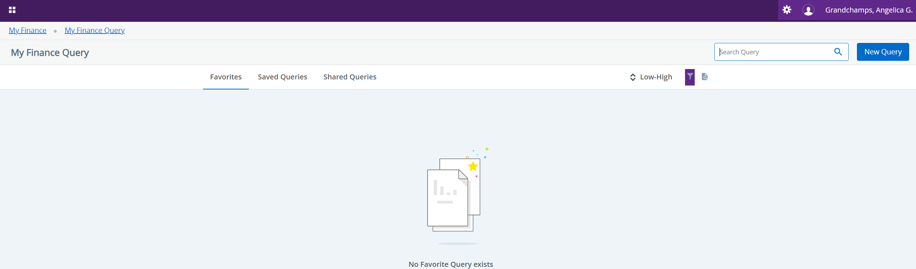
You will need to select the Saved Queries tab to view your saved queries.
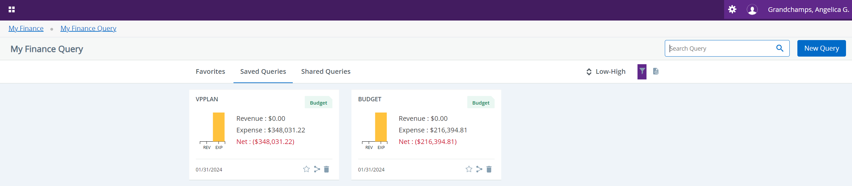

Pending Documents
To view a list of pending documents within an index, perform a Budget Status by Account query.
From the query results screen, click on the view more icon  at the top right corner, then select view pending documents.
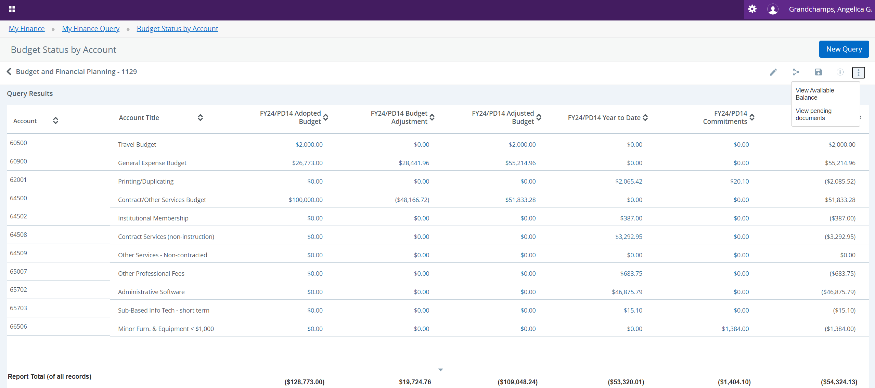
After selecting view pending documents, you will see a list of your pending documents within the index in query.
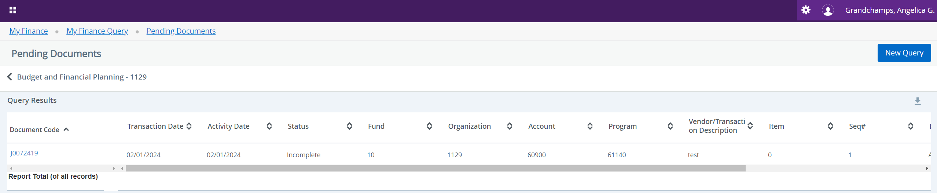

View Document
To view a specific finance document, go back to your FSW dashboard, then select View Document on the portal’s Finance Budget Admin tile.
This option provides finance document details and approval history for requisitions, purchase orders, invoices, journal vouchers, and encumbrances.
Select the document type you want to view from the drop-down list.
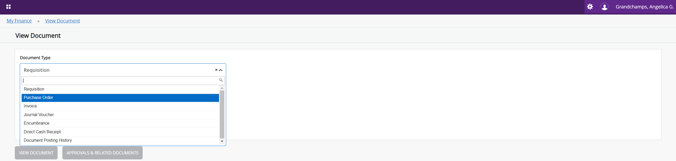
Enter the document number, then you may either view the document or look at its approval history and related documents.
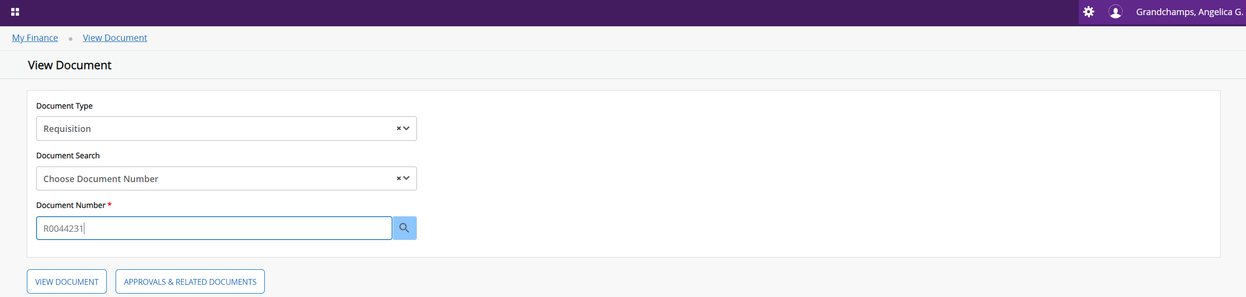
Below is what you’ll see if you select view document:
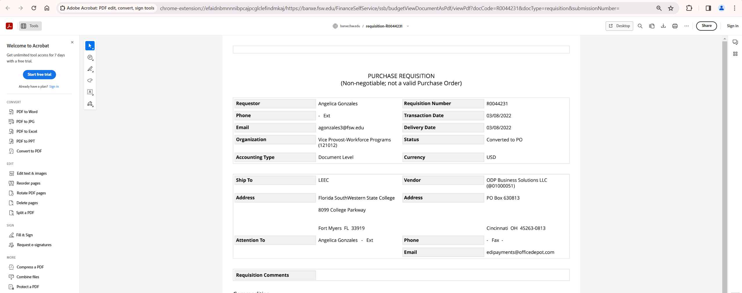
Below is what you’ll see if you select approval and related documents:
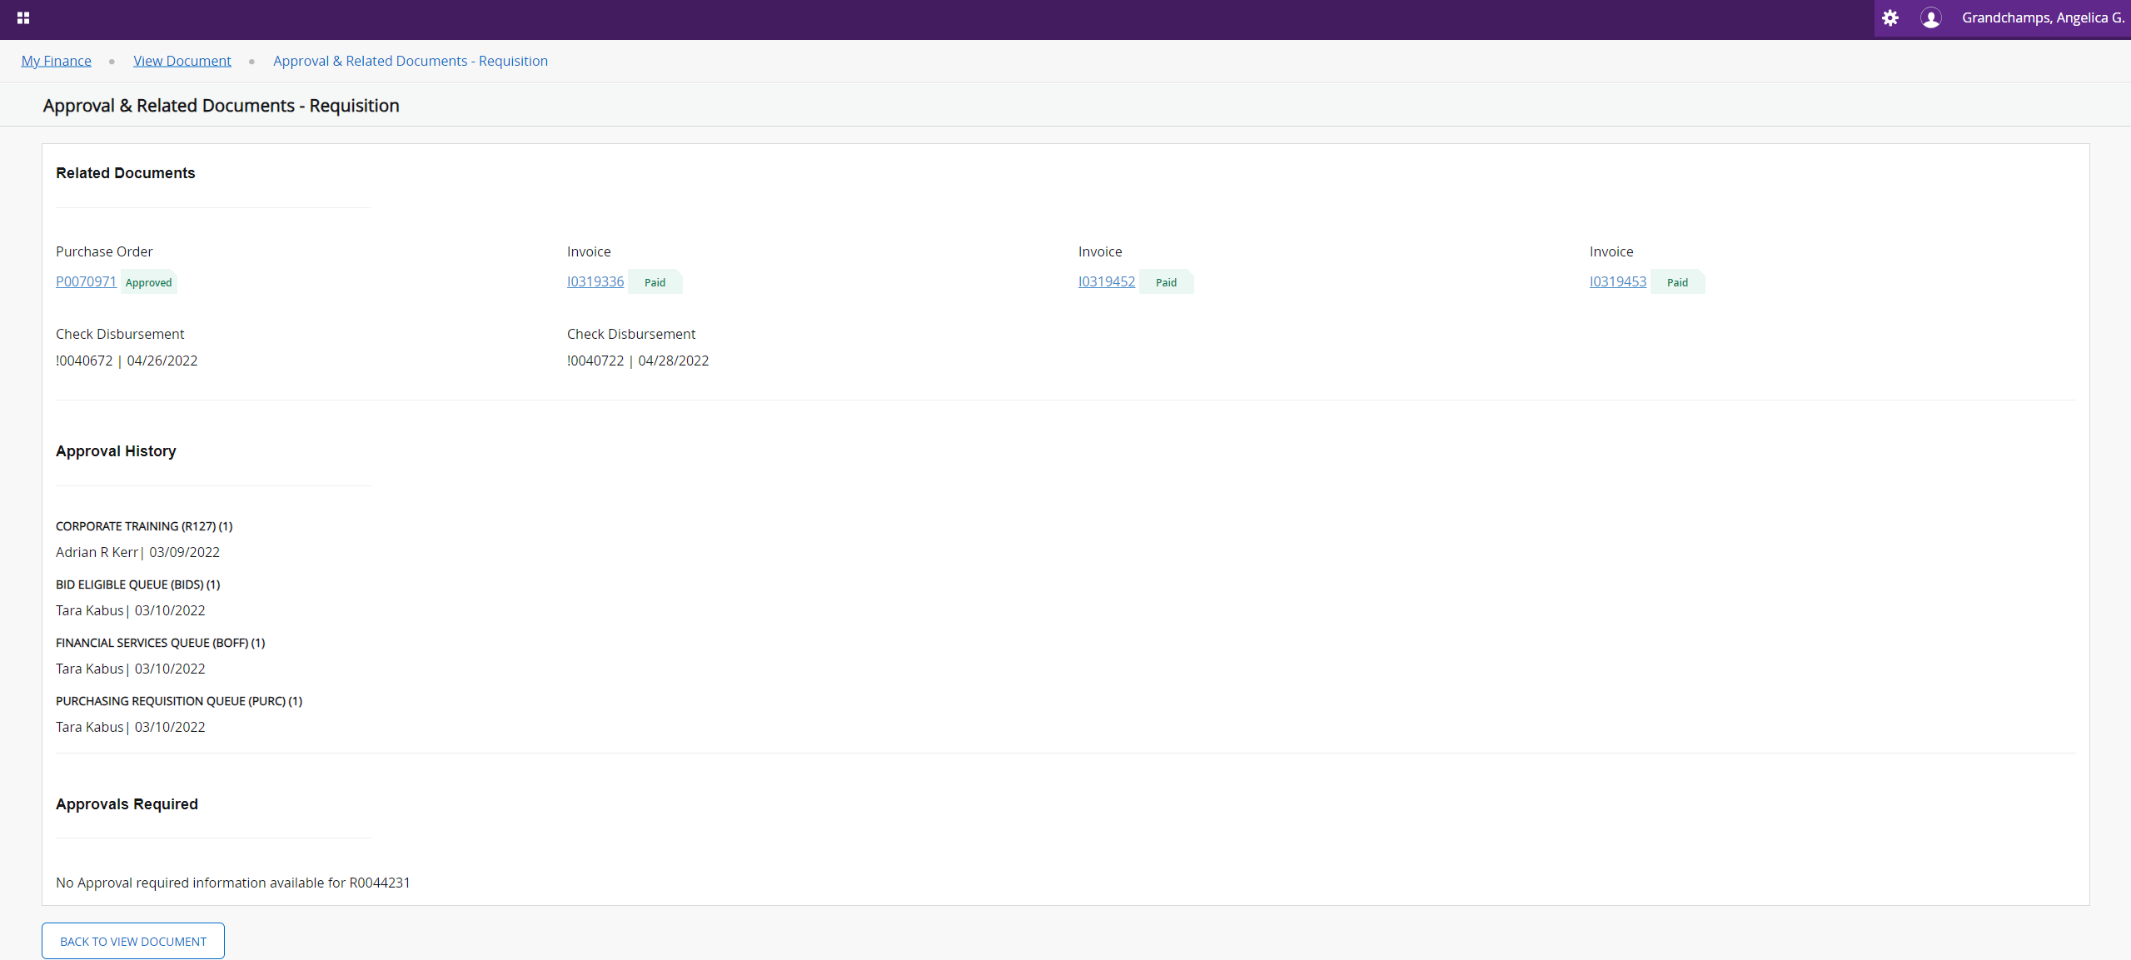
If you don’t know the document number of what you want to look up, you may select the document type, then click the document number lookup icon to run a query.
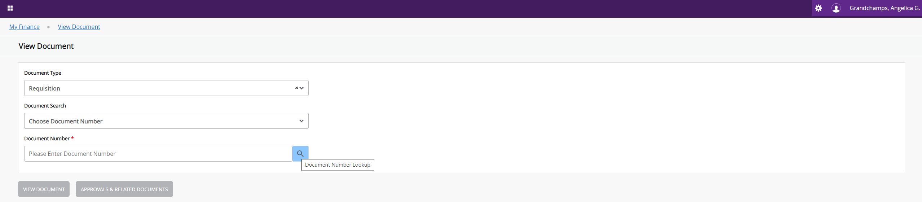

Enter the user ID you want to query. You may enter specific dates, or enter all for the transaction date-year and transaction date-month parameters. You may modify the approval status under the approved and completed values as needed, then click execute query.
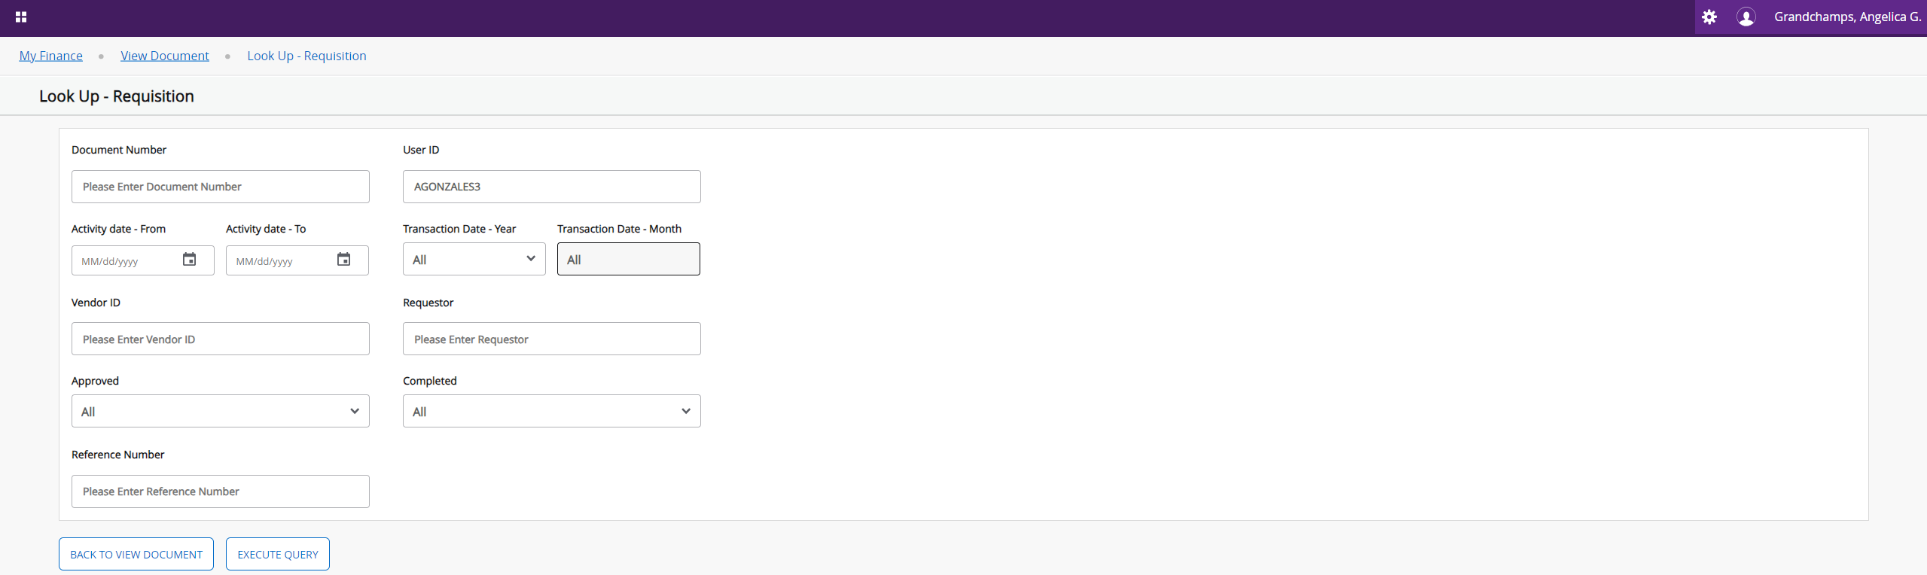
Below is a result view after performing a query of all requisitions. You may select a document from this list, go back to view document, or perform another query for the same document type.
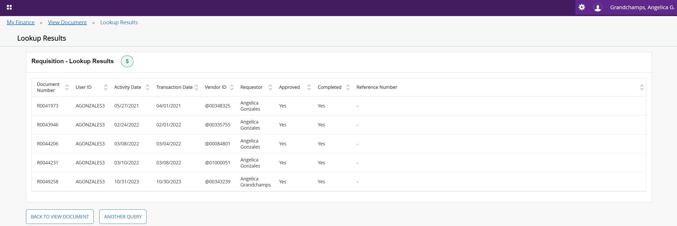

Budget Transfer
To complete a budget transfer, go back to your FSW dashboard, then select Budget Transfer on the portal’s Finance Budget Admin tile.
Budget transfers may be completed within the department as long as they are to and from the fund type or within the same index between the pooled accounts. They can be permanent or temporary, but we normally process temporary budget transfers (BOTT). BOTT is only reflected in the current fiscal year.
Select the date from the drop-down lists, the type of transfer, and enter the transfer amount.
Enter your chart, index, and account codes in both rows and a description of the transfer. Select the budget period, then click complete.
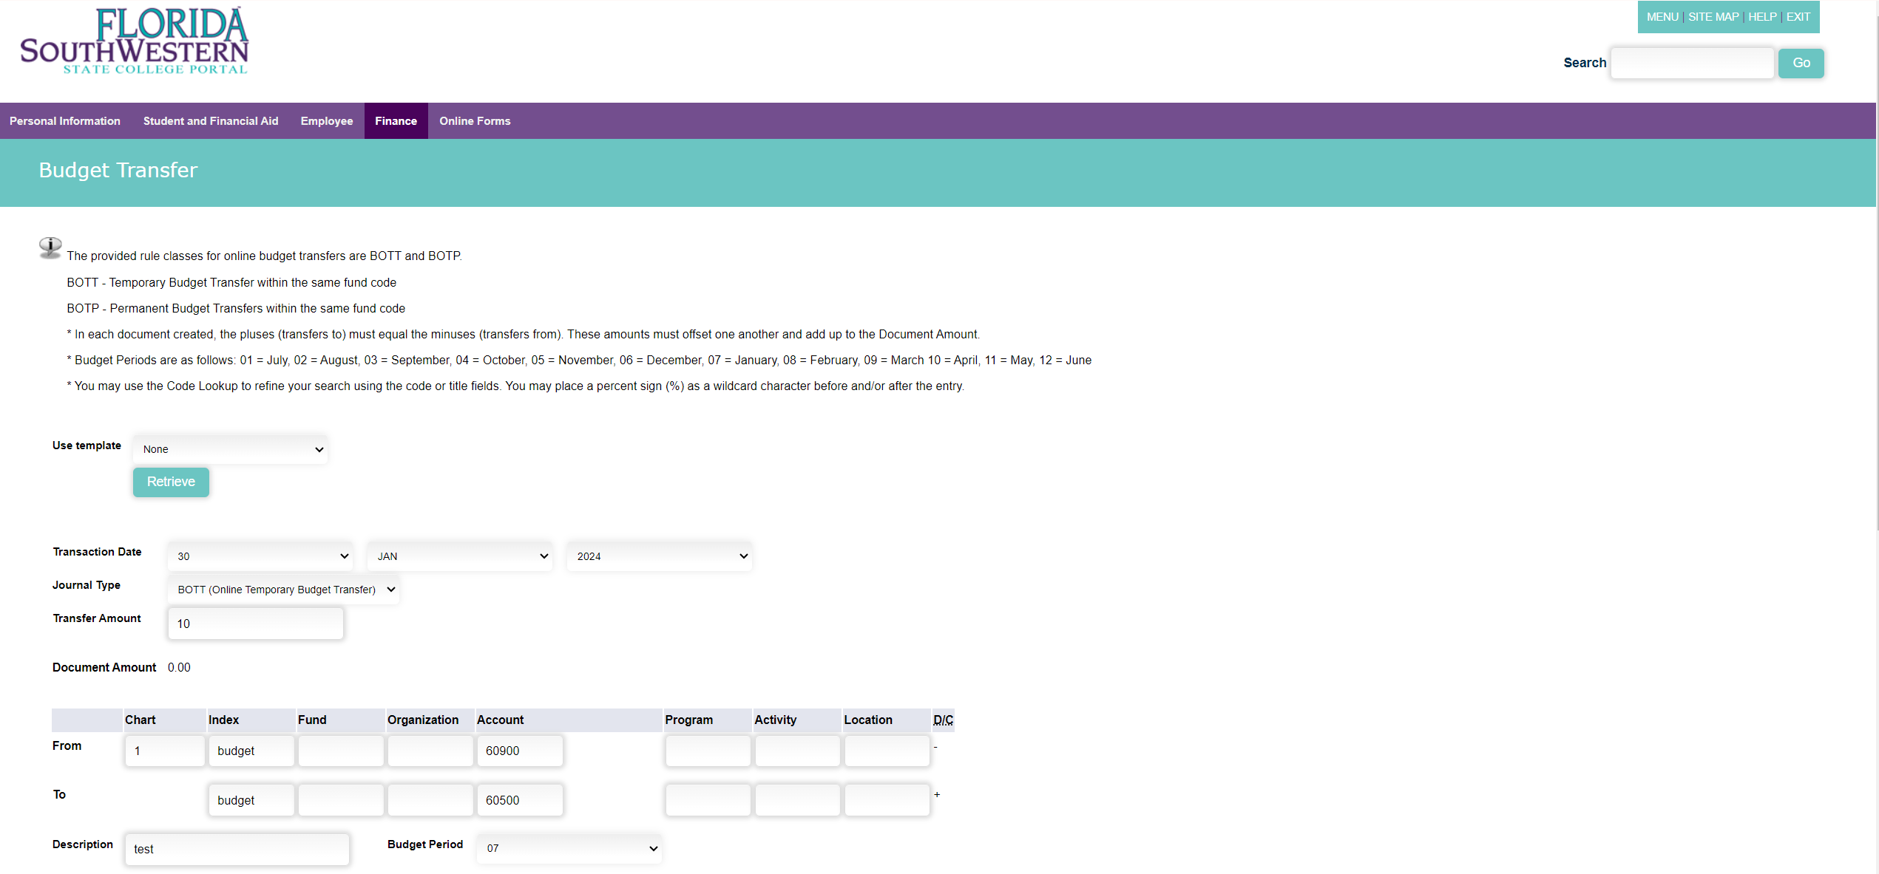
After you click complete, the document amount doubles because the transfer affects two pooled accounts. The index and account codes disappear, and values populate for the fund, organization, and program parameters. You will need to re-enter JUST the account codes, then click complete again.
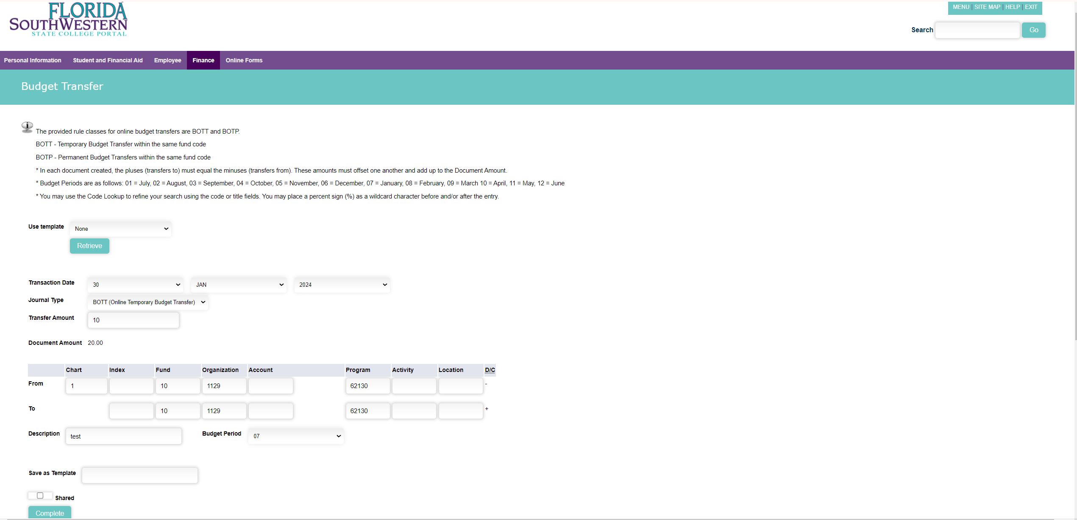
Successfully completed budget transfers generate a journal voucher document number at the top of the screen.
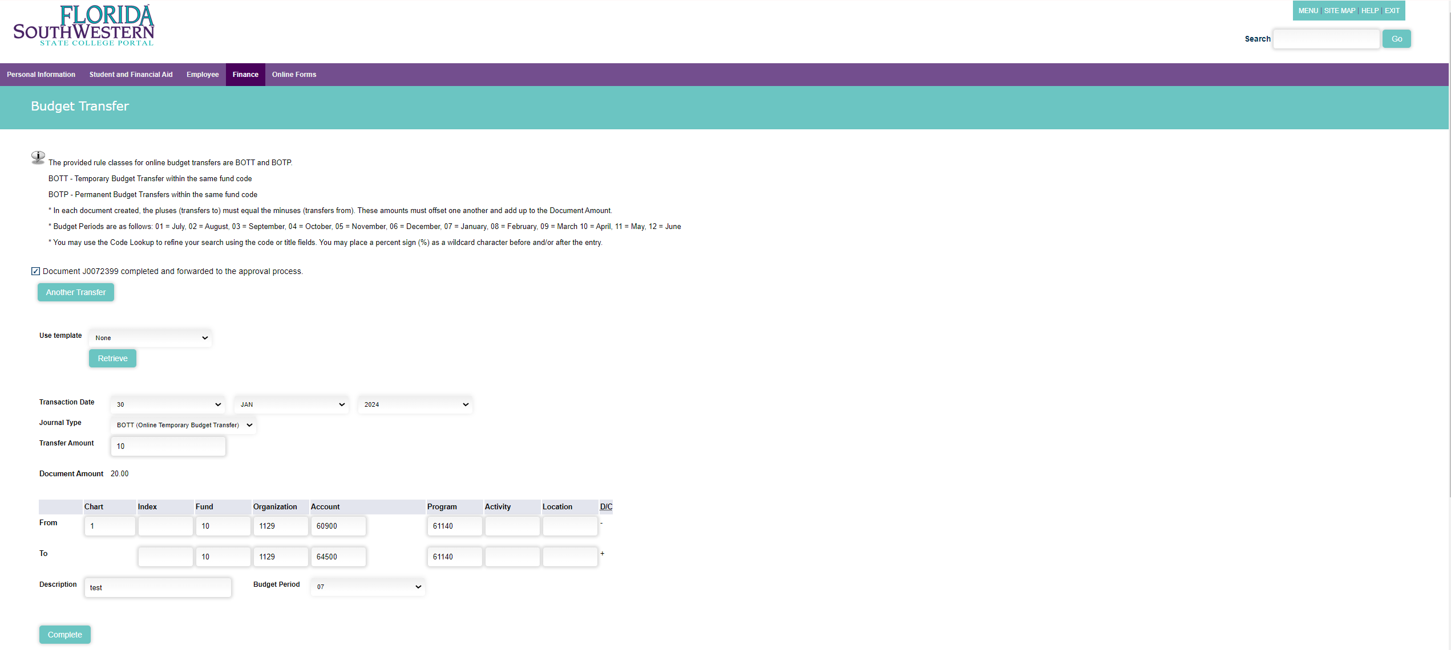

Multiline Budget Transfer
To complete a multiline budget transfer, go back to your FSW dashboard, then select Multiline Budget Transfer on the portal’s Finance Budget Admin tile.
This option allows transfers within the department as long as they are to and from the same funds or within the same index between the pooled accounts. Budget transfers can be permanent or temporary, but we normally process temporary budget transfers (BOTT). BOTT is only reflected in the current fiscal year.
Select the date from the drop-down lists, the type of transfer, and enter the sum of the amount column. Select from (-) or to (+) accordingly and submit. The plusses must equal the minuses.
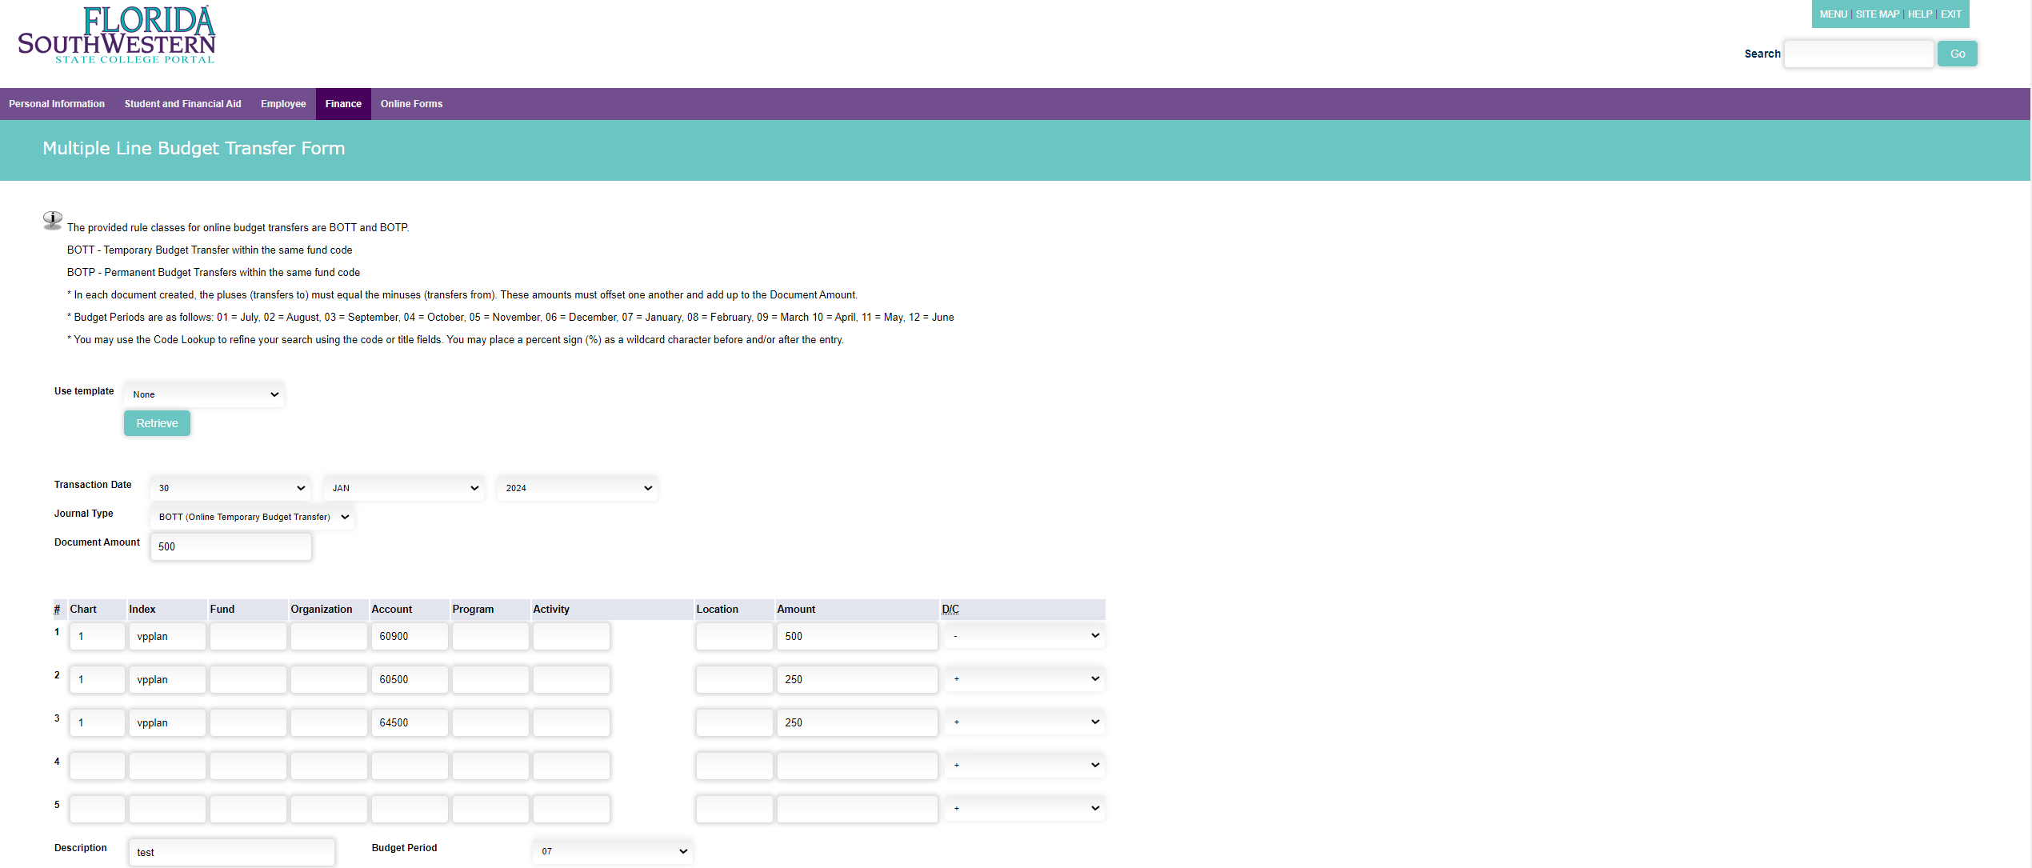
Similar to budget transfer, the document amount changes, the index and account codes disappear, and values populated for the fund, organization, and program parameters. You will need to re-enter JUST the account codes, then click complete again.
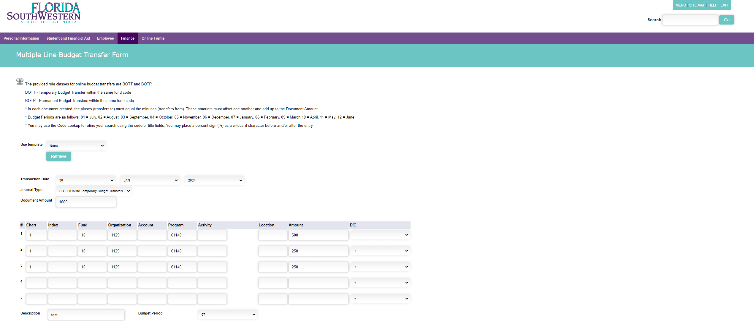
Similar to budget transfer, successfully completed multiline budget transfers also generate a journal voucher document number at the top of the screen.

User Approval
To approve or disapprove finance documents, go back to your FSW dashboard, then select User Approval on the portal’s Finance Budget Admin tile.
Budget Administrators may approve or disapprove requisitions and journal vouchers (budget transfers) with this option.
End-users may also use this option to view a list of pending requisitions and budget transfers, and disapprove them as needed.
The User ID should populate your information, then you may click submit.
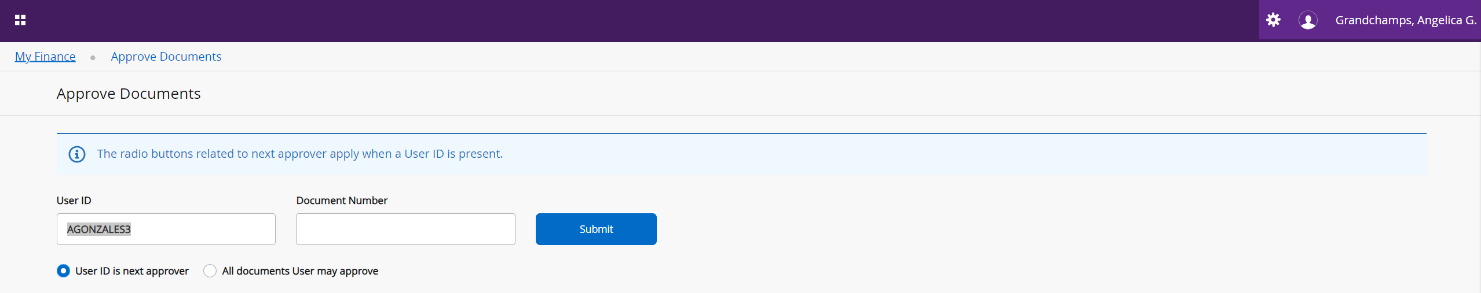
The “User ID is next approver” option provides a list of finance documents pending your approval.
The “all documents you may approve” option allows you to view finance documents in your queue pending others’ approval.
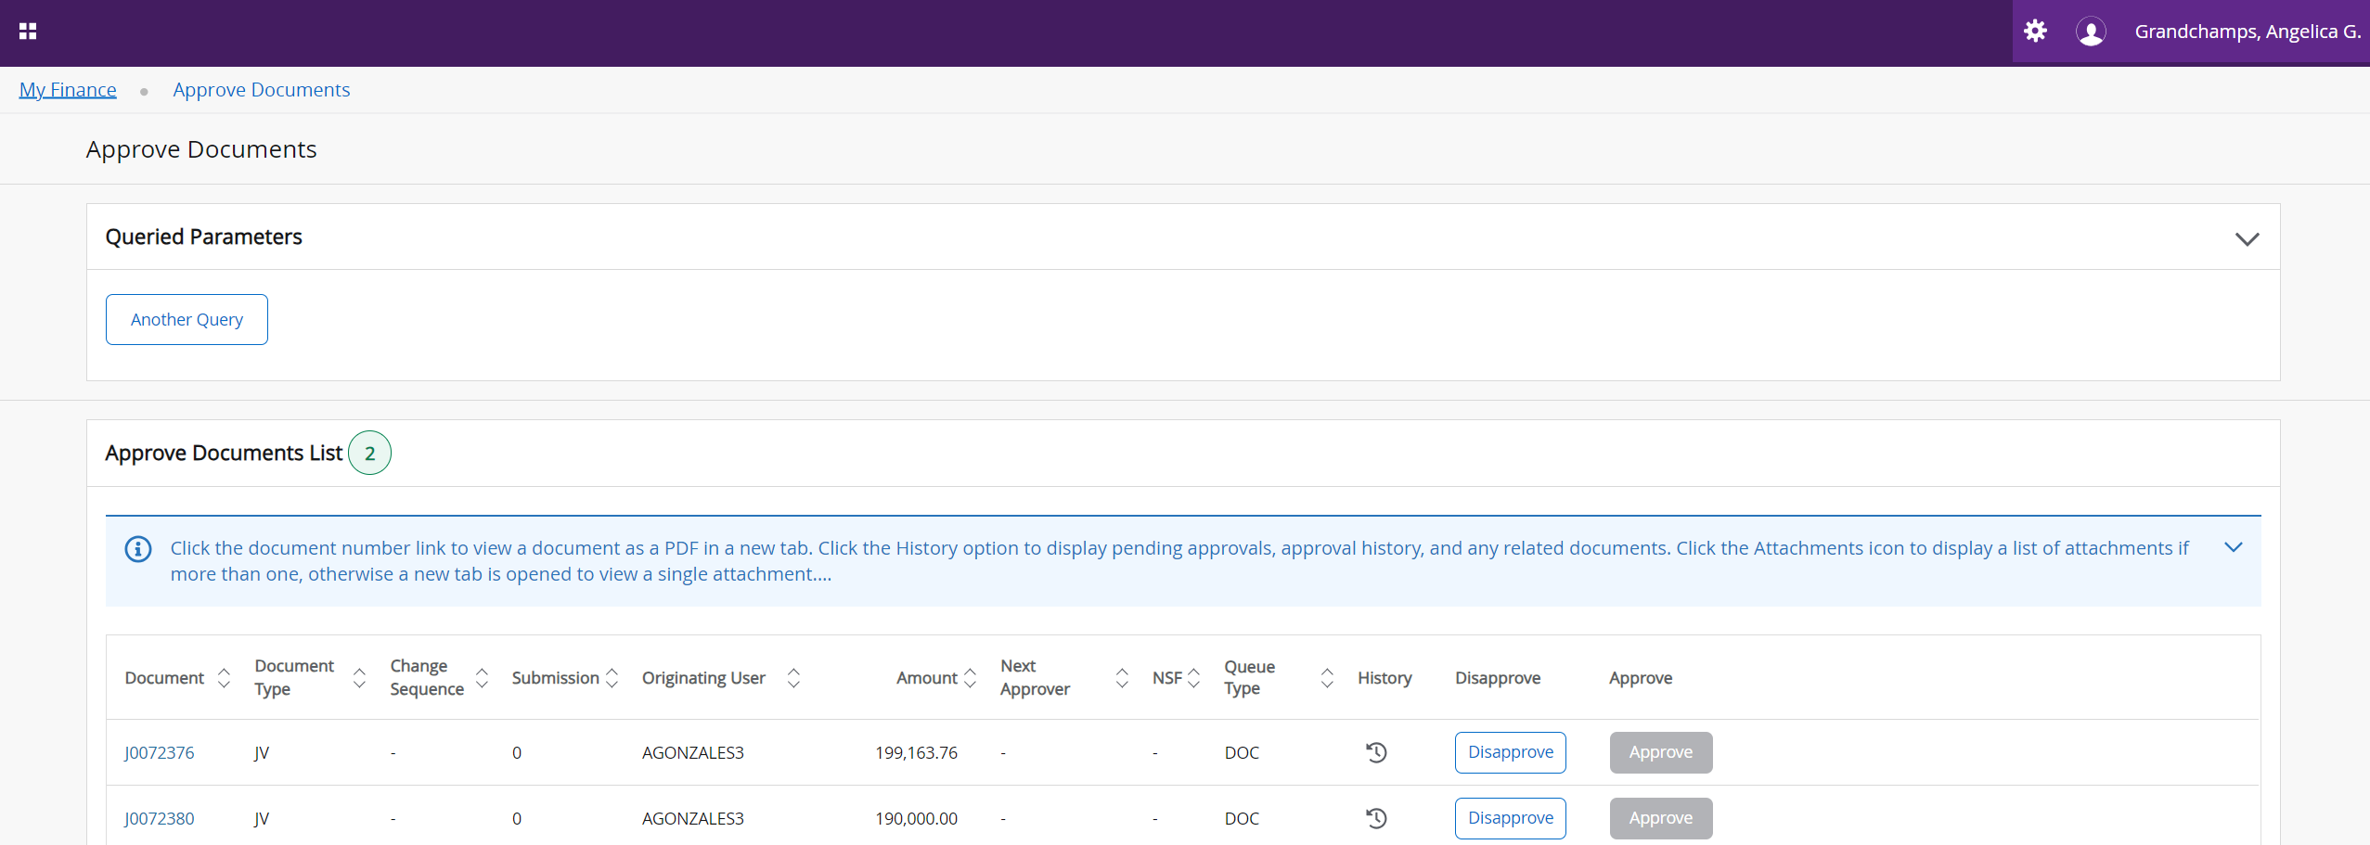
You may disapprove budget transfers and purchase requisitions from this list. If you disapprove a budget transfer, please contact the Office of Budget and Financial Planning so we may delete your disapproved budget transfer completely.

Delete Finance Template
To delete a finance template, go back to your FSW dashboard, then select Delete Finance Template on the portal’s Finance Budget Admin tile. Finance templates are also known as your saved queries.
You may enter a template name, or select all under the template/query type, then click submit query to generate a list of your saved templates.
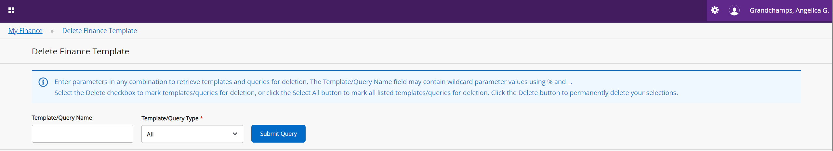
Select the associated delete box to the template you want to delete, then click delete.
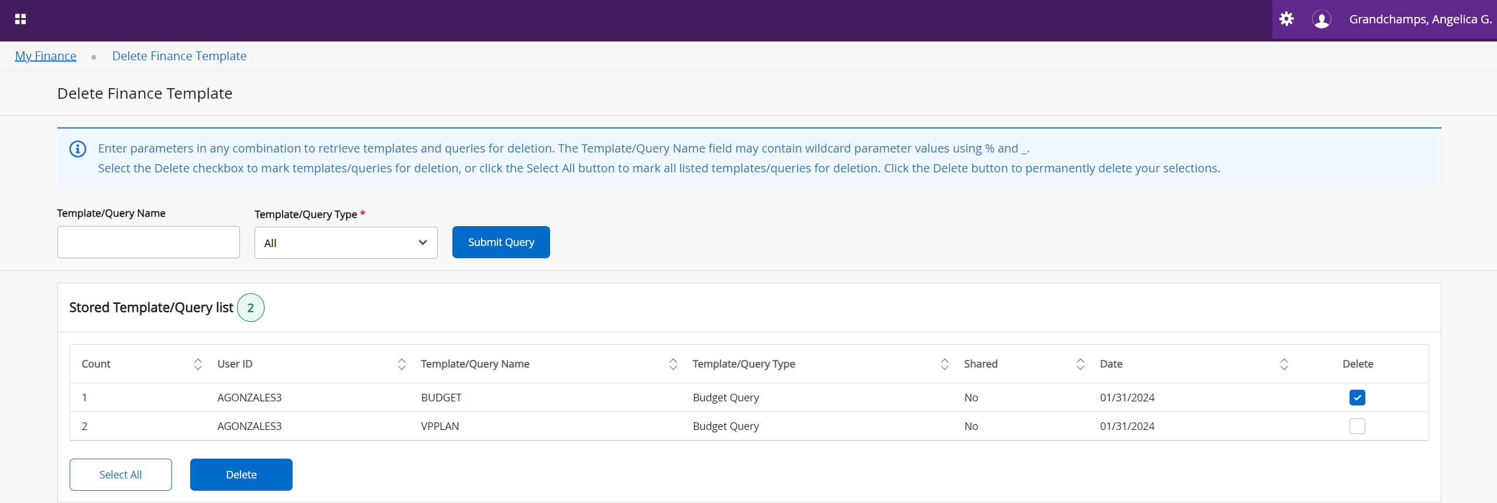
If successfully deleted, you will see a confirmation at the top right corner of your screen.
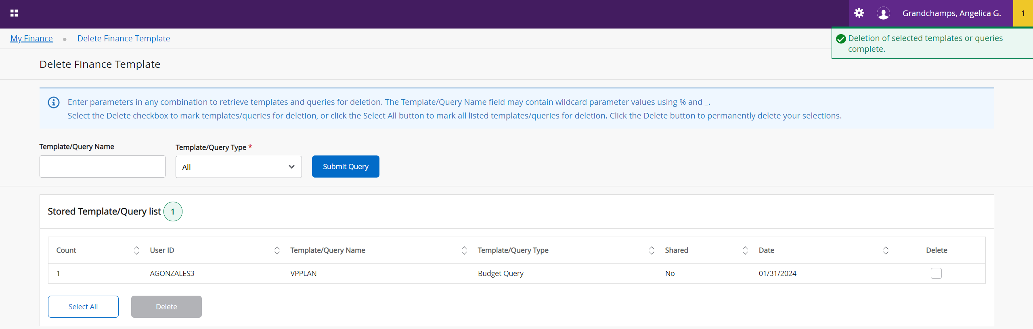

Contact Us
Please contact the Office of Budget and Financial Planning if you have any questions.
Esther Puig Torres- extension 16639, eapuigtorres@fsw.edu
Angelica Grandchamps- extension 11009, agrandchamps@fsw.edu
Joshua Taylor- extension 11395, joshua.taylor@fsw.edu

