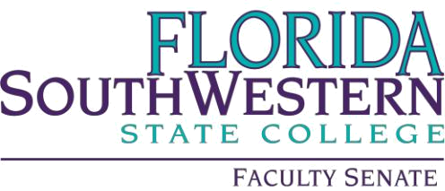

Minutes

Friday 3/1/2024
1:00 – 2:00 PM
Online via Zoom
Quorum of 30 @ 1:01 pm

- Agenda Adoption

- Minutes Approval

- Information Items:

  - VPAA Update – (Dr. Martin McClinton filling in for Dr. Judith Bilsky)
    - The accelerated application process for accreditation is 70% complete
    - Details were shared on the accelerated timeline for the General Education survey, which was expected to be 12/1/24 and is now 9/1/24.
  - Shared Governance Committee Update – Dr. Tim Bishop
    - Meetings are going well, and the administration seems receptive, e.g., easier access to buildings on the Charlotte campus. Dr. Bishop will forward the minutes.
  - Standing Committee Membership Reminder – Dr. Tim Bishop
    - Many openings coming soon; chairs, please ask Dr. Bishop if any email lists are needed for communication.
  - FSW Courtesy Appointments Proposal – Dr. Gabriel Gaidos – please see PowerPoint file sent by Dr. Bishop

- Action Items:
  - COP on Academic Integrity – Prof. William VanGlabek
    - Dr. Scott Ortolano moved to consider
    - Professor Jeremy Pilarski seconded the motion
    - Vote of 97% approval

- Standing Committee Updates:

  - Academic Standards: Prof. William VanGlabek
    - Process continues with the Academic Integrity flowchart training.
  - Academic Technology: Prof. James Chan
    - N/A
  - Curriculum Committee: Prof. Jeremy Pilarski
    - No longer using Curriculog
    - New forms will be discussed at their next meeting (3/29)
    - Examples will be available for faculty
  - General Education Advisory Council: Prof. Dani Peterson
    - Opening writing intensive to other areas.
  - Learning Assessment Committee: Dr. Jennifer Patterson
    - Welcoming new members
    - Reminder for self-paced professional development
  - Open Educational Resources (OER): Prof. Leonard Owens
    - Professional development opportunities for March
  - Professional Development: Dr. Scott Ortolano
    - Shared funding opportunities
    - Easier process coming soon (links)

- Faculty Updates – N/A

- New Business –
  - An ad hoc committee will need to be formed to explore the FSW Courtesy Appointments Proposal from Dr. Gabriel Gaidos.
  - Dr. Bishop will follow up via email to move forward.

Minutes by Kerri Posner 3/1/24

