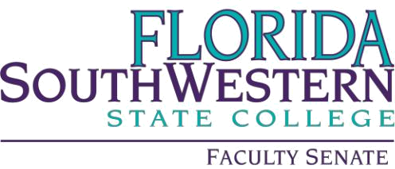

Minutes

Friday 11/3/2023
1:00 – 2:00 PM
Online via Zoom
Quorum of 34 at 1:01 pm

- Agenda Adoption and Minutes adoption

- Approval of the 11/3/2023 agenda and minutes

- Information Items:

- VPAA Update – Dr. Judith Bilsky
  - Accreditation process with the Higher Learning Commission is going smoothly. FSW was the first college approved in Florida and the application was so impressive, permission was asked and granted to use as a model for future applicants.
  - Certificates are now embedded within degrees. Many students (297) that had graduated were granted certificates retroactively.
  - Automated attendance verification beginning soon.
  - Please see online training for emergency preparation.
  - Saturday Scholars Program information:
    - Program is set in mini semesters
    - Concierge advising
    - Cohort model
    - Incentive ($250) for first 25 students
  - Hodges agreement: PT assistant program beginning soon, aiming for fall for medical assistant and supply chain.
    - Questions regarding renting Hodges buildings were discussed and concluded it is not financially responsible. Equipment will be purchased from Hodges, however.
  - Commencement 5/3- faculty procession will return.
  - Dr. Michelle Yovanovitch is on contract until June 30 and is working on First Generation Students.
  - Student Affairs contact for now: Ian Newhard
  - Budget is due April 2024
  - Disciplinary flow chart needs to be revised and streamlined to add Artificial Intelligence (AI)
- College Wide Updates – Dr. Tim Bishop – N/A
- Shared Governance Committee Update – No updates

- Action Items:

- NA

- Standing Committee Updates:

- Academic Standards: Prof. William VanGlabek
  - Improving Faculty handbook with access via new portal
  - Checking forms and handbooks for consistency
- Academic Technology: Prof. James Chan
  - Please look for surveys and complete
- Curriculum Committee: Prof. Jeremy Pilarski
  - Curriculog is disorganized, so we are looking to change to a new system in Summer 2024
- General Education Advisory Council: Prof. Dani Peterson
  - Creating technical writing courses, but in discussion phase only.
- Learning Assessment Committee: Dr. Jennifer Patterson
  - Assessment 101 – mini course on Canvas which is self-paced. Look for more professional development on this.
- Open Educational Resources (OER): Prof. Leonard Owens
  - Open-educational week March 4-8
- Professional Development: Dr. Scott Ortolano
  - Annual fund resources
  - Travel application
  - Conferences
  - Deadline 11/24 for January-March

- Faculty Updates – N/A

- New Business

- No official December meeting unless necessary

