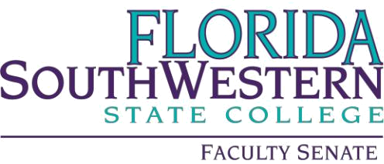

Meeting Minutes

Friday 10/6/2023
1:00 – 2:00 PM
Online via Zoom
Quorum of 44 at 1:00

- Agenda Adoption

- Agenda of 10/6/2023 approved

- Minutes Adoption

- Minutes of 9/1/2023 approved

- Information Items:

- VPAA Update – Dr. Judith Bilsky – N/A
- Simple Syllabus Notes – Dr. Scott Ortolano
  - The system locks six weeks into the semester. Dr. Roz Jester confirmed using Canvas calendar is the best way to get around this.
- Shared Governance Committee – looking for topics

- Action Items:

- NA

- Standing Committee Updates:

- Academic Standards: Prof. William VanGlabek
  - Satisfied with membership.
  - Handbook has been updated.
    - Program handbooks have been checked for consistency.
- Academic Technology: Prof. James Chan
  - Survey coming soon to full-time faculty and students.
- Curriculum Committee: Prof. Jeremy Pilarski
  - Reviews will be posted on Monday 10/9
  - Next meeting is 10/20
  - Artifact Storage – changes have been made to the page since Document Manager is no longer relevant.
  - In need of Health Professions representative
- General Education Advisory Council: Prof. Dani Peterson
  - Last meeting discussed membership and charge
    - No change to the committee charge
    - Meet third Friday of the month 10-11:30
    - https://www.fldoe.org/policy/articulation/general-edu-core-course-options.stml
- Learning Assessment Committee: Dr. Jennifer Patterson
  - In the process of revising mission
  - Some PD will come as a Canvas course and be self-paced.
  - Please share any suggestions for additional PD topics
- Open Educational Resources (OER): Prof. Leonard Owens (new chair)
  - Deciding on PD, especially in March during OER week
  - Any interest in joining, please contact Prof. Owens
  - Meetings are third Fridays at noon
- Professional Development: Dr. Scott Ortolano
  - Apply for December funds soon
  - Ancillary funds:
    - $150 can be applied to books, memberships, etc.

- Faculty Updates
- Questions and concerns regarding administration shifts with no communication

- New Business

