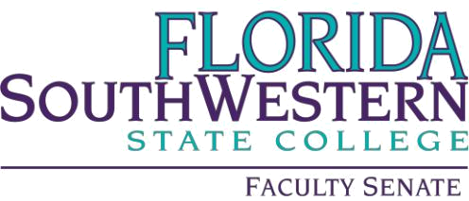

Agenda

Friday 9/1/2023
1:00 – 2:00 PM
Online via Zoom
Quorum of 50 at 1:01

- Agenda Adoption

- Approved 9/1/2023 agenda

- Minutes Adoption

- Approved 4/21/2023 minutes

- Information Items:

- Accreditation Update – FSW is the first college to be approved. The new accreditor is Higher Learning Commission (HLC)
- Shared Governance Committee Update – Dr. Bilsky is looking for new faculty members (10) especially those who do not have other committee obligations. The monthly meetings are on predetermined topics. Please contact Dr. Bilsky or Dr. Bishop if interested.
- Faculty Union Update: Dr. Peggy Romeo – concern for low membership numbers since the change in membership due automatic withdrawals. Please contact Dr. Romeo for assistance.

- Action Items:

- NA

- Standing Committee Updates: Standing Committee Chair Updates AY 23/24

The Senate president extended gratitude for the department chairs serving in this role especially due to the changes in the new contract.
Most committees had not met at the time of this meeting:

- Academic Standards: Prof. William VanGlabek – nothing to report
- Academic Technology: Prof. James Chan – nothing to report
- Curriculum Committee: Prof. Jeremy Pilarski – This committee meets on the third Friday of the month and needs new representation from Math and Sciences.
- General Education Advisory Council: Prof. Dani Peterson - need new representation Business and Technology.
- Learning Assessment Committee: Dr. Jennifer Patterson - need new representation from Humanities.
- Open Educational Resources (OER): Prof. Arenthia Herren - not present
- Professional Development: Dr. Scott Ortolano – Travel funds are stable, for now, and the application is now using the Qualtrics system. New opportunities were shared in the chat and faculty is encouraged to stay updated via emails.
- Simple Syllabus – Dr. George Kodsey – minutes were shared with the Senate President after the Senate meeting and subsequently forwarded to faculty. The topic of syllabi revision limits was discussed.
- OTOC – Dr. Brandon Jett – Limited events due to a decrease in funding. Please attend the 9/21/23 event with Dr. Carolyn Sanderson on the Science of Happiness, J-103 at 2:00 pm.

- Faculty Updates – N/A

- New Business – the topic of newly appointed trustees of the Board was discussed.

Adjourned

Minutes prepared by Kerri Posner

