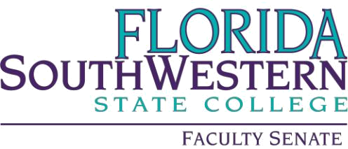

Agenda

Friday 3/1/2024
1:00 – 2:00 PM
Online via Zoom
Meeting ID: 828 1587 9163

- Agenda Adoption

- Approval of the 3/1/2024 Agenda

- Minutes Adoption

- Approval of 2/2/2024 minutes

- Information Items:

- VPAA Update – Dr. Judith Bilsky
- Shared Governance Committee Update – Dr. Tim Bishop
- Standing Committee Membership Reminder – Dr. Tim Bishop
- FSW Courtesy Appointments Proposal – Dr. Gabriel Gaidos

- Action Items:

- COP on Academic Integrity – Prof. William VanGlabek

- Standing Committee Updates:

- Academic Standards: Prof. William VanGlabek
- Academic Technology: Prof. James Chan
- Curriculum Committee: Prof. Jeremy Pilarski
- General Education Advisory Council: Prof. Dani Peterson
- Learning Assessment Committee: Dr. Jennifer Patterson
- Open Educational Resources (OER): Prof. Leonard Owens
- Professional Development: Dr. Scott Ortolano

- Faculty Updates

- New Business

