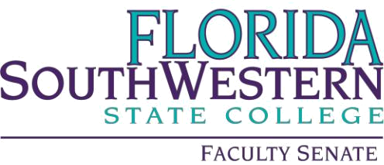

Meeting Minutes

Friday 1/20/2023
1:00 – 2:00 PM
Locations: online via Zoom
Quorum of 79 at 1:08 PM

- Agenda Adoption: motion to adopt by Gus Cameron; second by Sara Dustin; motion passed.

- Minutes Adoption: Approval of the 11-18-2022 minutes: motion to adopt by Gus Cameron; second by Sara Dustin; motion passed.

- Information Items
  - VPAA, Judith Bilsky:
Discussed Department of Education statement aand Florida College President’s letter, which included FSW, regarding stance on programs of DEI. Discussed that the college had to comply with the request from the Governor’s office and submit class names that discussed topics associated with DEI. She encouraged faculty to attend the State of the College with the assumption it would be addressed.

  - One Book, One College Transition: Brandon Jett:
OBOC will turn into OTOC using a theme instead of a book. The focus will be of a “shared academic experience” and theme recommendations will be from everyone at FSW, not just faculty.

c. Committee / College Updates:
Simple Syllabi: George Kodsey shared his PowerPoint (attached)

Academic Standards: Vera Verga:
Academic Dishonesty Process – flowchart attached; please review for future vote (most likely at February meeting). A tab will be included within Grades on Canvas to streamline the process.
ChatABT (AI chat bot) was discussed (notes attached)

Academic Technology: Ellie Bunting:
Still looking for a new chair
Discussion on Flex options with Jill Hummel
Chat ABT

Curriculum Committee: Sheila Seelau:
Deadlines: 2/6 for proposals for March meeting
3/6 for proposals for April meeting.
Curriculog will be in place by Fall 2024
Committee opening for AS nursing program representative

GEAC: Dani Peterson:
Updating designation definitions (general education, writing intensive, etc.) and creating checklists from those designations to help guide faculty members who are updating their courses or proposing new courses. GEAC will use these checklists as a guide for determining whether a course can carry those designations.

Currently two open spots on GEAC, 1) Social Sciences 2) Pure and Applied Sciences.

Definitions of General Education
Openings available Pure & Applied Science as well as Arts, Humanities & Social Sciences

LAC: Jennifer Summary
Discussing scoring for Visualize & Engage

OER: Arenthia Herren
Showcase 3/9

PD: Scott Ortolano
Ancillary funds are still available, but not to be used for technology.
Technology requests should go through the IT office.
Deadline: 2/24 for travel funds for April-June

- Action Items: N/A
- Faculty Updates: N/A
- New Business: N/A

- Motion to adjourn by Gus Cameron and seconded by Dani Peterson

Minutes by Kerri Keough Lampos, 1/20/23

