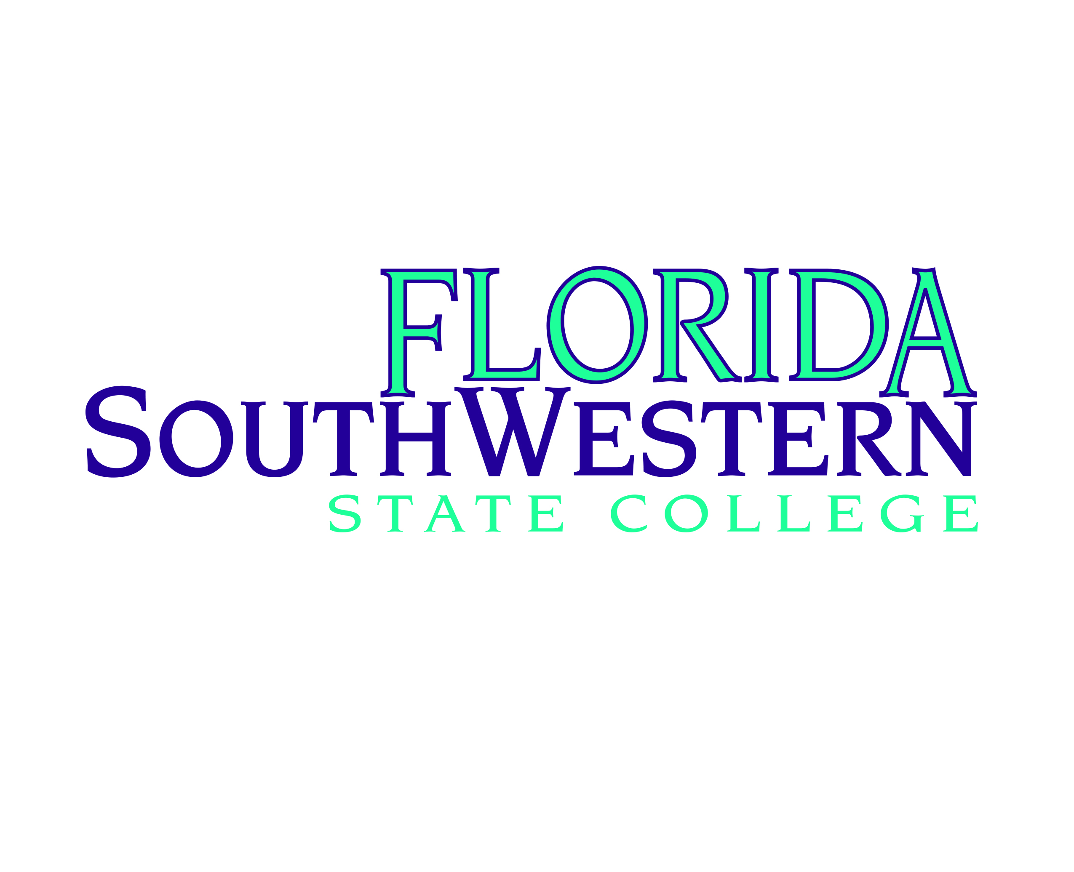
Date

Name
Address

Dear Name:

Florida SouthWestern State College acknowledges the receipt of your gift on date of item valued in the amount of $amount accepted by Name, Title of Department and Campus.

In accordance with IRS Code Section 6115, the College declares that the amount of the gift, which is deductible for federal income tax purposes, is limited to the excess of the value of goods, services and/or other privileges provided by the College.

Accordingly, there were no goods, services or other privileges provided by the college related to this contribution.

Florida SouthWestern State College, Federal ID 59-1211051, is a public educational institution authorized by the laws of the State of Florida and the Florida State Board of Education and is a political subdivision of the state of Florida in accordance with United States of America, Department of the Treasury, Internal Revenue Service, Code §170.00.

Sincerely,

Gina Doeble, EdD, CPA
Vice President of Operations

GD/initials

