MEMORANDUM OF UNDERSTANDING BETWEEN
FLORIDA SOUTHWESTERN STATE COLLEGE
AND
FLORIDA SOUTHWESTERN STATE COLLEGE FACULTY FEDERATION

This is a Memorandum of Understanding concerning the agreement between the Florida SouthWestern State College, FL (hereinafter “College”) and the Florida SouthWestern State College Faculty Federation (hereinafter “Union”).

WHEREAS, the College and Union have a Collective Negotiations Agreement in effect from July 1, 2019 to June 30, 2021 , and

WHEREAS, Article 4, Section 4.3 outlines the reassigned time for Standing Committee Chairs mutually negotiated by both parties;

WHEREAS, both parties wish to further clarify the intent of the language negotiated;

NOW, THEREFORE, and in consideration of the mutual promises to each other, as hereinafter set forth, the parties hereto do mutually agree that Section be amended as follows:

4.3 Standing Committees

A. The College will maintain the following standing committees consisting of faculty and representatives from the administration, faculty, and staff as appropriate to review and/or prepare recommendations for the Provost:
- Academic Standards Committee
- Academic Technology Committee
- Curriculum Committee
- General Education Advisory Council
- Learning Assessment Committee
- Professional Development Committee
- Continuing Contract Review Committee

The Chair of the Curriculum will be granted six (6) hours of re-assigned time from instructional duties for each major academic term. The Vice-Chair of the Curriculum Committee and the Chair of the remaining of these committees will be granted three (3) hours of re-assigned time from instructional duties for each major academic term.

IN WITNESS WHEREOF, the authorized representatives of the parties have executed this Agreement on this 4th day of May 2020.

Florida SouthWestern State College Florida SouthWestern State College
Faculty Federation

By: By: 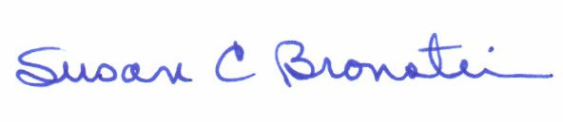

Chief Human Resources & Organizational
Title:_President, FSW State College Faculty Federation Development Officer

