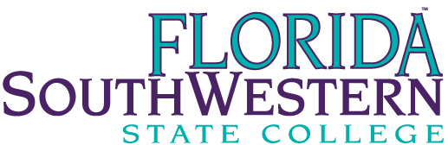

FACULTY CONTRACT RECOMMENDATION FORM
CONTRACT PERIOD - 2018 - 2019
Employee Name |  |  |  | Banner ID
Position Number |  | School |  | Campus
Prepared By | Annual Salary $ |  |  | Date

INSTRUCTIONS: This form should be used for all full-time faculty members, whether or not the faculty member is due a formal performance evaluation this year.

A. | CLASSIFICATION: (Check the appropriate block)
 |  | Instructional Faculty
 |  | Library Faculty/Counselors
B. | CONTRACT TYPE: (Check the appropriate block)
 |  | Renewal of Annual Contract
 |  | Non-renewal of Annual Contract
 |  | Continuation on Annual Contract* (Continuing Contract Eligible)
 |  | Initial Granting of Continuing Contract*
 |  | Return to Annual Contract*
C. | DUTY DAYS: (Check the appropriate block)
 |  | Instructional Faculty – 166 Duty Days
 |  | Library Faculty/Counselors – 208 Duty Days
 |  | Other (Specify):*
*Above denotes an item requiring documentation on separate sheets attached to this form.

D. | SIGNATURES:
Faculty Member |  |  | Date
Dean of School (if different from Supervisor) |  |  | Date
Provost/Vice President, Academic Affairs |  |  | Date
HR-023(Revised 2014, 2018)

