  INTERLIBRARY LOAN  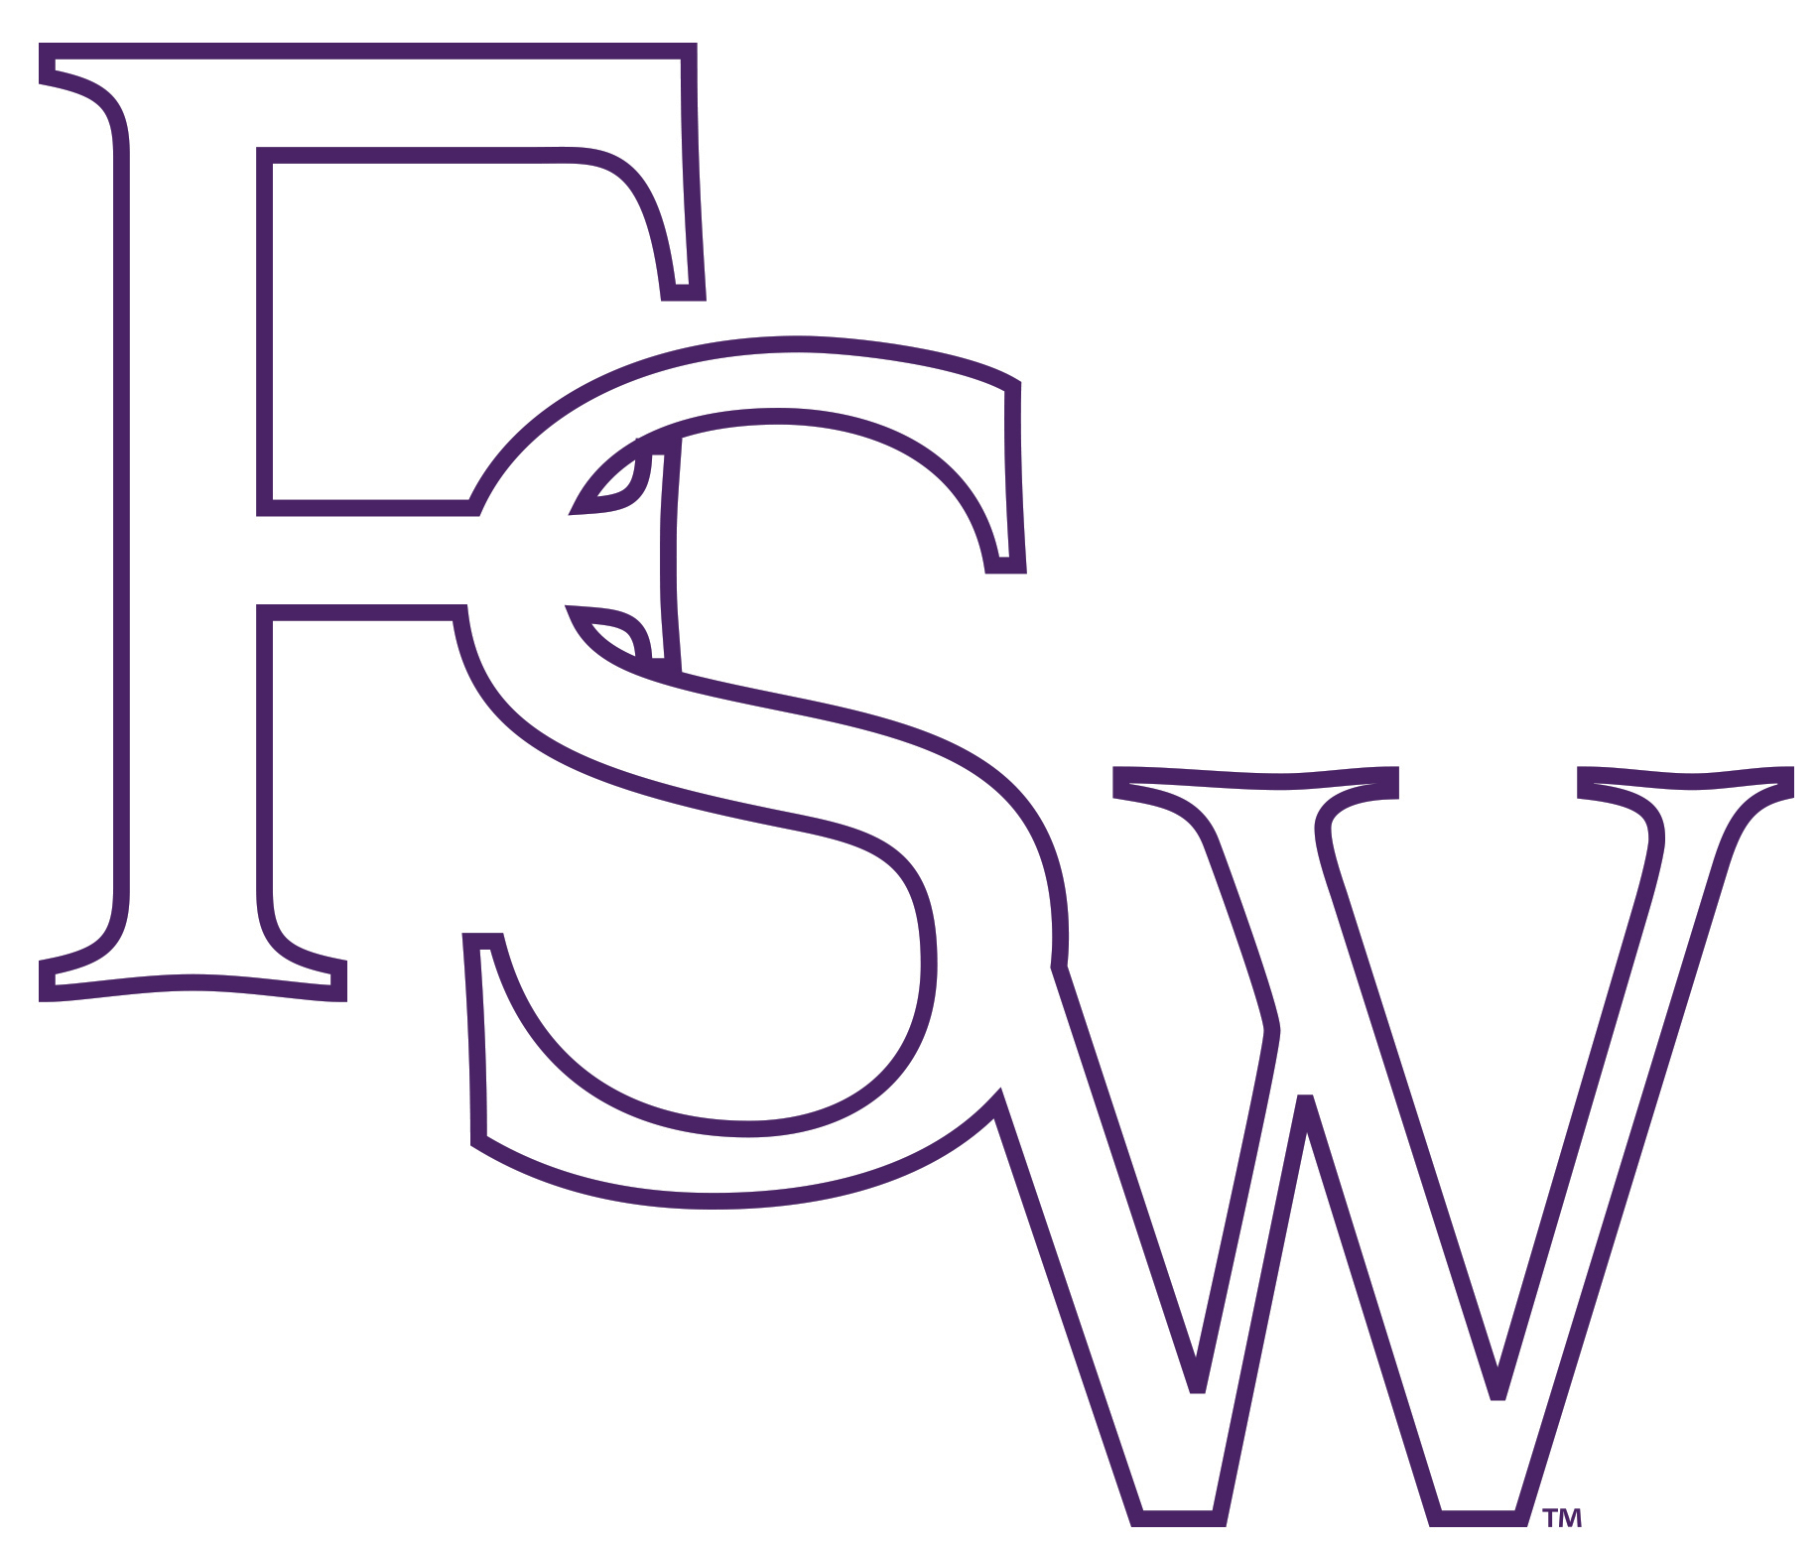  FSW LIBRARIES  8099 COLLEGE PKWY  FT. MYERS, FL 33919 |  | D  O  N  O  T  R  E  M  O  V  E  L  A  B  E  L
  NAME:_________________________________________ |  | D  O  N  O  T  R  E  M  O  V  E  L  A  B  E  L
  DUE DATE: ____________________________________ |  | D  O  N  O  T  R  E  M  O  V  E  L  A  B  E  L
  Lender #: _____________ Borrower #: _____________ |  | D  O  N  O  T  R  E  M  O  V  E  L  A  B  E  L
  RENEW BEFORE DUE DATE |  | D  O  N  O  T  R  E  M  O  V  E  L  A  B  E  L
  INTERLIBRARY LOAN  FSW LIBRARIES  8099 COLLEGE PKWY  FT. MYERS, FL 33919 |  | D  O  N  O  T  R  E  M  O  V  E  L  A  B  E  L
  NAME:_________________________________________ |  | D  O  N  O  T  R  E  M  O  V  E  L  A  B  E  L
  DUE DATE: ____________________________________ |  | D  O  N  O  T  R  E  M  O  V  E  L  A  B  E  L
  Lender #: _____________ Borrower #: _____________ |  | D  O  N  O  T  R  E  M  O  V  E  L  A  B  E  L
  RENEW BEFORE DUE DATE |  | D  O  N  O  T  R  E  M  O  V  E  L  A  B  E  L
  INTERLIBRARY LOAN  FSW LIBRARIES  8099 COLLEGE PKWY  FT. MYERS, FL 33919 |  | D  O  N  O  T  R  E  M  O  V  E  L  A  B  E  L
  NAME:_________________________________________ |  | D  O  N  O  T  R  E  M  O  V  E  L  A  B  E  L
  DUE DATE: ____________________________________ |  | D  O  N  O  T  R  E  M  O  V  E  L  A  B  E  L
  Lender #: _____________ Borrower #: _____________ |  | D  O  N  O  T  R  E  M  O  V  E  L  A  B  E  L
  RENEW BEFORE DUE DATE |  | D  O  N  O  T  R  E  M  O  V  E  L  A  B  E  L
  INTERLIBRARY LOAN  FSW LIBRARIES  8099 COLLEGE PKWY  FT. MYERS, FL 33919 |  | D  O  N  O  T  R  E  M  O  V  E  L  A  B  E  L
  NAME:_________________________________________ |  | D  O  N  O  T  R  E  M  O  V  E  L  A  B  E  L
  DUE DATE: ____________________________________ |  | D  O  N  O  T  R  E  M  O  V  E  L  A  B  E  L
  Lender #: _____________ Borrower #: _____________ |  | D  O  N  O  T  R  E  M  O  V  E  L  A  B  E  L
  RENEW BEFORE DUE DATE |  | D  O  N  O  T  R  E  M  O  V  E  L  A  B  E  L
  INTERLIBRARY LOAN  FSW LIBRARIES  8099 COLLEGE PKWY  FT. MYERS, FL 33919 |  | D  O  N  O  T  R  E  M  O  V  E  L  A  B  E  L
  NAME:_________________________________________ |  | D  O  N  O  T  R  E  M  O  V  E  L  A  B  E  L
  DUE DATE: ____________________________________ |  | D  O  N  O  T  R  E  M  O  V  E  L  A  B  E  L
  Lender #: _____________ Borrower #: _____________ |  | D  O  N  O  T  R  E  M  O  V  E  L  A  B  E  L
  RENEW BEFORE DUE DATE |  | D  O  N  O  T  R  E  M  O  V  E  L  A  B  E  L
  INTERLIBRARY LOAN  FSW LIBRARIES  8099 COLLEGE PKWY  FT. MYERS, FL 33919 |  | D  O  N  O  T  R  E  M  O  V  E  L  A  B  E  L
  NAME:_________________________________________ |  | D  O  N  O  T  R  E  M  O  V  E  L  A  B  E  L
  DUE DATE: ____________________________________ |  | D  O  N  O  T  R  E  M  O  V  E  L  A  B  E  L
  Lender #: _____________ Borrower #: _____________ |  | D  O  N  O  T  R  E  M  O  V  E  L  A  B  E  L
  RENEW BEFORE DUE DATE |  | D  O  N  O  T  R  E  M  O  V  E  L  A  B  E  L

