 |  | 
  OCLC INTERLIBRARY LOAN  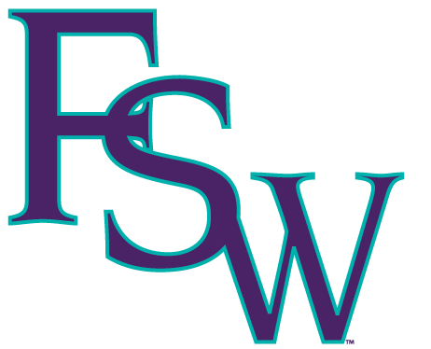  FSW LIBRARIES  8099 COLLEGE PKWY  FT. MYERS, FL 33919 |  | D  O  N  O  T  R  E  M  O  V  E  LA  B  E  L
  IL: |  | D  O  N  O  T  R  E  M  O  V  E  LA  B  E  L
  DATE DUE: |  | D  O  N  O  T  R  E  M  O  V  E  LA  B  E  L
  PATRON: |  | D  O  N  O  T  R  E  M  O  V  E  LA  B  E  L
  BARCODE: |  | D  O  N  O  T  R  E  M  O  V  E  LA  B  E  L
  RENEW BEFORE DUE DATE |  | D  O  N  O  T  R  E  M  O  V  E  LA  B  E  L
  OCLC INTERLIBRARY LOAN  FSW LIBRARIES  8099 COLLEGE PKWY  FT. MYERS, FL 33919 |  | D  O  N  O  T  R  E  M  O  V  E  LA  B  E  L
  IL: |  | D  O  N  O  T  R  E  M  O  V  E  LA  B  E  L
  DATE DUE: |  | D  O  N  O  T  R  E  M  O  V  E  LA  B  E  L
  PATRON: |  | D  O  N  O  T  R  E  M  O  V  E  LA  B  E  L
  BARCODE: |  | D  O  N  O  T  R  E  M  O  V  E  LA  B  E  L
  RENEW BEFORE DUE DATE |  | D  O  N  O  T  R  E  M  O  V  E  LA  B  E  L
  OCLC INTERLIBRARY LOAN  FSW LIBRARIES  8099 COLLEGE PKWY  FT. MYERS, FL 33919 |  | D  O  N  O  T  R  E  M  O  V  E  LA  B  E  L
  IL: |  | D  O  N  O  T  R  E  M  O  V  E  LA  B  E  L
  DATE DUE: |  | D  O  N  O  T  R  E  M  O  V  E  LA  B  E  L
  PATRON: |  | D  O  N  O  T  R  E  M  O  V  E  LA  B  E  L
  BARCODE: |  | D  O  N  O  T  R  E  M  O  V  E  LA  B  E  L
  RENEW BEFORE DUE DATE |  | D  O  N  O  T  R  E  M  O  V  E  LA  B  E  L
  OCLC INTERLIBRARY LOAN  FSW LIBRARIES  8099 COLLEGE PKWY  FT. MYERS, FL 33919 |  | D  O  N  O  T  R  E  M  O  V  E  LA  B  E  L
  IL: |  | D  O  N  O  T  R  E  M  O  V  E  LA  B  E  L
  DATE DUE: |  | D  O  N  O  T  R  E  M  O  V  E  LA  B  E  L
  PATRON: |  | D  O  N  O  T  R  E  M  O  V  E  LA  B  E  L
  BARCODE: |  | D  O  N  O  T  R  E  M  O  V  E  LA  B  E  L
  RENEW BEFORE DUE DATE |  | D  O  N  O  T  R  E  M  O  V  E  LA  B  E  L
  OCLC INTERLIBRARY LOAN  FSW LIBRARIES  8099 COLLEGE PKWY  FT. MYERS, FL 33919 |  | D  O  N  O  T  R  E  M  O  V  E  LA  B  E  L
  IL: |  | D  O  N  O  T  R  E  M  O  V  E  LA  B  E  L
  DATE DUE: |  | D  O  N  O  T  R  E  M  O  V  E  LA  B  E  L
  PATRON: |  | D  O  N  O  T  R  E  M  O  V  E  LA  B  E  L
  BARCODE: |  | D  O  N  O  T  R  E  M  O  V  E  LA  B  E  L
  RENEW BEFORE DUE DATE |  | D  O  N  O  T  R  E  M  O  V  E  LA  B  E  L
  OCLC INTERLIBRARY LOAN  FSW LIBRARIES  8099 COLLEGE PKWY  FT. MYERS, FL 33919 |  | D  O  N  O  T  R  E  M  O  V  E  LA  B  E  L
  IL: |  | D  O  N  O  T  R  E  M  O  V  E  LA  B  E  L
  DATE DUE: |  | D  O  N  O  T  R  E  M  O  V  E  LA  B  E  L
  PATRON: |  | D  O  N  O  T  R  E  M  O  V  E  LA  B  E  L
  BARCODE: |  | D  O  N  O  T  R  E  M  O  V  E  LA  B  E  L
  RENEW BEFORE DUE DATE |  | D  O  N  O  T  R  E  M  O  V  E  LA  B  E  L

