
To find a book

Go to Library home page at www.edison.edu/library/

There is a grey search box near the top of the web page. The default tab is Books and Film. This will search the catalog.

Enter your keyword search terms and click Search

Click on any title link and additional information will appear to check Call Number, location and availability

Book(s) may be requested from other libraries (Inter Library Loan)
Lending Privileges

Books, CD's and Audiotapes
Faculty/ Staff 42 Days 30 Items
Students 21 Days 20 Items
Community Patrons 21 Days 5 Items
Videos and DVD's
Faculty/Staff 3 Days
Students 3 Days

Course Reserve Materials
Students 2 Hours (or as indicated)

Telecourse/ Distance Learning Materials
You must be enrolled in the class.
Please show proper ID and class schedule.
Items may be loaned until the end of the current semester
To find an article/use the databases

You'll need a Connect card to access the databases, both on and off campus

Go to Library home page at www.edison.edu/library/
There is a grey search box near the top of the web page. Click on tab Articles in Databases.
Enter your 8 digit code (off your Connect ID card)
Enter your PIN number
Select a relevant database and begin searching

Need assistance using databases?
Click on Research Guides tab for suggestions from your Edison Research Librarians !
Select a subject to find database, book, film, and website suggestions for your research

Printing/Copying and Saving
You must buy a PRINT CARD to print in the library! Purchase a card in the Library.
A copier is available in the library and the charge is .05 cents a page using your PRINT CARD only.
We strongly recommend a USB flash drive to save your documents. Our computers will not allow you to save to their hard drives.
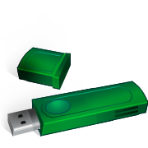
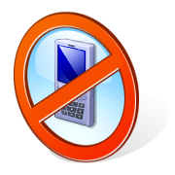
All cell phones and pagers must be turned off or in silent mode.
Please go outside if you need to speak on your phone. Thank You!
Revised Fall 2011
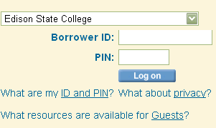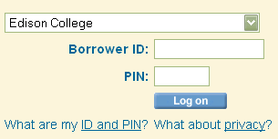
Overdue & Lost Materials
Replacement costs for lost material are set by the Board of Trustees and include administrative and overhead charges. Edison College charges replacement costs for overdue or lost materials solely to secure their prompt return. You can renew your material online or at the Circulation Desk.
The Edison College Library Card must be presented to check out materials. Cards are not transferable and cardholders are responsible for all materials charged to their accounts. If you have a change of address, it is your responsibility to notify the library and/or Edison College with current information. When you receive "late notices" it is your responsibility to respond and take action concerning late or lost materials.

Monday - Thursday 7:30 AM – 9:00 PM
Friday 7:30 AM – 4:30 PM
Saturday 9:00 AM – 2:00 PM
Sunday CLOSED

COLLIER CAMPUS LIBRARY
G Building
(239) 732-3774
http://www.edison.edu/library/
Edison Libraries

Collier Campus Student Activities/ Clubs
http://www.edison.edu/collier/campusclubs.php
Your Edison Email and WEBCT
To get to WEBCT/Edison Portal:
http://my.edison.edu
Login to Edison College Online System
Follow Directions
Password problem? Call Help Desk: 489-9202 (On Collier Campus: ext. 1202)

To find a syllabus for Distance Learning Class:

Go to http://www.edison.edu/elearning/
Click on "Courses & Syllabi"
Choose your semester & classes/courses
Learning Assistance Lab J-204

Monday - Friday 9:00AM - 9:00PM

TUTORS are located in the Learning Assistance Lab

Anthony P. Valenti

Collier Campus Director-Learning Resources
7007 Lely Cultural Parkway
Naples, FL 34113
(239) 732-3776
apvalenti@edison.edu
IMPORTANT NUMBERS

Admissions | M Bldg | 3701/3702/3704
Advising | M Bldg | 3703
Biology Lab | E-109 | 3604
Book Store | M Bldg | 3738
Career Center | A-144 | 3792
Cashier | M Bldg | 3714
Chemistry Lab | E-121 | 3606
Computer Lab | G-117 | 3774
Financial Aid | M Bldg | 3705
Library | G Bldg | 3774
Learning Assistance  Lab/ Math/English | J-204 | 3773
Nursing/AP | J-117 | 3745
Nursing/Basic | J-117 | 3748
Peer Tutorial Lab | J-204 | 3771/3916
Physics Lab | E-108 | 3793
Security | A-135 | 3712
Student Government | A-118 | 3736
Testing Lab | J-217 | 3706

All extensions listed above follow (239) 732-xxxx format.
Collier Campus Continuing Education
http://www.edison.edu/collier/ce/

Registration Hours
Monday - Thursday 8:30 AM - 7:00 PM
Friday 8:30 AM - 4:30 PM

Academic Advising Hours
Monday - Thursday 8:30 AM - 7:00 PM
Friday 8:30 AM - 4:30 PM

No appointments necessary
Testing Center Hours:
http://www.edison.edu/elearning/testing
FOR DISTANCE LEARNING EXAMS YOU MUST HAVE: Photo Identification, Course No., Course Name, Professor Name, Type of Exam (telecourse, internet, compressed video, distance).

Bookstore Hours:
Monday & Tuesday 9:00 AM – 6:00 PM
Wednesday & Thursday 9:00 AM – 4:00 PM
Friday 9:00 AM – 1:00 PM

