Step 1 – Click Reports
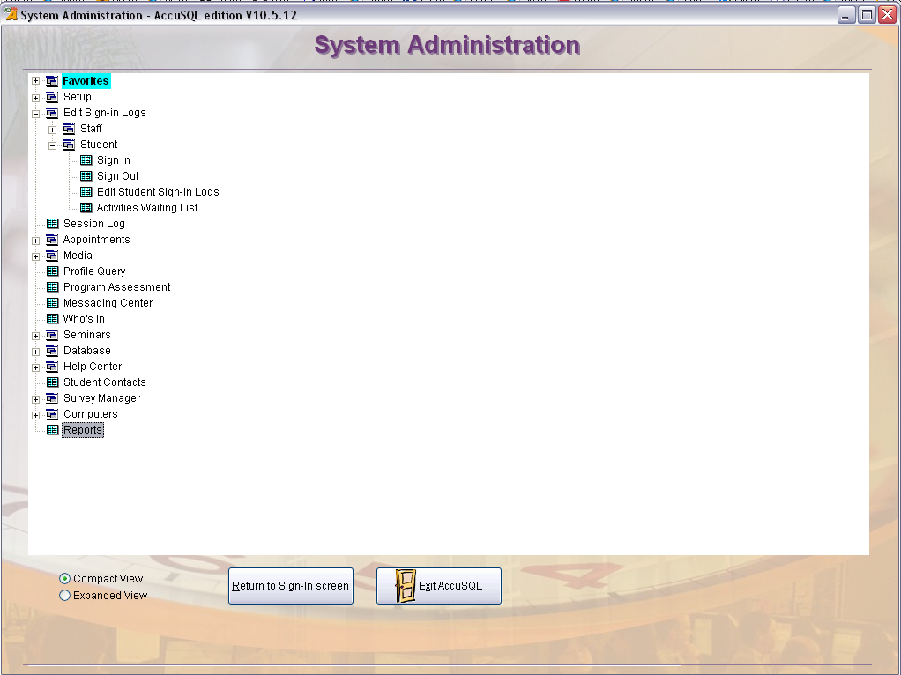
STEP 1
Step 2 – Click the “ + ” next to the report category to expand it
Step 3 – Select the desired report
Step 4 – Set your filters for the selected report by date (period), Activities, Instructors, etc. by using the panels on the right side of this screen

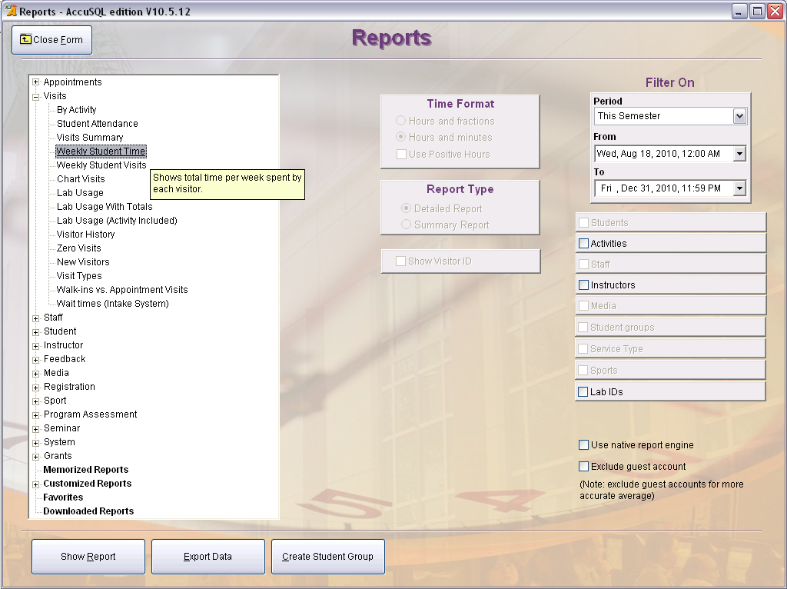
STEP 3
STEP 4
STEP 2
Step 5 – Select your filter criteria (use the shift or the “Ctrl” key when clicking to highlight multiple lines)
Step 6 – Close the form
Step 7 – Click “Show Report” to display the report as a PDF. For Excel, click “Export Report” and select “Excel Direct” from the menu.

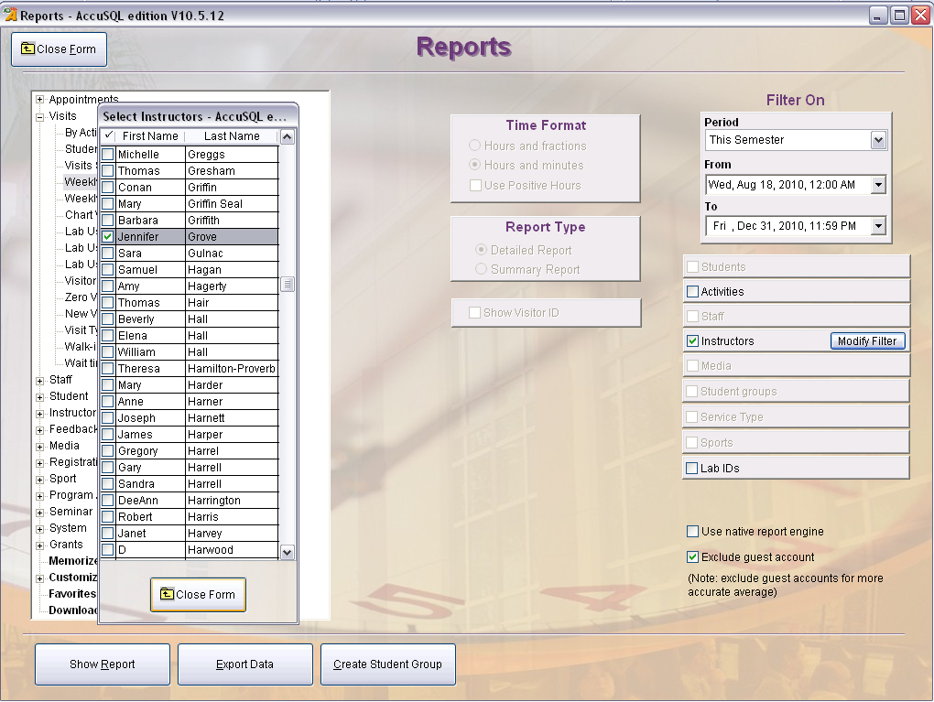
STEP 5
STEP 7
STEP 6

