- Sign into AccuTrack System Administration using the Expanded User account (99999999 / Accupass123)
- Click Setup Student Setup Students

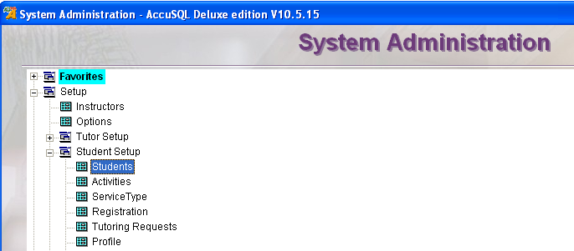

- Confirm that the student is not in AccuTrack by searching through the existing students on this screen (Tip: You can type in last names/student IDs or sort the columns for a faster search)
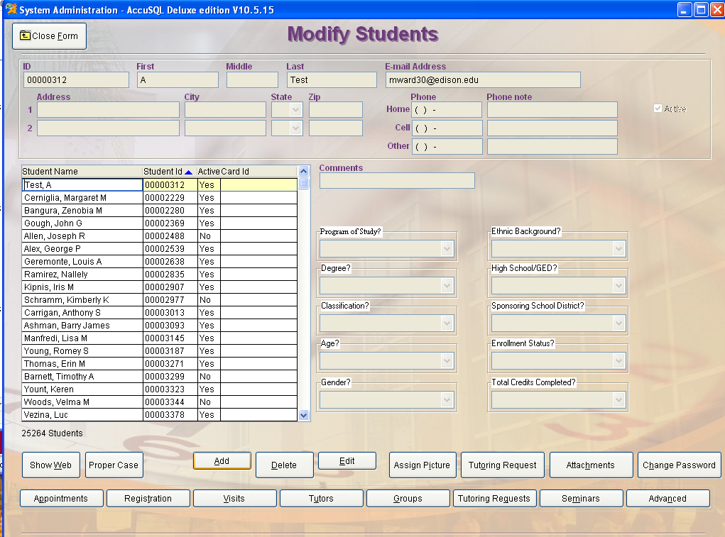
- Click Add
- Type in the following for the new student:
  - 8 digit Banner ID (no “@” symbol),
  - First Name,
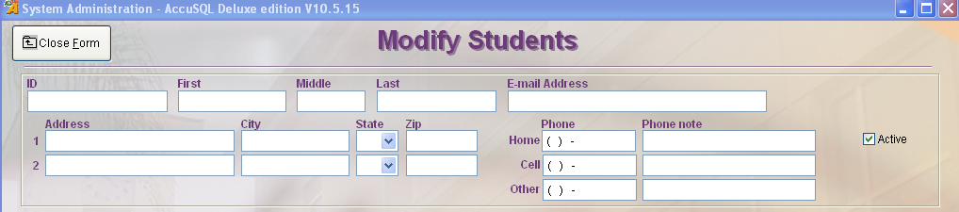
  - Last Name and
  - School email address

- Click Save

