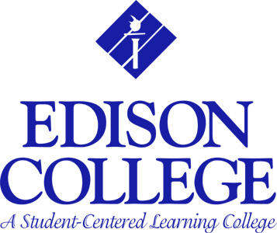

LEARNING RESOURCES USERS SURVEY

The Learning Resources is committed to offering students the best possible service, support, and access to necessary information resources. Please assist us in evaluating our services and resources by completing this user survey.

CIRCLE YOUR CHOICE

- How satisfied are you with the quality of services at the Learning Resources?

- Always
- Usually
- Sometimes
- Not very often

- Do you generally find the resources in print that you are looking for within the Learning Resources collection?

- Always
- Usually
- Sometimes
- Not very often

- Do you generally find the resources in electronic format that you are looking for within the Learning Resources collection?

- Always
b. Usually
- Sometimes
- Not very often

- How often do you approach the Reference Desk for help?

- Frequently
- Sometimes
- Not that often
- Only once
- Never

- On average, how long do you have to wait before receiving help at the Reference Desk?

- One (1) minute or less
- Under five minutes
- 5 to 10 minutes
- I walked away a few times because the Librarian was too busy.

Please turn over and complete the next page of this survey.

LEARNING RESOURCES USERS SURVEY

Page 2

- The Reference Librarians are

- Always willing to assist
- Willing to spend quality time with you, but are always busy
- Somewhat abrupt
- Preoccupied, usually chatting, reading or using the computer

7. How would you describe the help you receive from Reference Librarians?

- Above average, the answers are always accurate
- Average, usually steer you in the right direction
- Fluctuates, the information is not always useful
- Poor, usually steer you in the wrong direction

8. How important to you is the Learning Resources as a place to study?

- Very important
- Important
- Somewhat important
- Not too important
- Not important at all

- Do you have any suggestions for library materials that you think might be useful for Edison’s Learning Resources? Please include as much information as possible in identifying the item. Example: Titles and authors of the books.

CIRCLE ONE: Are you –

a. An Edison College student
b. A member of the community
c. Other_________________________________________________
COMMENTS OR SUGGESTIONS:
LRC-020

