- I cannot log into the databases or eBooks but have a borrower ID number—how do I delete cookies, etc.?
  - In Internet Explorer 6:
    - Go to Tools>Internet Options…>Under the General Tab click “Delete Cookies…”> OK.
  - In Firefox:
    - Go to Tools>Options…>Under the Privacy Tab click “Settings” in the Private Data portion>In the dialog window check mark: Cache, Cookies, and Authenticated Sessions>OK>Click “Clear Now”>OK.
  - In Safari:
    - Go to Edit>Empty Cache…
  - Most Databases will NOT accept the Google Chrome Browser or Dial-up connections.
- I can not print from my computer – what should I do?
  - Try to reprint the original Document with the student:
    - If, the computer at which the student is printing has a box that says “ERROR – Open Printer.” Then, that computer must be restarted to reinitialize the printing script. HAVE THE STUDENT SAVE WORK to an email, jump drive, or the Student on “Spiff” Drive.
    - If, the computer does not pop up with any box then, follow the same procedure as above.
  - Be sure the student is typing in a user name at the sending computer and at the release terminal.
  - NOTE: Print jobs are cleaned from the print server after 2 hours from when they were originally sent.
- The print release terminal is acting up – can you fix it?
  - If, the print release terminal screen will not let you perform any actions [i.e. clicking buttons or appears frozen] then, restart the print machine by holding in the power button until it turns off.
    - Print jobs are stored on a server and not the actual release station so data will not be lost.
- My memory stick is not working – what do I do?
  - Try restarting the machine with the Memory stick plugged in.
    - If, the student has any active documents then, please save them to an email or the Student on “Spiff” Drive.
    - If, the reboot cycle does not fix the problem and the computer asks for “Administrator” then, the staff can enter the username/password combination to install the device.

- How do I save documents to the hard drive [S: Drive]?
  - In Word or any of the Office programs click on the circular windows icon at the top left-hand corner of the screen. Select Save as…>When the dialog box appears on the screen select “My Computer” on the left-hand side>Double click on Student on “Spiff” (S:)>Have the student create a personalized folder for themselves by clicking on the “create new folder icon” >Give the file a name and click Save.
- How do I retrieve information from a floppy disk?
  - See the Circulation Desk to open the file and email to student.
    - If, the student only wishes to read the contents then, they can use the Research Instruction Lab [if it is not in use].
  - See the Student Technology Support Center in K-121.
- How do I print a PowerPoint with 3 or 6 slides per page?
  - In Microsoft Office PowerPoint 2003:
    - Click File>Print…>In the “Print what:” section click the Drop-down menu and select “Handouts”>in the “Handouts” section [directly to the right] select the desired amount of slides per page>OK.
      - NOTE: Only the 3 Slides per page selection will provide note space on the right-hand side of the page.
  - In Microsoft Office PowerPoint 2007:
    - Click the Circular Windows icon in the top left-hand corner>Print…>In the “Print what:” section click the Drop-down menu and select “Handouts”>in the “Handouts” section [directly to the right] select the desired amount of slides per page>OK.
      - NOTE: Only the 3 Slides per page selection will provide note space on the right-hand side of the page.
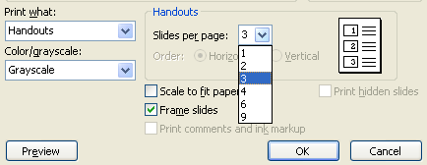

- How do I create a PowerPoint?
  - Open PowerPoint and use the pre-designed slides.
  - For more PowerPoint assistance visit the Student Technology Support Center in K-121.
- How do I open a file, start a new document, or save a file in new Word?
  - In Microsoft Office 2007, the top menu bar has been removed and combined together under the Circular Windows icon in the top left-hand corner. This is where the New document, Open file, Save, and Print buttons are located.
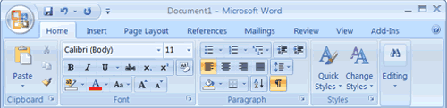
- How do I double-space in new Word?
  - In Microsoft Office Word 2007:
    - Select all text and then click the Home tab>In the Paragraph section>select the line spacing icon and click “More”> in the Spacing section use the “Line Spacing” Drop-down and select “Double”>In the “after:” spot type 0>OK.
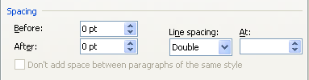
- How do I adjust margins in new Word?
  - In Microsoft Office Word 2007:
    - Go to Page Layout tab>in the Page Setup group>click Margins> Top 1”, Bottom 1”, Left 1”, Right 1”.
- How do I insert a header or footer in Word? E.g., name and page number
  - In Microsoft Office Word 2007:
    - Go to the Insert Tab>Page Number>Plain Number 3 for Right justified Page Numbering. Insert 3 spaces then type Last Name or Short Title.
- How do I make a Hanging Indent for my MLA and APA papers?
  - In Microsoft Office Word 2003:
    - Select all citation text and then click>Format>Paragraph…>in the Indentation section use the “Special:” Drop-down and select “Hanging”>OK.
  - In Microsoft Office Word 2007:
    - Select all citation text and then click the Home tab>In the Paragraph section>select the line spacing icon and click “More”> in the Indentation section use the “Special:” Drop-down and select “Hanging”> OK.
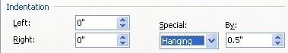
- The right printer station [facing North] will not print.
  - Press the “Go” button if the screen of the printer says “80 Scheduled Maintenance.” The printer will then print after warming up.
- I am having problems accessing myEdison portal – I can not login. Can you help?
  - Go to http://my.edison.edu/
  - Have the student click on the “Forgot your password, locked your account, or first time user?” Link.
  - Have them enter their personal information for verification purposes.
  - Click the button at the bottom of the screen and their account will be reset.
    - Have them write down the new password or account information.
      - Then have them then try logging into their account.
    - If, the account is not reset Peggy, Jill, or Steven can reset accounts OR send them to K-121 for more assistance.
