MINUTES
School of Education Meeting
Wednesday, February 24, 2010
5:30-7:30 PM J-326

Meeting commenced at 5:30 p.m.

In attendance: Dr. Erin Harrel, Dr. Eileen DeLuca, Professor Joyce Rollins, Professor Peggy Van Voorhis, Professor William Dwyer, Professor Ellen Reinig, Professor Mary Ellen Schultz, Professor Steve Bedford, Professor Michelle Propper, Dr. Martin Tawil, Professor Kim Lonergan, Professor Ellen Keegan, Professor Joyce Gelfand, Professor Jane McWeeny, Professor Joanne Devine, Dr. Christy Duda, Ms. Barbara Miley, Professor Donnalee Washburn, Professor Mary Harder, Professor Margaret Desjardins, Professor Betty Campbell

- The Associate Dean of the School of Education, Dr. Erin Harrel (eharrel@edison.edu) welcomed the faculty.
- Dr. DeLuca thanked present faculty for work on syllabi revisions. Full-time and adjunct faculty from Lee, Charlotte, and Collier County participated in revising learning outcomes, aligning learning outcomes with General Education Competencies, creating common assignments, and designing rubrics.
- Dr. DeLuca and Professor Rollins led a “World Café” activity allowing faculty to discuss three topics: 1. “What is going well?/What are you jazzed about?,” 2. “What are your frustrations?”, 3. “What is confusing to you?/What are your questions?/What kind of support do you need?” Faculty moved from table to table to discuss topics and to create a “graffiti” record on chart paper. A summary of responses appears below.

What is going well?/What are you jazzed about?
Working at ESC
Students’ positive attitudes
Students work hard and want to achieve
Partnership with Fort Myers Middle Academy
Enthusiasm at FMMA
Student Feedback
Student Engagement
Literature Circles
Project-Based Instruction
Guest Speakers
Everything
The support I get from faculty at ESC
Positive feedback from local principals and commitment to hiring our interns!

What are your frustrations? | Solutions offered by Present Faculty, Department Chair and Associate Dean
Some students lack writing skills and/or research skills | Work with ESC support systems (SOAR, Writing Center, Library Reference Desk), Encourage students to read widely so that they can acquire academic writing style, add a use of Standard English criteria to rubrics (see samples @rubistar.com), keep and share examples of excellent papers/presentations. Direct students to www.sentenceworks.com (available to students with an @edison.edu email).
Student tardiness | Baccalaureate Programs have an attendance policy and contract. Lateness may count as half an absence. Keep good records and use attendance contracts.  Be clear about start and end times. Model punctuality by beginning class on time.  Check-in with tardy students. Remind them of professional standards. Some faculty members give extra credit to students who are never late.
Live Text  Grading issues with Live Text | Consult with Joyce Rollins (jrollins@edison.edu) for training, send email to Meryl Worley (mworley@edison.edu) for technical issues.
Feel Pressured to cover a great deal of material in a short time | Start with clear course objectives. Use expertise to engage students in experiences and assessments that align with course objectives. Give yourself permission to cover key aspects of the textbook while encouraging the students to read on their own. Choose concepts to teach that will build knowledge and skill to apply to future topics. Get to know program curriculum to see what is duplicated in other course.

What is confusing to you?  What are your questions? What kind of support do you need? | Responses offered by Present Faculty, Department Chair and Associate Dean
When are adjunct portfolios due? | March 3rd
When will ECE and Elementary Bachelor’s Programs be offered at Charlotte campus? | No current plans to offer ECE Bachelor’s, though this may be something the department may want to consider pursuing in the future. Department is exploring options of phasing in Elementary Baccalaureate courses in Charlotte and Collier. Start date TBA.
Sometimes I can’t open student work on Live Text. | You may need to ask students to resend assignments in Rich Text (.rtf) format. Otherwise, if there is a technical issue, contact mworley@edison.edu, or Live Text support (866-LIVE TEXT).
How do we know who is supposed to be in Live Text and who is a Certification student? | Certification students’ names will appear in red in Live Text. At the beginning of each term, poll the class and determine which students are teachers seeking certification. Send those names to mworley@edison.edu to be removed from the Live Text roster.
How do you grade non-Live Text students? | Teachers seeking certification that are enrolled in courses do not use Live Text. You can have these students submit via email, CE6 Drop box, or hard copy. All degree-seeking students in the baccalaureate programs must register and use Live Text. Critical tasks for these students should only be accepted via Live Text.
What do you do with students not signed in for Live Text? | All Elementary and Secondary majors in the baccalaureate programs should be signed in to Live Text. Do not accept critical tasks assignments from them unless they are submitted to Live Text. Notify the Special Topics professor (this term: jrollins@edison.edu) so that s/he may ensure that the student registers their account.
Rubrics unclear or difficult to adjust to. | Take notes on changes and adjustments and share them with lead faculty as we continue to revise courses/assignments.

- Dr. Harrel shared experiences, news and updates from the AACTE (American Association of Colleges for Teacher Education) Conference: “Preparing Educators for the New World” Feb. 19-22nd. She shared how ESC’s School of Education is ahead of many other institutions in regards to assessment and accountability. Current legislation shaping teacher education programs: Higher Education Act (HEA), Elementary and Secondary Education Act (ESEA) and its current incarnation: No Child Left Behind (NCLB), and Title II. Much of the funding tied to legislation is moving towards competitive grants, especially those that are tied to clinical-based programs and/or district partnerships. Dr. Harrel also shared vision for ESC’s School of Education including the intent to pursue NCATE (National Council of Accreditation for Teacher Educators) Accreditation.
- Professor Propper reminded present faculty that the first ESC Elementary and Secondary majors will graduate in May. She is interested in putting together a special event. Full-time faculty have already been discussing some ideas and welcome more suggestions and adjunct participation in planning.
- Dr. DeLuca reminded present faculty members to submit the Faculty Credential form by March 1 to Barbara Miley (bimiley@edison.edu) to assist in documentation for Florida DOE and NCATE. Also, if faculty members have a valid certificate in Florida or another state, please submit copies to Barbara Miley.
- Dr. DeLuca (ecdeluca@edison.edu) discussed adjunct portfolios. She has been scheduling follow-up conferences with adjunct faculty who turned in portfolios. Faculty who taught in Spring 2009 and/or Fall 2009 who did not submit in November should submit by March 3rd.
- Dr. DeLuca (ecdeluca@edison.edu) has been observing adjunct faculty who are teaching in the School of Education for the first time this semester. Follow-up conferences are being scheduled for the next few weeks.
- Barbara Miley (bimiley@edison.edu) reminded all faculty members to turn off all technology equipment, especially the projector if no class is coming in after yours. She also asked faculty to remind students to update their contact information in the portal.
- Dr. DeLuca reminded faculty to be respectful of start and end times. When class is over, be sure to allow the following instructor to set up. Also, if students need to talk after class, move outside so that the next class can begin on time.
- Dr. Duda (cduda@edison.edu) explained the current process for placing practicum and internship students for the fall 2010 semester. She has sent out dates for students to meet with her. She is starting with students intending to be in Internship in the fall, and then students who intend to be in one of the Practicum courses in the fall. She will be placing students in foundation hours within the first few weeks of fall 2010. Students seeking placement in Charlotte County will continue to work through their district office. Students seeking placement in Lee and Collier will go through Dr. Duda.
- Dr. Tawil shared an idea for gathering anonymous student feedback to improve instruction. Mid-term is a good time to “check in” with students and reflect on current practices. The two forms he shared are included at the end of this document.

Future Spring 2010 District Faculty Meetings:

Friday, April 9 1:00-2:30 p.m. I-117
Wed., April 14 5:30-7:30 p.m. J-326 (Curriculum Library, 3rd floor Rush Library)
*Adjunct faculty are welcome to attend all department meetings but especially encouraged to attend the evening meetings if available.

Meeting adjourned at 7:30 p.m.

Minutes submitted by Eileen DeLuca

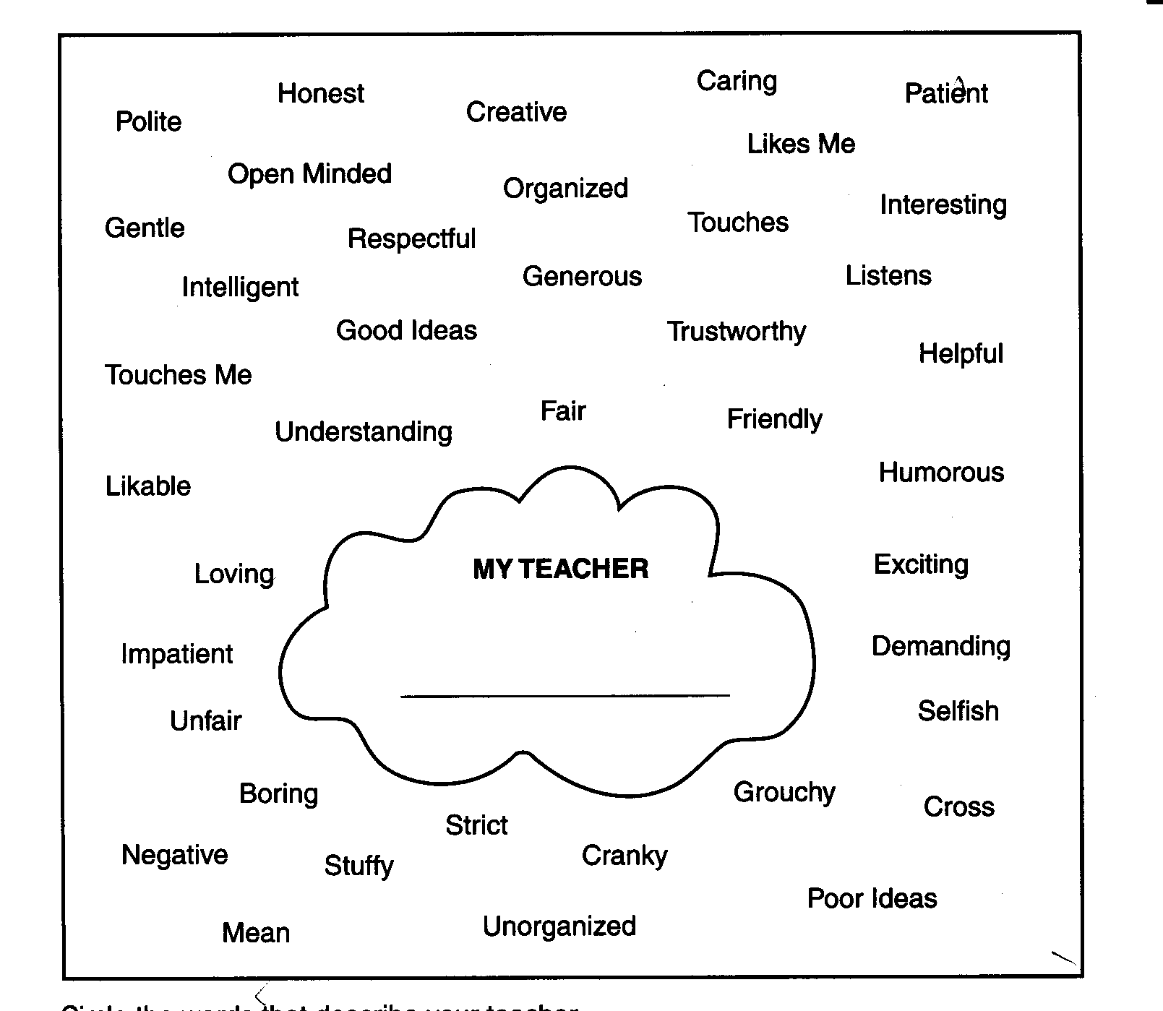
Circle the words that describe your teacher.
Circle in red if the words describe your teacher most of the time.
Circle in blue if the words describe your teacher sometimes.
Circle in green if the words seldom describe your teacher.
Circle in orange if the words never describe your teacher.

EVALUATING THE QUALITY OF TEACHER-STUDENT RELATIONSHIPS
Before implementing any of the varied behaviors that you can use to create more positive teacher-student relationships, you should evaluate the current quality of your own interactions with students. Just as effective teaching involves both a diagnostic and a prescriptive component, any decision to alter our behavior can be helped by first assessing the students’ reaction to the current behavior. This approach enables us to focus changes in areas in which student’s feedback suggests that changes may be needed in order to improve teacher-student relationships.

1. Do I listen to you?

2. Do I help you enough?

3. Do I care about you?

4. Do I help you feel good about
learning?
5. Do I seem happy when I teach?

6. Do I think you can do your work?

7. Can you share your good and bad
feelings with me?
8. Am I polite?

9. Am I fair?

10. Do you know what I want you to do?

11. Do I help you understand why we are doing each activity in class?
12. Do I call on you enough in class?

13. Do I let you know when you have
done good work?
14. Are you excited about what I teach
you?

Date

