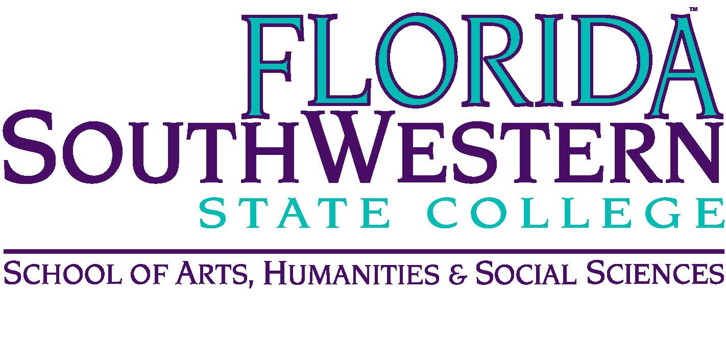
Department of Humanities and Fine Arts
Meeting Minutes
Date: January 11, 2019, 10:00 a.m.
Location: Edison/Lee campus
Chair: Dana Roes
Minutes: Michael McGowan

 | Present | Absent | Excused
Brown | X
Chase, S | X
Chase, W | X
Doiron | X
Hoover | X
Lublink | X
McGowan | X
Mompoint | X
Pritchett | X
Roes | X
Sutter | X
Smith | X
Swanson | X
Molloy | X
Krupinski | X
Guests

- Opening
  - Call to Order: 10:00 a.m.
  - Attendance taken
  - Minutes from Nov. 2018 Approved
- Announcements:
  - Attendance Verification due Tuesday: check on last day to make sure it hasn’t changed.
  - Summer Schedule request
  - Upcoming Events
    - 1/15: Depue Brothers Concert (strings, banjo, etc.), 7 pm (Location TBD)
    - 1/16: Red Sands Project, Human Trafficking Exhibit (talk to Wendy), 2 pm, Reception at 3-3:15
    - 1/17: Guerilla Girls opening, Rauschenberg Gallery, 6 pm
    - 1/26: Chalk Art on 5th Ave. (talk to Les)
    - 2/4: Innovation Grants (talk to Myriam)
    - 2/4 Poet Peuo Tuy (Rush Auditorium), 3 pm
- Information items
  - Website/brochure: Steve – send the bio by 2/1/19.
  - Assessment: Elijah –
    - Focus Groups were a total bust. We need the “push in” model this semester. He’s willing to do a “mutant” push in that incorporates his questions into our course content. Joe will come into our next meeting. This is a way to ask students whether our disposition questions make sense to them on our surveys (not a refection on our teaching)
    - We need to set up our in-house reviews of our assessment results from fall 2018. Proposed date: April 12th (Friday).
  - Professional Development: Sarah – the process will be changing. There’s going to be an emphasis on whether you’ve lead a TLC session in the prior 12 months. It’s going to privilege people who’ve never used these awards and the TLC awards. It’s not as much “will you present?” and more of “have you presented?” They’re also making the application include less documentation. (Talk to Sarah about funding, starting fall 2019.) Note, too: September will probably get lumped into Summer travel. The narrative/explanation of how the conference will expand your content knowledge is probably going to break ties in point values. The limits have gone down from $3,000 to $1,500.
- Discussion items
  - OER: if you want to lead the charge, collect materials, let Dana know.
  - One Book, One College: 21 Lessons for the 21st Century (by Yuval Noah Harari)
  - Hiring Committees:
    - Digital Arts: Chair is Dana: Jade, Stuart, Steve
    - Humanities (Lee): Chair is Myriam: Wendy, Sarah, Mike
    - Split Humanities/English (Charlotte): Chair is Teed: Sarah, Mike, Dale
- Next Meeting: February 8, 2019 at 10:30 a.m. in L-119B.

ACTION INTEMS:
- All: Send Steve a Bio if you haven’t already: 2/1 is the deadline!
- All: Decide how we want Joe to evaluate our classes: mutant or regular push in.

