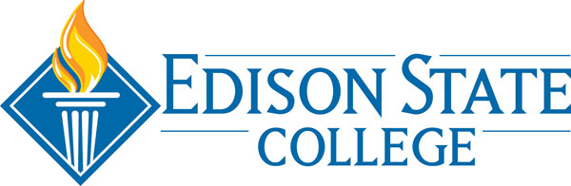

**Community/Public Service Events Checklist**

**Event Approval Process:**

☐ Develop and submit narrative, approved by the appropriate administrator, to the Director of Academic Services

☐Narrative should include associated effectiveness plan (if applicable), purpose and/or objective, intended audience, dates and venues, approximate budget, and the assessment plan

☐ When appropriate, solicit the assistance of the Director, Effectiveness and Accountability in the development of the assessment instrument for the event

☐ If applicable, contractual obligations are submitted to the Office of General Counsel for approval

☐ Notify appropriate Campus Public Safety Office, Technology Services, and Studio Edison State of the event and potential issues

**Upon Event Approval:**

☐ Schedule the event with staff and administrators

☐ Confirm details with Public Safety, Technology Services, and Studio Edison State

☐ Verify approval of contracts

☐ Notify the Director of Academic Services of event approval and details

☐Promote and publicize event via the College Communications and Studio Edison State

☐Ensure assessment of event is completed

**After the Event:**

☐ Submit summary of data and use of assessment results to the Director of Academic Services